# Git

**“Git is a tool that helps you keep track of changes you make to**

**code/files.”**

* **Git** is a tool for **version control** that helps you track and manage changes to files.
* It is widely used for **collaboration** on projects, allowing multiple people to work together without conflicts.
* **Branching** enables developers to work on new features safely without affecting the main project.
* Git also serves as a **Backup** system, storing the complete history of your project.

**Centralized version control** keeps everything in one place. Ex **SVN**

**Distributed version control** gives everyone a full copy, making it more robust and flexible for collaboration. Ex **Git**

### Git Uses

**Version Control** : you can control diff versions of you app.

**Collaboration**  : Multiple members can work on same code.

**Distributed System** : Everyone can have local repository and remote repository.

**Integration and Automation**: Any changes in code will trigger automation tools to check the code.

Security : you can control access of your code.

What are in .git

* **config**: Configuration settings.
* **HEAD**: Current branch pointer.
* **description**: Repository description.
* **hooks**: Scripts for automation.
* **info**: Additional info and ignored files.
* **logs**: Logs of reference changes.
* **objects**: Actual data and history.
* **refs**: Branch and tag pointers.
* **index**: Staging area for changes.
* **packed-refs**: Compact reference storage.

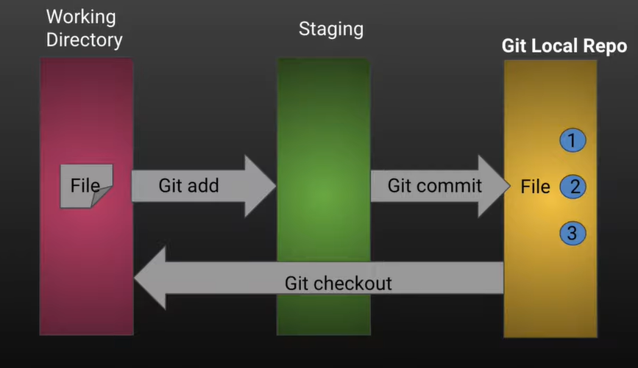

### Git Commands to add and commit code

Git congif –global user.name “Anil”

Git congif –global user.email “email@gmail.com”

Git init

Git diff ( working directory vs staging area (unstaged changes).)

Git status

Git add <file name>

Git diff –staged ( staging area vs last commit )

Git commit –m “text”

Git log (to see all versions)

Git reset –hard <commitID> (to got to a specified version)

git commit -a -m "Your commit message" (without staging)

### Configuration Commands

**git config**: Set configuration options for your Git installation.

* **git config --global user.name "Your Name"**: Set your Git username.
* **git config --global user.email "you@example.com"**: Set your Git email.

### Repository Commands

**git init**: Initialize a new Git repository.

* **git init**: Create a new local repository in the current directory.

**git clone**: Copy a repository from a remote source.

* **git clone** [**https://github.com/user/repo.git**](https://github.com/user/repo.git): Clone a remote repository to your local machine.

### File Commands

**git add**: Add files to the staging area.

* **git add filename**: Stage a specific file.
* **git add .**: Stage all changed files in the current working directory.

**git commit**: Save changes to the local repository.

* **git commit -m "Commit message"**: Commit staged changes with a message.
* **git commit --amend**: Adjust/edit the last commit without creating a new commit.
* **git commit -a -m "Your commit message":** Skipping the Staging Area and commit for already commited.

**git status**: Check the status of your working directory and staging area.

* **git status**: See which files are staged, unstaged, and untracked.

**git rm**: Remove files from the working directory and staging area.

* **git rm –f filename**: Remove a specific file from working directory and staging area.
* **git restore --staged filename.txt:** Remove a specific file from staging area but not from working directory.
* **rm filename:** Remove a specific file from working directory but not from staging area.
* **git restore filename.txt**: to discard changes that have not been staged.

### Branching and Merging Commands

**git branch**: Work with branches.

* **git branch**: List all branches.
* **git branch branchname**: Create a new branch.
* **git branch -d branch-name**: Delete a branch.
* **git push remote-repo new-branch-name :** Create a new remote branch.
* **git push <remote-repo> --delete branch-name**: Delete a remote branch.
* **git branch -r**: List all branches in remote.
* **git branch -m new-branch (or)**

**git branch** –**m <old branch name> <new branch name**>: Rename a branch.

* **git push <local branch name> <new branch name**>: Push changes from local branch to remote branch.
* **git push remote-repo old-branch:new-branch :** Renaming remote branch.

**git checkout**: Switch between branches or restore working tree files.

* **git checkout branchname**: Switch to a specific branch.
* **git checkout -b newbranch**: Create and switch to a new branch.
* **git checkout master -- file.txt:** Copy a file from master branch to current branch

**git merge**: Merge branches into the current branch.

* **git merge feature-branch**: Merge the specified branch into the current branch.

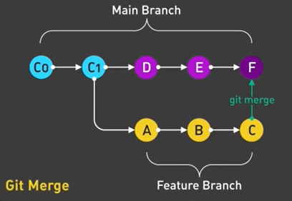

* **git rebase -i main**: change the base of current feature branch to recent main branch commit.

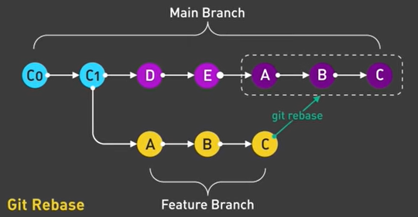

### Remote Commands

**git remote**: Manage remote repositories.

* **git remote** : List remote repositories names
* **git remote -v**: List remote repositories with URLs.
* **git remote add <repo-name>** [**https://github.com/user/repo.git**](https://github.com/user/repo.git): Add a new remote repository.
* **git remote remove <repo-name>**: Remove a remote repository.
* **git remote show <remote-name>:** Gives detailed information about a specific remote.
* **git remote rename <old name> <new name>:** To rename a remote repo.

**Adding a Remote Repo + Pulling**: Connects an existing local repository to a remote one and optionally syncs it with the latest remote changes.

**Cloning a Remote Repo**: Creates a new local repository by copying everything from the remote repository.

**git fetch**: Download objects and refs from another repository.

* **git fetch <remote repo name in local> <branch in remote repo>**:

Fetch changes from the remote repository.

**git pull**: Fetch and merge changes from a remote repository to your current branch.

* **git pull remote-repo branchname**: Pull changes from the remote repository and merge into your current branch.

**git push**: Upload local repository content to a remote repository.

* **git push remote-repo branchname**: Push your changes to the remote repository.

### History and Comparison Commands

**git log**: Show commit logs.

* **git log**: See the commit history.
* **git log --oneline**: See a simplified commit history.
* **git log -<number>**: Limits the number of commits shown.
* **git log <filename>**: Shows commit history for a specific file.
* **git log --grep="keyword"**: Searches for commits with a specific keyword.
* **git log –after=”2 days ago”:** by time
* **git log --after="2019-11-01" --before="2019-11-08 " :** between dates.
* **git log --author="Author name"  :** by author.
* **git log --grep=" Commit message."**

**git diff**: Show changes between commits, commit and working tree, etc.

* **git diff**: See changes in the working directory.
* **git diff --staged**: See changes between the staging area and the last commit.
* **git diff branch1 branch2:** compare files in two branches.
* **git diff commitID1 commitID2:** compare differences in two commits.

**git show**: Show various types of objects.

* **git show commitID**: Show details of a specific commit.

### Stashing Commands

**git stash**: Save changes temporarily so you can work on something else.

* **git stash**: Stash your current changes.
* **git stash apply**: Reapply stashed changes.

### Tagging Commands

**git tag**: Create, list, delete or verify a tag object signed with GPG.

* **git tag tagname**: Create a new tag.
* **git tag -d tagname**: Delete a tag.
* **git tag -l**: List all tags.

### Undoing Changes Commands

**git reset**: Reset current HEAD to the specified state.

* **git reset --soft HEAD~1:** The last commit is undone, but the changes are still staged (ready to be committed again).
* **git reset --mixed HEAD~1:** The last commit is undone, the changes are unstaged, but the files still have the changes in your working directory.
* **git reset --hard HEAD:** The last commit is undone, and all changes are removed from the working directory and staging area. The files are reset to match the state of the previous commit.
* **git reset HEAD~N**: Undo the last commit to N times back, keeping changes in the working directory.
* **git reset –hard commitID**: rest to specified commit.

**git revert**: Create a new commit that undoes the changes of a previous commit.

* **git revert commitID**: Revert a specific commit.
* **git revert commitID..commitID** : Reverts a range of commits.

# Branching strategy

A structured branching model ensures **smooth development, testing, and deployment** while maintaining **stability in production**.

## **1. Developer Starts a New Feature (Feature Branch)**

* A **feature branch (feature/new-feature)** is created from the **develop branch**.
* The developer writes code, tests locally, and commits changes to the feature branch.
* Once ready, the **feature branch is pushed to GitHub and a Pull Request (PR) is created** to merge it into develop.

**Connections:**

* Feature branch → develop branch
* Feature branch exists **only for development** and is deleted after merging.

## **2. Development Testing (Dev Environment)**

* The develop branch is automatically deployed to the **Dev Environment** via CI/CD.
* Developers & QA teams test the new features.
* If bugs are found, **bugfix branches (bugfix/fix-issue)** are created from develop, fixed, tested, and merged back.

**Connections:**

* develop branch → **Dev Environment**
* Bugfix branch → develop

## **3. Preparing for Staging (Stage Branch & Staging Environment)**

* Once develop is stable, the changes are **merged into the stage branch**.
* The stage branch is automatically deployed to the **Staging Environment** for final testing.
* QA teams perform **performance, security, and UAT (User Acceptance Testing)**.
* If a major issue is found, a **bugfix branch** is created, fixed, tested, and merged back into stage.

**Connections:**

* develop → stage → **Staging Environment**
* Bugfix branch → stage

## **4. Deploying to Production (Main Branch & Production Environment)**

* Once staging is **approved**, the stage branch is **merged into main** (production branch).
* The main branch is automatically deployed to the **Production Environment** via CI/CD.
* End-users now access the live application.

**Connections:**

* stage → main → **Production Environment**

## **5. Handling Urgent Production Issues (Hotfix Branch)**

* If a **critical bug** is found in production, a **hotfix branch (hotfix/fix-critical-issue)** is created from main.
* The fix is developed, tested in staging, and merged back into main.
* The hotfix is **immediately deployed to production** and then backported to develop to avoid conflicts.

**Connections:**

* hotfix → main → **Production Environment**
* hotfix → develop (backport fix to keep all branches updated)

## **6. Role of CI/CD Pipeline in Each Environment**

**Dev Environment** (Test New Features)

* **Source:** develop branch
* **Deployment:** Auto-deployed via CI/CD
* **Testing:** Developers & QA test features

**Staging Environment** (Final Approval)

* **Source:** stage branch
* **Deployment:** Auto-deployed via CI/CD
* **Testing:** QA, UAT, and performance testing

**Production Environment** (Live Users)

* **Source:** main branch
* **Deployment:** Auto-deployed via CI/CD
* **Testing:** Production monitoring & issue tracking

### **Feature Branch Terms**

* **Feature Branch (feature/xyz)** – A branch created from develop to work on a new feature.
* **Branch Protection** – Rules to prevent direct changes to main or develop, ensuring PR-based merges.
* **Continuous Integration (CI)** – Automated tests that run when a feature branch is updated.
* **Feature Flags** – A technique to enable/disable a feature without redeploying.

### **Bugfix Branch Terms**

* **Bugfix Branch (bugfix/abc)** – A branch used to fix non-critical bugs found in development.
* **Issue Tracking** – The process of documenting bugs in tools like Jira, GitHub Issues, or Trello.
* **Regression Testing** – Ensuring that a bug fix does not break existing functionality.

### **Hotfix Branch Terms**

* **Hotfix Branch (hotfix/xyz)** – A branch used to fix critical issues in production quickly.
* **Cherry-Picking** – Applying specific commits from one branch to another, often used in hotfixes.
* **Rollback Strategy** – A plan to revert to a previous stable version if a hotfix causes issues.
* **Patch Release** – A small release containing only critical fixes (e.g., v1.2.1).

**Dev Environment (Development Environment)**

**Purpose:** Developers test new features and bug fixes before sending them for formal testing.

**What Happens?**

* New **features and code changes** are deployed frequently.
* Developers test their code manually and debug issues.
* Basic **unit testing** is done, but it's not a full test environment.

**Example:**

* A developer writes code for a new login feature.
* They push the code, and the CI/CD pipeline **automatically deploys** it to the **Dev Environment** for testing.

**QA Environment (Quality Assurance Environment)**

**Purpose:** QA teams test the application for **bugs, functionality, and performance**.

**What Happens?**

* Full-fledged **manual and automated testing** is done.
* **Regression testing** ensures new changes don’t break old features.
* If QA finds issues, they report them, and the developers fix them in develop.
* The **bugfix branch is merged into develop and redeployed to QA**.

**Example:**

* A QA team tests the new login feature in the **QA Environment**.
* They find that the "Forgot Password" button isn’t working and report it.
* Developers fix it, and a new version is deployed to QA for retesting.

**Pre-Prod Environment (Staging Environment)**

**Purpose:** Simulates the **production environment** to ensure everything works as expected before going live.

**What Happens?**

* The application is **tested with production-like data and configurations**.
* Business users, UAT testers, and security teams **approve the final version**.
* If no issues are found, the same version is **approved for production deployment**.

**Example:**

* A company is launching a new checkout system.
* They deploy it to **Pre-Prod** and test real-world transactions without affecting actual users.
* Once approved, the same code is **moved to production**.

**Prod Environment (Production Environment)**

**Purpose:** The final, **live environment where real users interact with the application**.

**What Happens?**

* The **stable and approved** version is deployed.
* Real customers use the application.
* **Monitoring tools** track performance, errors, and security issues.
* If a critical bug is found, a **hotfix is deployed immediately**.

**Example:**

* The new checkout system is now live.
* Real customers make purchases using the updated system.
* If payments fail due to a bug, a **hotfix is created and deployed immediately** to fix it.

**Branching strategies in Git**

**Git Flow:**

* Develop new features in feature branches.
* Merge feature branches into develop.
* Create release branches from develop to finalize and test releases.
* Merge release branches into main and tag the release.
* Use hotfix branches for critical fixes directly on main and then merge back into develop.

**GitHub Flow:**

* Create a feature branch from main (e.g., feature/new-feature).
* Work on the feature in the branch and commit changes.
* Open a pull request to merge the feature branch into main.
* Review and test changes, then merge the pull request into main.
* Deploy code from main to production.

**GitLab Flow :**

* Use feature branches for development and merge them into pre-production.
* Test changes in pre-production.
* Merge pre-production into main for deployment to production.

**Feature branching :**

* Create a new branch for each feature or bug fix (e.g., feature/new-feature).
* Work on the feature branch and commit changes.
* Merge the feature branch into main or a designated integration branch when the feature is complete.

**Trunk Based Development :**

* Developers make small, frequent changes directly on the main branch or short-lived branches.
* Regularly integrate changes into the main branch to keep the codebase up-to-date and reduce conflicts.

### . **Benefits of** Version Control

1. **Track Changes**: Keeps a detailed history of all changes.
2. **Collaborate**: Makes it easy for teams to work together.
3. **Revert Changes**: Allows you to undo mistakes and return to previous versions.
4. **Branch and Merge**: Supports working on different features independently and combining them later.
5. **Document**: Provides a record of what was changed and why.
6. **Backup**: Acts as a safeguard against data loss.
7. **Audit**: Shows who made changes and when.

# CI/CD

**Code Commit**: Developers write code and commit it to a shared repository.

**CI Pipeline**: The CI system automatically builds the code and runs tests. Building the code ensures that all components work together correctly and that there are no missing dependencies.

* If tests pass, the code is considered integrated successfully.
* If tests fail, developers fix the issues and commit again.

**CD Pipeline**: The code that passes CI is automatically prepared for deployment.

* In Continuous Deployment, the code is deployed to production automatically.
* In Continuous Delivery, the code is deployed to production after manual approval.

**”CI tests ensure the code is functional and stable as it is developed, while CD tests ensure that the code is ready for a smooth and successful deployment to production”**

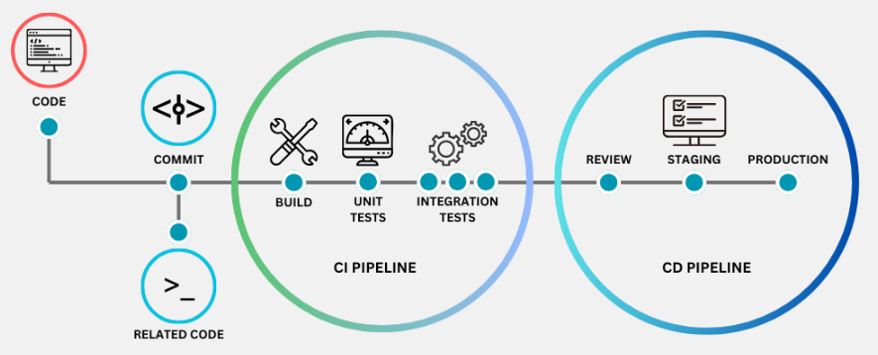

**Why It Matters**: CI helps catch errors and issues early, as code changes are tested frequently.

It also ensures that the code base is always in a workable state.

## **Everything About Continuous Integration (CI)**

**Continuous Integration (CI)** is the process of automatically building, testing, and verifying code whenever a developer pushes changes to a repository. The goal is to catch errors early, improve code quality, and ensure that the software is always in a deployable state.

### **CI Workflow in DevOps**

1. **Developer Writes Code** – A developer writes code in a local environment.
2. **Code is Pushed to Version Control System (VCS)** – Code is committed to a repository like GitHub, GitLab, or Bitbucket.
3. **CI Server Detects Changes** – The CI/CD tool (like Jenkins, GitHub Actions, GitLab CI/CD, or Harness) detects the new commit.
4. **Build Process Starts** – The tool compiles the code and checks for syntax errors.
5. **Automated Testing** – Unit tests, integration tests, and functional tests are run.
6. **Build Passes or Fails**

* If the build **passes**, it moves to the next stage (CD).
* If the build **fails**, developers are notified to fix the issue

**Real-time CI Workflow with tools**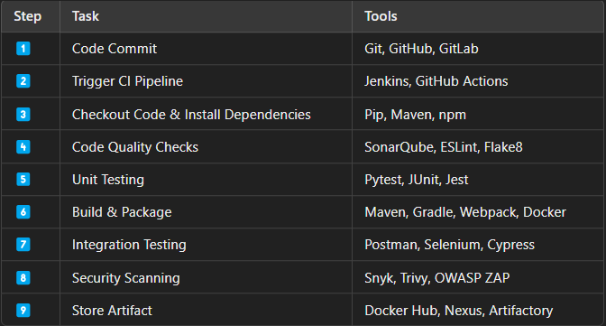

### **1. Code Commit & Version Control**

Developers write code and push changes to a **Version Control System (VCS)** like **GitHub, GitLab, or Bitbucket**.  
A proper **branching strategy** is used:

* main → Stable, production-ready code.
* develop → Ongoing development work.
* feature/* → New feature branches.
* hotfix/* → Quick fixes to production issues.

**Tools Used**:

* **Git** – Version control system
* **GitHub/GitLab/Bitbucket** – Repository hosting services
* **Pre-commit hooks** – Enforce formatting, linting before committing

### **2. Triggering CI Pipeline**

Once the code is pushed, a **CI server** detects the change and triggers a pipeline.  
The pipeline can be defined in a **CI configuration file** like:

* **Jenkinsfile** (for Jenkins)
* **.gitlab-ci.yml** (for GitLab CI/CD)
* **GitHub Actions YAML workflows**

**Tools Used**:

* **Jenkins** – Most popular open-source CI/CD tool
* **GitHub Actions** – Native CI/CD for GitHub
* **GitLab CI/CD** – Built-in CI for GitLab
* **CircleCI, TravisCI, Azure DevOps** – Other CI providers

### 3.Code Checkout & Dependency Installation

CI server clones the latest code from the repository.

Required **dependencies** and **packages** are installed based on the project type.

**Python**: Use pip and requirements.txt to install dependencies.

**Java**: Use **Maven** (pom.xml) or **Gradle** (build.gradle) to install dependencies.

**Examples**:

* **Python**: pip install -r requirements.txt
* **Node.js**: npm install
* **Java (Maven)**: mvn clean install
* **Java (Gradle)**: gradle build

**Tools Used**:

* **Pip** (Python)
* **NPM/Yarn** (Node.js)
* **Maven/Gradle** (Java)
* **Composer** (PHP)

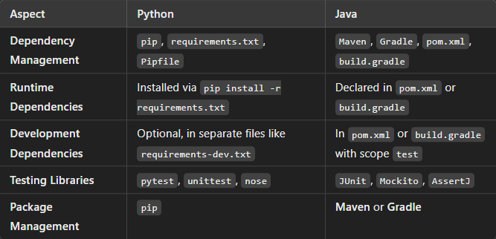

**4. Code Quality Checks : Linting**

The code is **scanned for syntax errors**, best practices, and security vulnerabilities.  
This ensures code consistency and avoids technical debt.

**How Linting Works?**

It scans **source code** and **identifies issues** like:

* Incorrect **indentation**.
* **Trailing spaces**.
* **Improper variable naming**.
* **Unused imports**.
* **Missing docstrings**.
* **Long lines of code**.

**5. Code Quality Checks : Static Code Analysis**

**Static Code Analysis** checks the **code structure and logic** without executing it. It helps detect:

* **Syntax errors**.
* **Security vulnerabilities**.
* **Memory leaks**.
* **Dead code** (unused code).
* **Performance issues**.

**Examples**:

* **Python**: flake8 (code quality), black (autoformatter according to Python Enhancement Proposal Guilelines),pylint,Mypy
* **JavaScript**: ESLint, Prettier
* **Java**: Checkstyle, SonarQube,Spotbugs,Findbugs
* **Terraform**: terraform fmt, tflint

**Tools Used**:

* **SonarQube** – Code quality and security analysis
* **ESLint, Flake8, Pylint** – Linting tools
* **Checkstyle, PMD** – Java-specific analysis

**6.Unit Testing**

CI pipeline runs **automated unit tests** to validate individual components of the application.  
**Test Coverage** reports help ensure most of the code is tested.

**Examples**:

* **Python**: pytest
* **JavaScript**: Jest, Mocha
* **Java**: JUnit, TestNG
* **Go**: go test

**Tools Used**:

* **Pytest, Mocha, Jest, JUnit** – Unit testing frameworks
* **SonarQube** – Code coverage analysis
* **Coverage.py** – Python code coverage tool

### **7.** Build Process

The application is compiled, packaged, or bundled into an **executable format**.  
This step produces an **artifact** (JAR, WAR, Docker image, etc.).

**Examples**:

* **Java (Maven)**: mvn package → Produces .jar or .war
* **Java (Gradle)**: gradle build → Produces .jar
* **Python**: pyinstaller --onefile app.py → Produces app.exe
* **Node.js**: npm run build → Bundles frontend assets
* **Docker**: docker build -t my-app:latest . → Creates Docker image

**Tools Used**:

* **Maven/Gradle** – Java build tools
* **PyInstaller** – Python package builder
* **Webpack** – JavaScript bundler
* **Docker** – Containerization

**8. Integration Testing**

The built application is tested in a simulated environment.  
These tests ensure that different components **work together correctly**.

**Examples**:

* **REST API Tests**: Postman, Newman, REST Assured
* **Selenium**: UI automation testing
* **Cypress**: Web application testing

**Tools Used**:

* **Postman/Newman** – API testing
* **Selenium, Cypress** – UI testing
* **JMeter** – Performance testing

**9.Security Scanning**

The application is scanned for **security vulnerabilities**.  
This step prevents **misconfigurations, dependencies with known CVEs, and secrets leakage**.

**Examples**:

**SAST (Static Application Security Testing)**: Scans source code

Here are some **security vulnerabilities** that **SonarQube** checks for**SQL Injection** – Malicious code in database queries can allow unauthorized access.

1. **Cross-Site Scripting (XSS)** – Injecting malicious scripts into webpages that affect users.
2. **Hardcoded Secrets** – Storing passwords or keys in code that can be easily accessed.
3. **Insecure Deserialization** – Manipulating data to execute harmful code.
4. **Command Injection** – Allowing users to run dangerous system commands via input fields.
5. **Cross-Site Request Forgery (CSRF)** – Tricking users into making unwanted requests without their knowledge.
6. **Unvalidated Redirects and Forwards** – Redirecting users to malicious sites without validation.
7. **Sensitive Data Exposure** – Not properly protecting sensitive information like passwords and credit card numbers.
8. **Improper Error Handling** – Exposing detailed error messages that attackers can use to exploit the system.
9. **Broken Authentication** – Weak authentication mechanisms that can be exploited to gain unauthorized access.
10. **Security Misconfiguration** – Poor configurations that leave the system vulnerable to attacks.
11. **Insecure Cryptography** – Using weak or outdated encryption that can be easily broken by attackers.
12. **Privilege Escalation** – Allowing users to gain higher-level privileges than intended.

**DAST (Dynamic Application Security Testing)**: Scans running applications

**Tools Used**:

* **Snyk** – Scans dependencies for vulnerabilities
* **Trivy** – Docker container security scanner
* **OWASP ZAP** – Web app security testing
* **Bandit** – Python security analysis

**10.Storing the Build Artifact**

The final **executable file** (JAR, WAR, EXE, Docker image) is stored in an **artifact repository**.  
This allows future deployments to use a stable, tested version.

**Examples**:

* **Docker Image**: Pushed to Docker Hub or Google Container Registry
* **JAR/WAR**: Stored in Nexus or JFrog Artifactory
* **Python Package**: Uploaded to PyPI

**Tools Used**:

* **Docker Hub, GCR, ECR** – Container registries
* **JFrog Artifactory, Nexus** – Artifact repositories

**Final Output: Ready-to-Deploy Executable File**

* **Java App** → .jar or .war
* **Python App** → .exe or .tar.gz
* **Node.js App** → .zip or dist/ folder
* **Containerized App** → **Docker Image** (my-app:v1.0)

**Example Jenkins CI Pipeline:**

Here is the **correct and complete Jenkins pipeline** script for a **Java application** using **Maven, SonarQube, Checkstyle, JUnit, JaCoCo, and Docker**.

✅ **Checks out code** from GitHub  
✅ **Downloads dependencies** using Maven  
✅ **Runs linting** using Checkstyle  
✅ **Runs unit tests & collects coverage** using JUnit & JaCoCo  
✅ **Performs Static Code Analysis (SCA) & SAST** using SonarQube  
✅ **Builds a Docker image**  
✅ **Pushes the Docker image to DockerHub**

pipeline {  
    agent any  // Runs on any available Jenkins agent  
  
    environment {  
        SONARQUBE_SERVER = 'SonarQube'  // Name from Jenkins SonarQube configuration  
        DOCKER_IMAGE = 'your-dockerhub-username/your-java-app'  
        DOCKER_TAG = 'latest'  
    }  
  
    stages {  
        stage('Checkout Code') {  
            steps {  
                git branch: 'main', url: 'https://github.com/your-repo/java-app.git'  
            }  
        }  
  
        stage('Download Dependencies') {  
            steps {  
                sh 'mvn clean install -DskipTests'  
            }  
        }  
  
        stage('Linting (Checkstyle)') {  
            steps {  
                sh 'mvn checkstyle:check'  
            }  
        }  
  
        stage('Unit Testing & Code Coverage') {  // ✅ RUN FIRST  
            steps {  
                sh 'mvn test'  
            }  
            post {  
                always {  
                    junit '**/target/surefire-reports/*.xml'  // Collects JUnit test reports  
                    jacoco execPattern: '**/target/jacoco.exec'  // Collects code coverage data  
                }  
            }  
        }  
  
        stage('Static Code Analysis & SAST (SonarQube)') {  // 🚀 RUN AFTER TESTS  
            steps {  
                withSonarQubeEnv('SonarQube') {  
                    sh 'mvn sonar:sonar'  
                }  
            }  
        }  
  
        stage('Build Docker Image') {  
            steps {  
                sh "docker build -t ${DOCKER_IMAGE}:${DOCKER_TAG} ."  
            }  
        }  
  
        stage('Push Docker Image to DockerHub') {  
            steps {  
                withCredentials([usernamePassword(credentialsId: 'DOCKERHUB_CREDENTIALS', usernameVariable: 'DOCKER_USER', passwordVariable: 'DOCKER_PASS')]) {  
                    sh 'echo $DOCKER_PASS | docker login -u $DOCKER_USER --password-stdin'  
                    sh "docker push ${DOCKER_IMAGE}:${DOCKER_TAG}"  
                }  
            }  
        }  
    }  
  
    post {  
        success {  
            echo '✅ Pipeline completed successfully!'  
        }  
        failure {  
            echo '❌ Pipeline failed! Check logs for errors.'  
        }  
    }  
}

## **Everything About Continuous Deployment/Delivery - CD**

**Continuous Delivery (CD)** is a practice where code changes are automatically prepared for a release to production but require manual approval before being deployed.

**Deploy to staging ⮚ Further testing ⮚Manual approval**

**Why It Matters**: CD ensures that the software can be released quickly and safely.

It reduces the risk of deployment issues by continuously preparing and testing the code.

**Continuous Deployment (CD)**: Continuous Deployment (CD) is a practice where code changes are automatically deployed to production as soon as they pass all automated tests, with no manual approval required.

**Automatic production deployment ⮚Monitoring and feedback**

**Why It Matters**: It allows for rapid delivery of new features and fixes to users.

Reduces manual work and human error by automating the entire deployment process.

### **CD Workflow in DevOps**

### **1.Deployment to Staging Environment**

**What is Staging?**

The **staging environment** is a **pre-production** environment that closely resembles the production server. It is used for testing the application with real-like conditions before deploying it to actual users.

**Process of Deployment to Staging**

1. **Pull the Latest Build** → The latest application artifact (e.g., Docker image, JAR, WAR) is fetched from the artifact repository.
2. **Deploy Using Automation** → Use Kubernetes, Ansible, Terraform, or Helm to automate deployment to the staging environment.
3. **Apply Configuration Settings** → Update environment-specific settings, such as database URLs, API keys, and logging levels.
4. **Run Tests in Staging** → Ensure the application works properly in a near-production environment.

**Testing in Staging**

✅ **User Acceptance Testing (UAT)** → Business users test the application functionality.  
✅ **Integration Testing** → Ensure all services interact correctly.  
✅ **Regression Testing** → Ensure new changes do not break existing functionality.  
✅ **Performance Testing** → Test system behavior under expected load conditions.

**Deployment Strategies in Staging**

* **Rolling Deployment** → Deploy updates gradually, without downtime.
* **Blue-Green Deployment** → Have two identical environments (Blue = Current, Green = New). Once testing is complete, switch traffic to the Green environment.
* **Canary Deployment** → Deploy to a small percentage of users first before a full rollout.

**Tools Used for Staging Deployment**

**Jenkins, GitLab CI/CD, GitHub Actions** → Automate deployment.  
**Kubernetes, Helm, Terraform, Ansible** → Infrastructure automation.  
**Selenium, JMeter, Postman** → Automated UI, Performance, and API testing.

### **2. Performance & Security Testing**

**Why is This Step Important?**

Before pushing the application to production, we need to ensure:

* The application can handle expected traffic and load.
* There are no security vulnerabilities that could lead to data breaches.

**Types of Performance Testing**

**Load Testing** → Simulates multiple users accessing the app to test performance under normal and peak conditions.  
**Stress Testing** → Pushes the system to its limits to check for crashes or failures.  
**Scalability Testing** → Ensures the app scales up or down efficiently based on load.

**Tools for Performance Testing**

* **JMeter** → Simulates thousands of users and measures response time.
* **Gatling** → Open-source load testing tool.
* **k6** → Script-based load testing tool.

**Types of Security Testing**

🔐 **Static Application Security Testing (SAST)** → Scans source code for vulnerabilities (e.g., SonarQube, Checkmarx).  
🔐 **Dynamic Application Security Testing (DAST)** → Tests running applications for security flaws (e.g., OWASP ZAP, Burp Suite).  
🔐 **Container Security Scanning** → Scans Docker images for vulnerabilities (e.g., Trivy, Aqua Security).  
🔐 **Penetration Testing (Ethical Hacking)** → Security teams try to break into the application to find weaknesses.

**What Happens If Issues Are Found?**

* If performance issues are found → Optimize database queries, caching, and server resources.
* If security vulnerabilities are detected → Patch them before deployment.
* If critical bugs are found → Rollback changes and re-test.

### **3. Approval & Manual Gates (If Required)**

**What is an Approval Gate?**

An **approval gate** is a checkpoint in the CI/CD pipeline that requires **manual approval** before deploying to production.

**Why is Approval Needed?**

✔ Ensures that only tested and stable code is released.  
✔ Allows business stakeholders to verify the features.  
✔ Helps in compliance with organizational policies.

**Who Approves the Deployment?**

👨‍💻 **Scrum Master / Release Manager** → Confirms that all quality checks have passed.  
👨‍💻 **Product Owner** → Validates that the feature meets business requirements.  
👨‍💻 **Security Team** → Ensures no security vulnerabilities exist.

**Approval Process in CI/CD Pipelines**

* **Jenkins** → Use "Input Step" for manual approval.
* **GitLab CI/CD** → Use "Manual Jobs" for gated approvals.
* **GitHub Actions** → Use "Environment Protection Rules" for review and approval.

**Example of Approval Gate in Jenkinsfile**

stage('Approval Required') {

input {

message "Deploy to Production?"

parameters {

choice(name: 'Proceed', choices: ['Yes', 'No'], description: 'Confirm Deployment')

}

}

}

**Strategies to Reduce Approval Delays**

📌 **Automate as Much as Possible** → Reduce manual steps by using automated testing.  
📌 **Use Feature Flags** → Deploy but keep new features off until approved.  
📌 **Gradual Rollouts** → Use canary deployments for risk mitigation.

### **4. Production Deployment (Release Stage)**

**Final Step: Deploying to the Live Environment**

The approved application is now **released to end-users** in the production environment. This process must be carefully managed to **avoid downtime or service disruption**.

**Key Considerations for Production Deployment**

1️⃣ **Zero Downtime Deployment** → Users should not experience service interruptions.  
2️⃣ **Rollback Strategy** → Have a plan in case deployment fails.  
3️⃣ **Monitoring & Logging** → Keep track of errors and system performance.  
4️⃣ **Deployment Automation** → Use CI/CD tools for seamless deployment.

**Deployment Strategies for Production**

🟢 **Rolling Deployment** → Updates servers gradually.  
🟢 **Blue-Green Deployment** → Switch traffic to the new version once it's stable.  
🟢 **Canary Deployment** → Release updates to a small group of users first.  
🟢 **Feature Flags** → Toggle features without redeploying the app.

**Example of Production Deployment Using Kubernetes**

apiVersion: apps/v1

kind: Deployment

metadata:

name: my-app

spec:

replicas: 3

strategy:

type: RollingUpdate

template:

spec:

containers:

- name: my-container

image: my-app:v2.0

**Monitoring After Deployment**

* **Logging** → Use ELK (Elasticsearch, Logstash, Kibana) or Splunk.
* **Metrics & Alerts** → Use Prometheus, Grafana, Datadog.
* **Error Tracking** → Use Sentry or New Relic for real-time monitoring.

**Rollback Strategy**

If deployment fails due to issues (bugs, performance problems, etc.), roll back to the previous stable version.

## **Deployment Strategies in CD**

Different **deployment methods** are used to avoid downtime.

### **1. Rolling Deployment**

**How it Works:**

* Updates are **gradually** rolled out to instances one by one or in small batches.
* Older versions are replaced with the new version **without downtime**.

**Example:**  
If you have **5 servers**, you update **one server at a time** while others keep running the old version.

Example: Update **10% of servers → 30% → 50% → 100%**.

🔹 **Pros:**  
✅ No downtime.  
✅ Low risk (if a new version has issues, only a few instances are affected).  
✅ Works well for microservices and cloud-based applications.

🔹 **Cons:**  
❌ Rollback is slow because you need to re-update each instance.  
❌ Users may experience **temporary inconsistency** (some see old, some see new version).

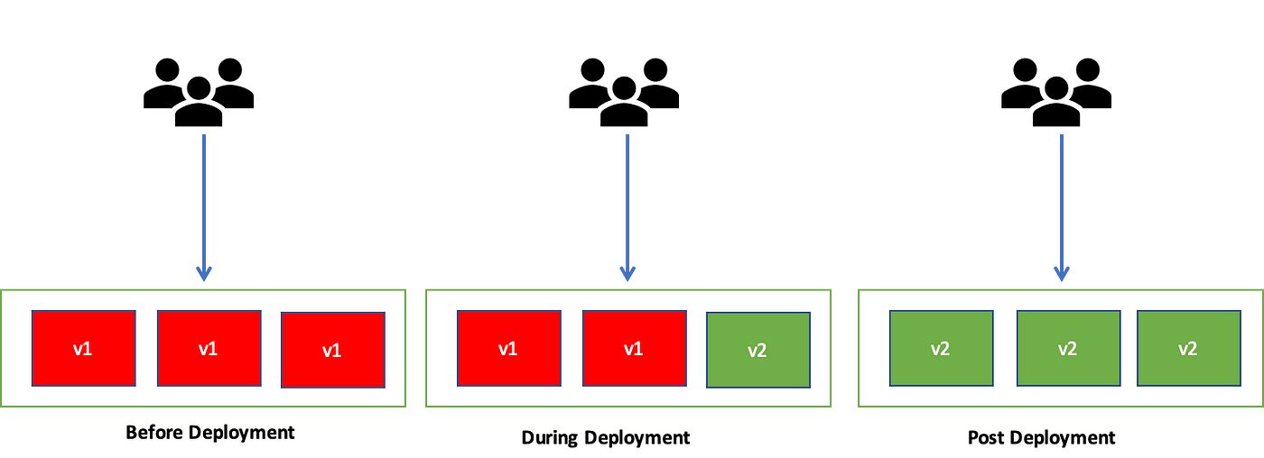

### **2. Blue-Green Deployment**

**How it Works:**

* Two identical environments exist: **Blue (current version)** and **Green (new version)**.
* Traffic is switched **instantly** from **Blue to Green** after testing the new version.
* If the new version has issues, you quickly switch back to Blue.

🔹 **Pros:**  
✅ **Zero downtime** deployment.  
✅ **Instant rollback** (switch traffic back to the Blue environment).  
✅ Ensures **consistency** (users don’t get mixed versions).

🔹 **Cons:**  
❌ **Expensive** (requires double infrastructure).  
❌ Not ideal for **stateful applications** (e.g., databases with active transactions).

**Best Use Cases:**

* High-traffic production environments.
* Applications requiring **zero downtime** (e.g., e-commerce, banking).

### **3. Canary Deployment**

**How it Works:**

* The **new version** is first deployed to a **small percentage of users**.
* If no issues are found, traffic is gradually increased.
* If issues are detected, rollback is done before full rollout.

🔹 **Pros:**  
✅ Low risk, as only a small portion of users are impacted.  
✅ **Real-world testing** with real users before full deployment.  
✅ Faster rollback if issues occur.

🔹 **Cons:**  
❌ Requires a **load balancer** or feature flag system to control traffic.  
❌ Some users may experience instability if issues exist.

**Best Use Cases:**

* Large-scale applications where **gradual rollout** is needed.
* Feature rollouts with A/B testing.

**Example:** Facebook rolls out features to **5% of users**, then **50%**, then **100%**.

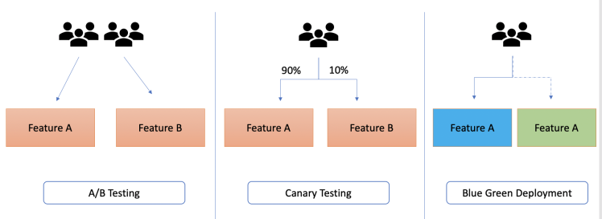

### **4. A/B Testing**

Deploys two versions (A & B) to test which one **performs better**.  
**Example:** Amazon tests different UI versions for user engagement.

### **5. Feature Flags**

Allows enabling/disabling features without code changes.

**How it Works:**

* New features are **deployed but kept hidden** behind a **feature flag**.
* The flag can be turned **on/off** without redeploying the application.
* Feature rollout is **controlled dynamically** (per user, per region, etc.).

🔹 **Pros:**  
✅ **Instant rollback** (just turn off the flag).  
✅ **Granular control** over feature rollout.  
✅ Enables **A/B testing** for product teams.

🔹 **Cons:**  
❌ Can lead to **complexity** in managing feature flags.  
❌ If not cleaned up, **technical debt increases** (old flags clutter the codebase).

**Best Use Cases:**

* SaaS applications releasing features to limited customers first.
* Applications needing **A/B testing**.

**Example:** Google rolls out new features **only to specific users**.

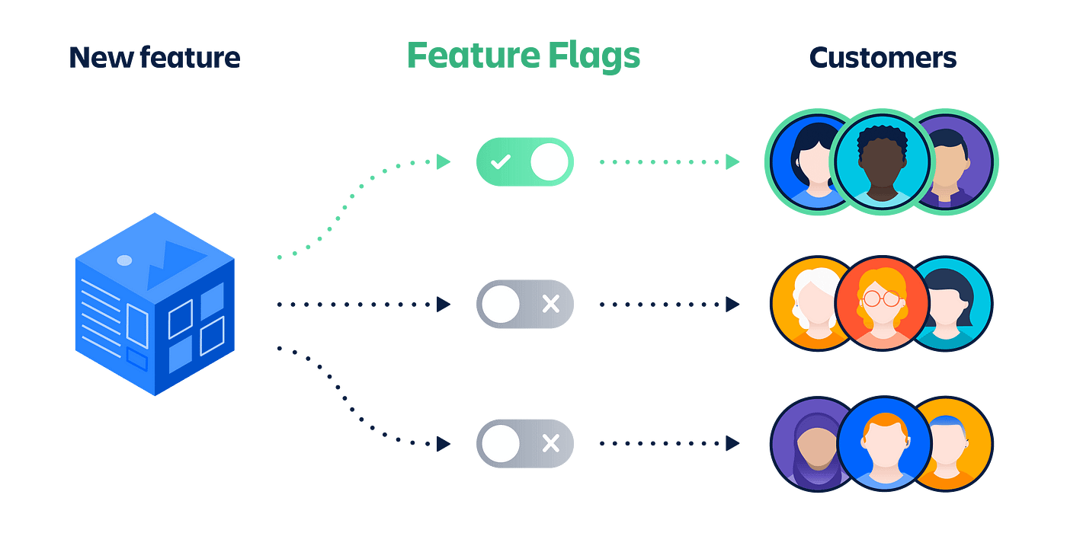

### **6. Shadow Deployment**

**How it Works:**

* The **new version runs in parallel** with the old version, but it does not handle user traffic.
* Instead, **real traffic is duplicated** and sent to the new version for testing.
* Once validated, the new version replaces the old one.

🔹 **Pros:**  
✅ Zero impact on users during testing.  
✅ Helps detect performance and security issues in real-world traffic.

🔹 **Cons:**  
❌ Expensive, as it requires duplicate resources.  
❌ Complex setup (needs traffic mirroring or duplication).

**Best Use Cases:**

* Applications that need **real-world testing** without impacting users.
* AI/ML models that need live data to test new versions.

# Jenkins

**“Jenkins** is an open-source automation server used to build, test, and deploy the software.“

It helps automate the parts of software development related to building, testing, and deploying, facilitating continuous integration and continuous delivery (CI/CD).

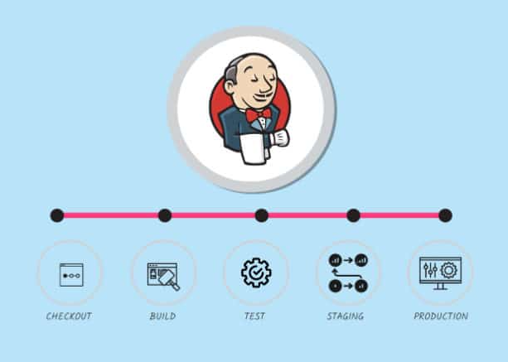

* **Developer Commits Code**: A developer commits code changes to a version control repository.
* **Jenkins Detects Change**: Jenkins is configured to monitor the repository and detect changes automatically. Jenkins pulls the latest code
* **Unit testing:** tests individual components.
* **Build Process**: build an artifact.
* **Testing**: Jenkins runs automated tests to verify the functionality.
* **Notification**: Jenkins notifies the team about the build status (success or failure). If the status is success, artifact will be saved in repo. If the status is fail, then the required changes will be made and CI process will be started again.
* **Deployment**: If the build is successful, Jenkins deploys the code to a specified environment

To create a Java deployment using Jenkins, you need to set up a CI/CD pipeline that pulls code from GitHub, builds the application, runs tests, creates an artifact, and deploys it. Below is a detailed explanation of the files Jenkins needs, the types of tests it performs, and how it creates and manages artifacts.

**1. Files Jenkins Needs from GitHub**

Jenkins requires specific files from your GitHub repository to build and deploy a Java application. These files typically include:

**Source Code**

* **Java Source Files**: Located in src/main/java.
* **Resource Files**: Located in src/main/resources (e.g., configuration files, templates).

**Build Configuration**

* **pom.xml**: For Maven-based projects (contains dependencies, plugins, and build configuration).
* **build.gradle**: For Gradle-based projects.

**Test Files**

* **Unit Tests**: Located in src/test/java.
* **Integration Tests**: Located in src/test/java or a separate module.

**Configuration Files**

* **Jenkinsfile**: Defines the CI/CD pipeline.
* **Dockerfile**: For containerizing the application.
* **Kubernetes Manifests**: For deploying to Kubernetes (e.g., deployment.yaml, service.yaml).

**Other Files**

* **.gitignore**: Specifies files to ignore in version control.
* **README.md**: Documentation for the project.

**2. Types of Tests Jenkins Performs**

Jenkins can automate various types of tests as part of the CI/CD pipeline. These tests ensure the application is functional and free of bugs.

**Code Quality Checks**

* **Purpose**: Ensure code adheres to quality standards.
* **Tools**: SonarQube, Checkstyle, PMD.
* **Command**:

mvn sonar:sonar

**Unit Tests**

* **Purpose**: Test individual components or methods in isolation.
* **Tools**: JUnit, TestNG.
* **Command**:

mvn test

gradle test

**Integration Tests**

* **Purpose**: Test interactions between components or with external systems (e.g., databases, APIs).
* **Tools**: JUnit, Spring Boot Test.
* **Command**:

mvn verify -P integration-tests

or

gradle integrationTest

**End-to-End (E2E) Tests**

* **Purpose**: Test the application from the user's perspective.
* **Tools**: Selenium, Cypress.
* **Command**:

mvn verify -P e2e-tests

**Security Tests**

* **Purpose**: Identify vulnerabilities in the application.
* **Tools**: OWASP Dependency-Check, Snyk.
* **Command**:

mvn dependency-check:check

**3. How Jenkins Creates Artifacts**

Jenkins builds the application and creates artifacts (e.g., JAR, WAR files) using build tools like Maven or Gradle. These artifacts are stored in a repository like Artifactory.

**Build Process**

* **Checkout Code**:
  + Jenkins pulls the code from GitHub.

stage('Checkout') { steps { git branch: 'main', url: 'https://github.com/your-username/your-repo.git' } }

* **Build the Application**:
  + Jenkins runs the build command to compile the code and create the artifact.

stage('Build') { steps { sh 'mvn clean package' } }

* **Run Tests**:
  + Jenkins executes unit and integration tests.

stage('Test') { steps { sh 'mvn test' } }

* **Create Artifact**:
  + The build process generates an artifact (e.g., target/your-app.jar for Maven).
* **Publish Artifact to Artifactory**:
  + Jenkins uploads the artifact to Artifactory.

stage('Publish Artifact') { steps { sh 'mvn deploy -s settings.xml' } }

**4. Example Jenkinsfile**

Here’s an example Jenkinsfile for a Java application:

**pipeline {**

**agent any**

**environment {**

**ARTIFACTORY_URL = 'https://your-artifactory-url'**

**ARTIFACTORY_REPO = 'your-repo'**

**}**

**stages {**

**stage('Checkout') {**

**steps {**

**git branch: 'main', url: 'https://github.com/your-username/your-repo.git'**

**}**

**}**

**stage('Build') {**

**steps {**

**sh 'mvn clean package'**

**}**

**}**

**stage('Test') {**

**steps {**

**sh 'mvn test'**

**}**

**}**

**stage('Publish Artifact') {**

**steps {**

**sh """**

**mvn deploy:deploy-file \\**

**-DgroupId=com.example \\**

**-DartifactId=your-app \\**

**-Dversion=1.0.0 \\**

**-Dpackaging=jar \\**

**-Dfile=target/your-app.jar \\**

**-DrepositoryId=artifactory \\**

**5. Artifactory Integration**

To publish artifacts to Artifactory:

* **Configure Artifactory Credentials**:
  + Add your Artifactory credentials in Jenkins (Manage Jenkins > Manage Credentials).
* **Update settings.xml**:
  + Add Artifactory repository details to your Maven settings.xml.

<server> <id>artifactory</id> <username>your-username</username> <password>your-password</password> </server>

Run HTML

* **Publish Artifact**:
  + Use the mvn deploy command to upload the artifact to Artifactory.

**6. Summary**

* **Files from GitHub**: Source code, build configuration, test files, Jenkinsfile, Dockerfile, Kubernetes manifests.
* **Tests**: Unit tests, integration tests, code quality checks, E2E tests, security tests.
* **Artifact Creation**: Jenkins builds the application using Maven/Gradle and publishes the artifact to Artifactory.

By following this process, you can automate the build, test, and deployment of your Java application using Jenkins.

**CI/CD Pipeline**

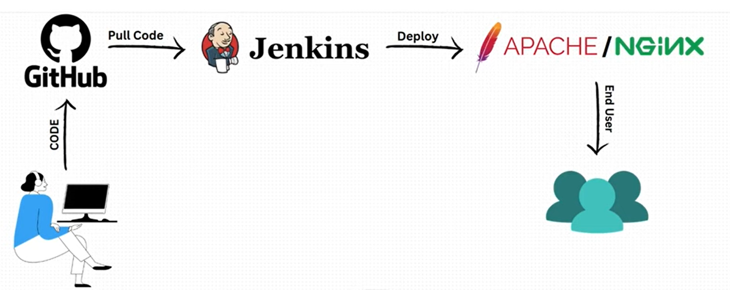

**Step 1: Push code or code changes from Local to GitHub.**

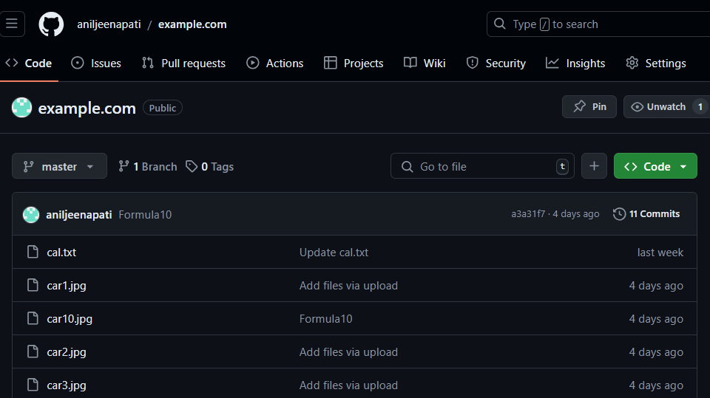

**Step 2: Add a webhook for repo in GitHub and give Jenkins URL.**

**Select application/json and enable pull requests and pushes.**

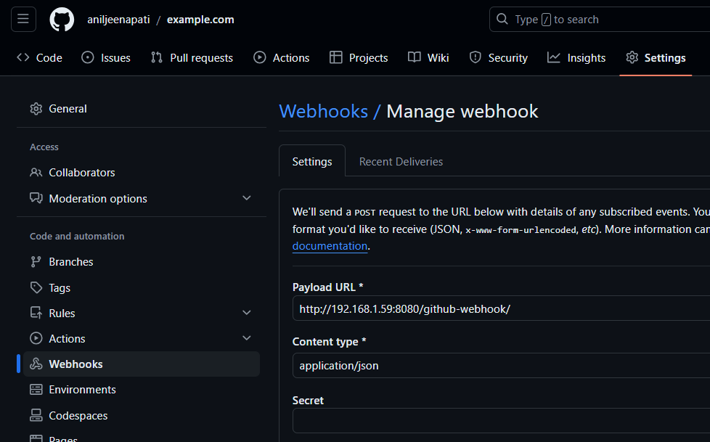

**Step 3: Create a Pipeline.**

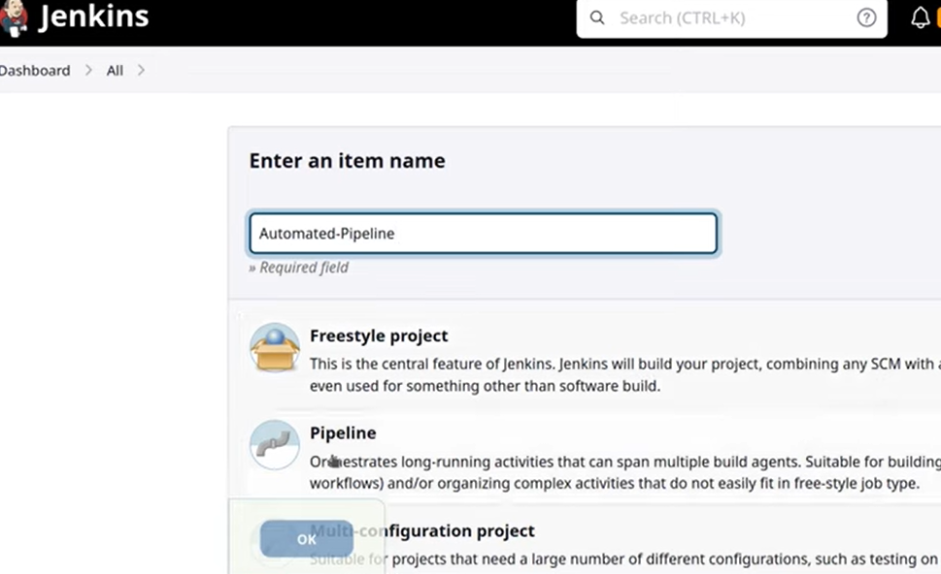

**Step 4: Select Git as Source Code and give Repo URL and Branch name.**

**Enable GitHub Hook trigger for GITScm pulling.**

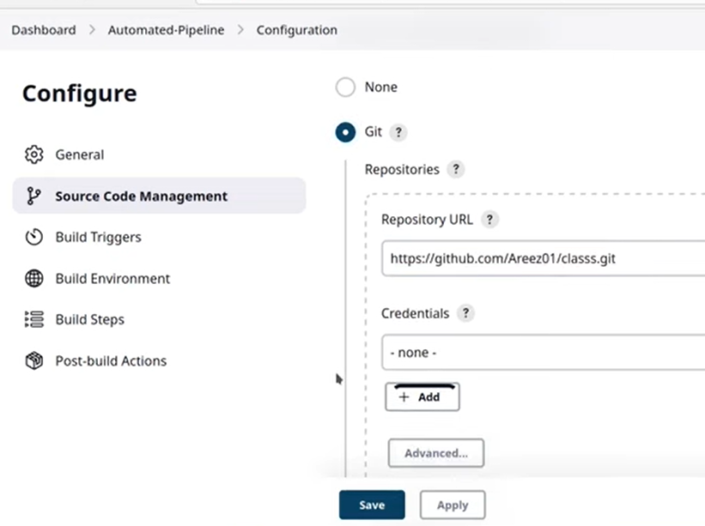

**Step 5: In Build Steps, select Execute shell to copy files from Git-repo to Server and give required permissions to those copied files in server.**

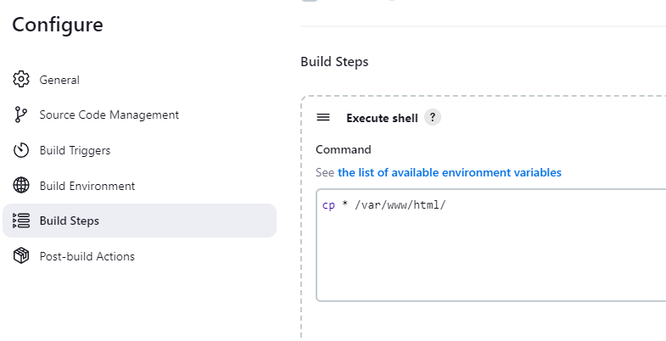

**Step 6: Click on Build Now to build app.**

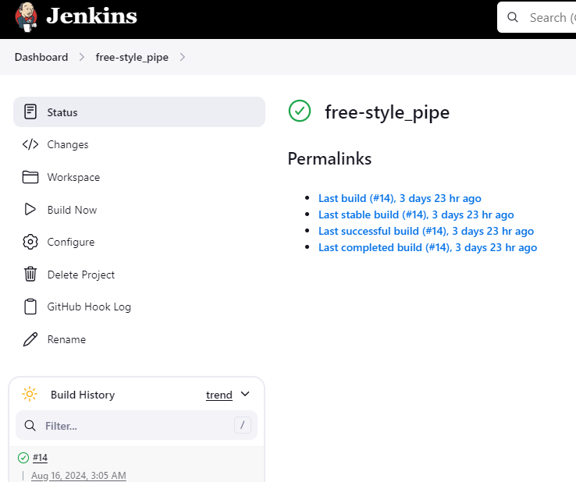

**Step 7: Test the web application.**



**Infrastructure as Code**

**Infrastructure as Code (IaC)** is a method of managing and provisioning computer infrastructure (like servers, networks, databases) using machine-readable configuration files, rather than through physical hardware or interactive configuration tools.

Instead of setting up servers or networks manually, with IaC, you write code that automatically sets up and manages your infrastructure. This code can be stored in version control systems like Git, allowing you to track changes, collaborate with others, and roll back to previous versions if needed.

* **Pulumi**: Uses familiar programming languages (Python, JavaScript, etc.) to define infrastructure as code.
* **AWS CloudFormation**: AWS-specific tool to manage resources using templates.
* **Azure Resource Manager (ARM)**: Azure's native infrastructure management tool.
* **Google Deployment Manager**: GCP-specific tool for managing resources via YAML or Python.
* **Ansible**: Focuses on configuration management but can also handle provisioning with modules like ec2 or gcp_compute.
* **Chef**: Automates provisioning and configuration using Ruby-based scripts.

### **Benefits of IaC:**

**Consistency:** IaC ensures consistent environments across development, testing, and production.

**Automation:** Automates the setup and management of infrastructure, reducing manual errors and effort.

**Speed:** Speeds up deployment times with quick provisioning and scaling of resources.

**Version Control:** Allows infrastructure changes to be tracked and versioned like code, improving manageability.

**Reproducibility:** Enables easy replication of environments, making testing and staging more reliable.

**Cost Efficiency:** Helps in optimizing resource usage and reducing costs through automated scaling and provisioning.

**Documentation:** Acts as living documentation of your infrastructure, making it easier to understand and manage.

# Terraform

## What is Terraform?

Terraform is an open-source tool developed by HashiCorp that allows you to define and manage your infrastructure as code. It is used to provision and manage infrastructure across various cloud providers and services, such as AWS, Google Cloud, Azure, and many others.

### Key Concepts

1. **Infrastructure as Code (IaC)**: Terraform allows you to describe your infrastructure using a high-level configuration language. This makes it easier to manage, version, and share your infrastructure setup.
2. **Providers**: Providers are plugins that Terraform uses to interact with different cloud platforms and services. Each provider knows how to manage the resources for a specific platform, like AWS, Azure, or Google Cloud.
3. **Resources**: Resources are the fundamental building blocks of your infrastructure. They can be virtual machines, storage, networking components, etc. In your configuration file, you define what resources you need and how they should be configured.
4. **Modules**: Modules are reusable configurations. They allow you to group resources together and reuse this group across different parts of your infrastructure.
5. **State**: Terraform keeps track of your infrastructure in a state file. This state file is used to map your configuration to the real-world resources it creates. It's crucial for planning and applying changes.

### Basic Workflow

**Write Configuration**: You write your infrastructure configuration in files with a .tf extension. These files are written in HashiCorp Configuration Language (HCL).

Example of a simple configuration file (main.tf):

provider "aws" {

region = "us-west-2"

}

resource "aws_instance" "example" {

ami = "ami-0c55b159cbfafe1f0"

instance_type = "t2.micro"

}

**Initialize**: Run terraform init to initialize your working directory. This will download the necessary provider plugins and dependencies.

**terraform init**

**Plan**: Run terraform plan to see what changes Terraform will make to your infrastructure. It shows a detailed execution plan and lets you review the changes before applying them.

**terraform plan**

**Apply**: Run terraform apply to create or update your infrastructure as defined in your configuration files.

**terraform apply**

**Destroy**: If you want to delete your infrastructure, you can run terraform destroy.

**terraform destroy**

### Benefits of Using Terraform

**Consistency**: Using code to manage infrastructure ensures that your setup is consistent across different environments.

**Version Control**: Since your infrastructure configuration is in code, you can store it in version control systems (like Git), making it easy to track changes and collaborate.

**Scalability**: Terraform can manage infrastructure for small projects to large-scale deployments across multiple cloud providers.

**Automation**: Automating infrastructure provisioning and management reduces human errors and saves time.

### Example Use Cases

* **Provisioning VMs**: Automatically create and configure virtual machines in the cloud.
* **Setting up Networks**: Define and manage network configurations, such as VPCs, subnets, and security groups.
* **Deploying Applications**: Automate the deployment of applications, databases, and other services.
* **Multi-cloud Management**: Manage infrastructure across multiple cloud providers from a single configuration file.

Terraform is a powerful tool that simplifies the management of complex infrastructures, making it a popular choice for DevOps and cloud engineering tasks.

## Creating an VM in GCP

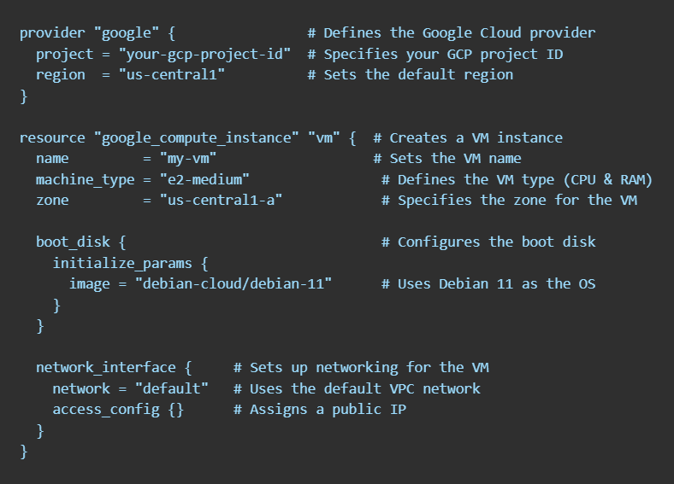

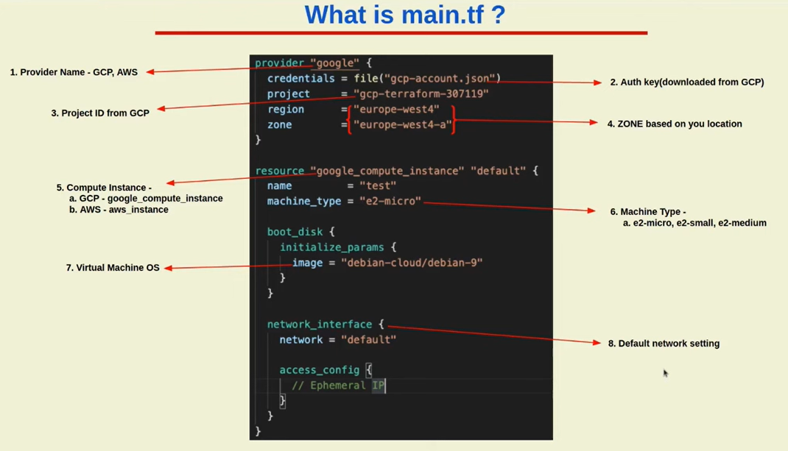

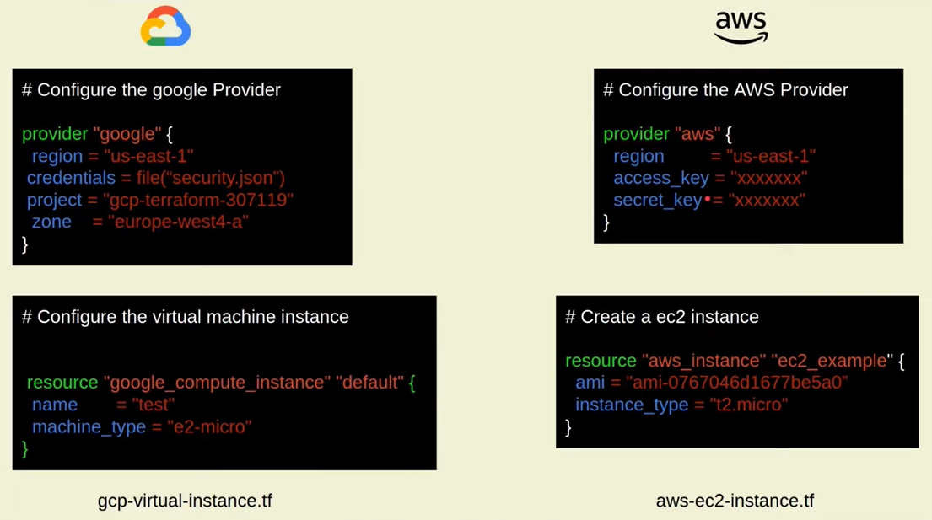

## Components in Terraform Script

### providers.tf : Specifies which providers the module uses.

**What it is**: A provider is a plugin that lets Terraform interact with different cloud platforms or services. Providers are what allow Terraform to manage resources on platforms like AWS, Google Cloud, Microsoft Azure, etc.

**Why it’s important**: It specifies the cloud platform you want to use and any credentials or configurations needed to authenticate with it.

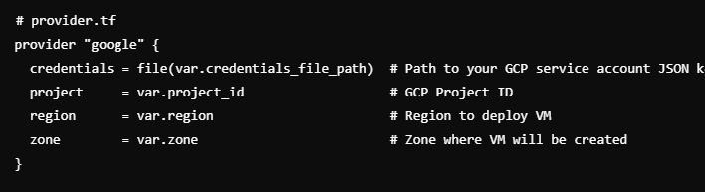

### main.tf: Contains the resources for the module.

**What it is**: A resource represents a specific component of your infrastructure, like a virtual machine (VM), a storage bucket, or a network. This is the main building block of your Terraform script.

**Why it’s important**: Resources define what specific cloud services you are provisioning and managing.

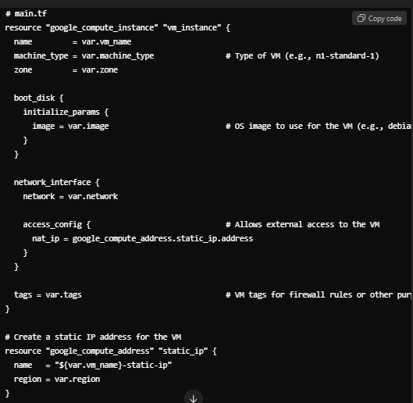

### variables.tf: Defines the inputs (variables) for the module.

**What it is**: Variables allow you to make your Terraform script more flexible and reusable. Instead of hardcoding values like instance types or regions, you can define variables and use them throughout your script.

**Why it’s important**: Variables make it easy to reuse the script across different environments (e.g., dev, staging, production) without having to modify the code every time.

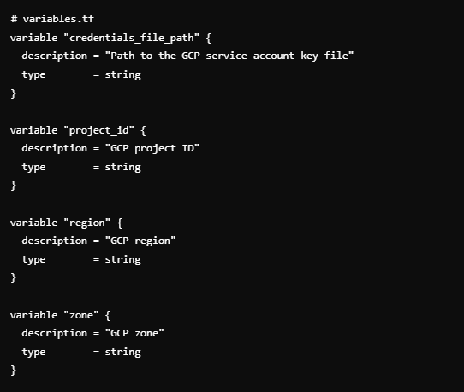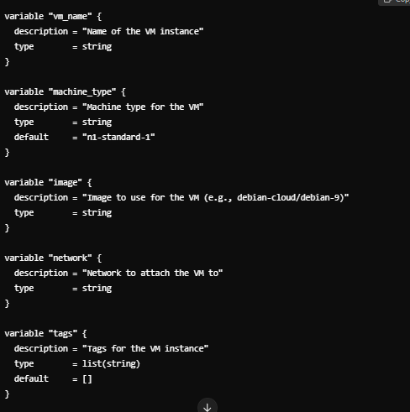

### terraform.tfvars– Provide Variable Values

This file defines the actual values for the variables, allowing you to separate configuration from code

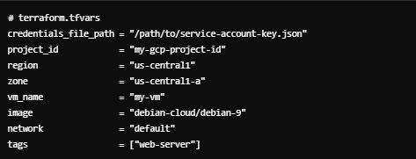

### outputs.tf: Defines the outputs (results) that the module will produce.

**What it is**: Outputs are used to display information after the infrastructure is created. For example, you might want to see the IP address of a server or the URL of a load balancer.

**Why it’s important**: Outputs give you important information that can be used in other processes or just for reference after your Terraform run completes.

## Modules

A module is a container for multiple resources that are used together. It’s a way to group related resources into a single unit. For example, you might create a module for setting up a database, a virtual machine, or a network.

**Reuse and Share**: By using modules, you can write code once and reuse it multiple times, which saves you from repeating the same configuration. You can also share modules with others or use modules shared by the community.

**Structure**: Each module typically has its own directory

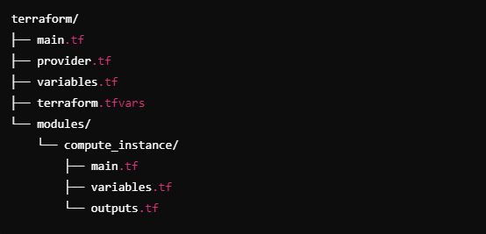

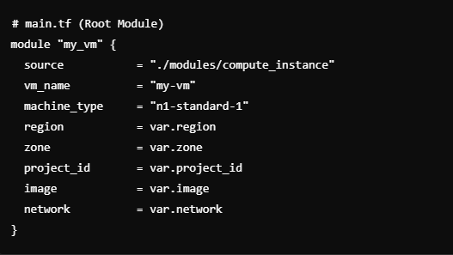

**modules/compute_instance/main.tf (Module to Create VM)**

This is the module where the VM creation logic resides. 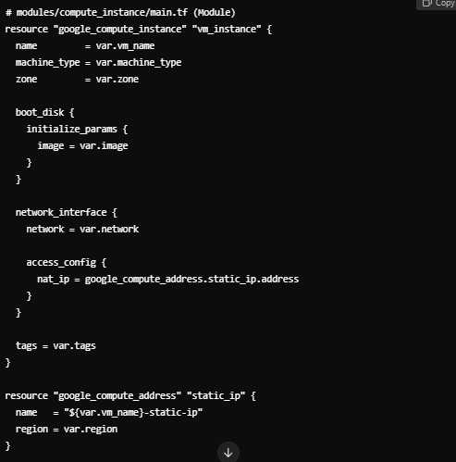

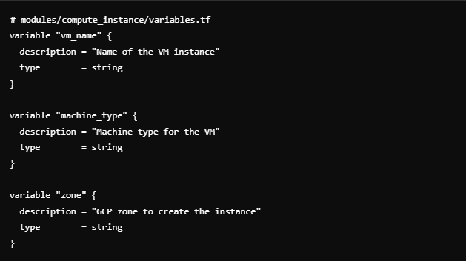

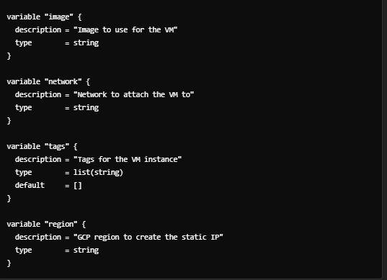

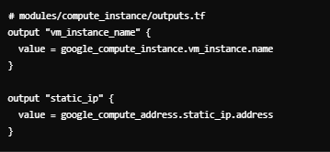

## State File

**What is the Terraform State File?**

This is a file that Terraform uses to keep track of the resources it manages.

It contains the current state of your infrastructure.

( including the resources you've created (like servers, databases, etc.), their configurations, and the relationships between them.)

**Why is it Important?**

* **Tracks Infrastructure**: The state file acts as a snapshot of your infrastructure. Terraform compares this file with your configuration to figure out what changes it needs to make.
* **Plans Changes**: When you run terraform plan, Terraform uses the state file to determine what’s already in place and what needs to be created, updated, or deleted.
* **Avoids Unnecessary Changes**: By keeping track of the current state, Terraform ensures that it only makes the changes that are necessary, preventing unintended modifications.

**How to Use the State File**

* **Automatic Creation**: Terraform automatically creates and updates the state file whenever you apply changes using terraform apply.
* **Don’t Edit Manually**: The state file is in JSON format, but you should avoid editing it manually because it can easily become corrupted, leading to potential issues in managing your infrastructure.
* **Backup**: Terraform often keeps a backup of the state file (terraform.tfstate.backup) to help recover from issues.

**Storing the State File**

* **Local Storage**: By default, the state file is stored locally on your machine in the directory where you run Terraform.
* **Remote Storage**: For collaboration and safety, it's common to store the state file remotely, such as in AWS S3, Google Cloud Storage, or Terraform Cloud.

**State Management Commands**:

* **terraform state list**: Lists all resources in the state file.
* **terraform state show <resource>**: Shows detailed information about a specific resource in the state file.
* **terraform state mv <resource> <new-location>**: Moves a resource to a different location in the state file.
* **terraform state rm <resource>**: Removes a resource from the state file without destroying it in your infrastructure.

**Best Practices**

* **Remote State Storage**: If working in a team, store your state file remotely to avoid conflicts and ensure everyone has access to the latest state.
* **State Locking**: Use state locking (supported by most remote storage solutions) to prevent multiple users from making changes simultaneously, which could corrupt the state file.
* **Secure the State File**: The state file can contain sensitive information (like passwords and secret keys), so ensure it's stored securely and access is controlled.

## Provisioners

Provisioners in Terraform are tools that allow you to run scripts or commands on a resource (like a virtual machine) after it has been created.

### File Provisioner:

**Purpose**: To copy files or directories from your local machine to the resource.

**Example Use Case**: Uploading a configuration file or a script to a VM after it's created.

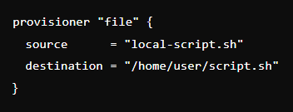

### Remote-exec Provisioner:

**Purpose**: To run commands on the remote resource after it's created.

**Example Use Case**: Installing software, starting services, or running a script on a VM.

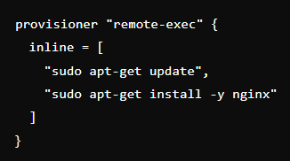

### local-exec Provisioner:

**Purpose**: To run commands on your local machine, not on the remote resource.

**Example Use Case**: Sending a notification, running a local script, or interacting with local files.

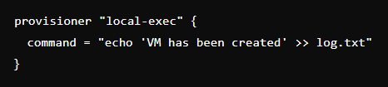

## Import in Terraform

**Common Terraform errors with a single-line explanation:**

* **Syntax Errors**: Mistakes in the Terraform file structure, such as missing brackets or incorrect indentation.
* **Invalid or Missing Credentials**: Terraform can't authenticate with the cloud provider due to missing or wrong credentials.
* **Missing Provider Plugin**: Terraform can’t find or download the necessary provider plugin (like AWS, GCP).
* **Resource Already Exists**: Terraform is trying to create a resource that already exists in the cloud.
* **Permission Denied**: You lack the proper permissions to create or modify a resource.
* **Unsupported Argument**: Incorrect attribute or argument used for a resource.
* **State File Corruption**: Terraform’s state file is corrupted or unreadable.
* **State Mismatch**: Terraform can't find a resource in the state file that should exist.
* **Circular Dependency**: Two or more resources depend on each other, creating a loop.
* **Version Mismatch**: The version of Terraform or a provider is incompatible with your configuration.
* **Resource Creation Timeout**: Terraform waits too long for a resource to be created and times out.
* **API/Networking Issues**: Terraform can't reach the cloud provider due to network or API problems.
* **Missing Variable**: A required variable hasn't been provided in the configuration or during execution.
* **Backend Initialization Error**: Problems with setting up or connecting to a remote state backend.
* **Quota Exceeded**: You've hit a resource limit imposed by your cloud provider.
* **Remote Backend Connection Error**: Terraform can’t connect to a remote backend like Terraform Cloud.

## Variables

[Terraform variables](https://developer.hashicorp.com/terraform/language/values) are a way to store values that can be reused throughout your Terraform configuration.

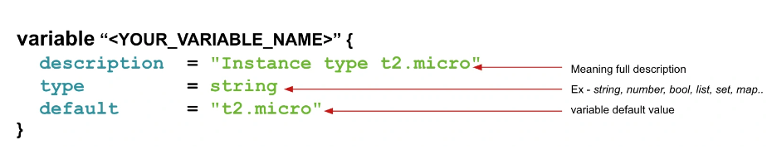

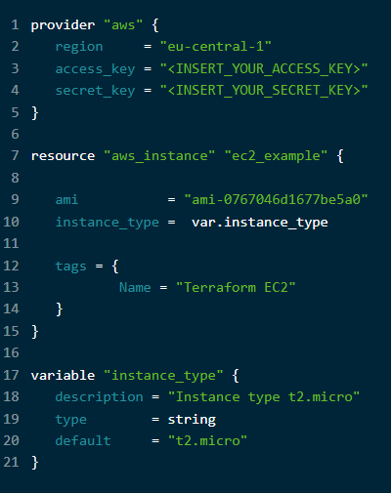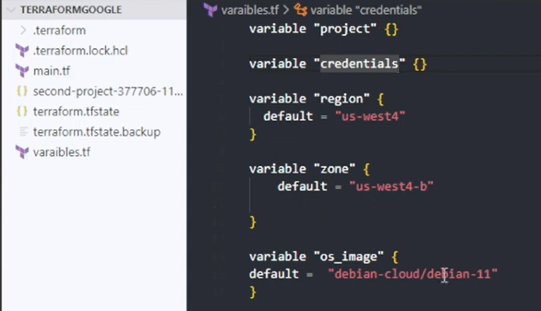

**Variables as List, Tuple**

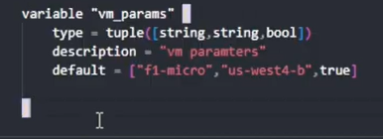

**Variables as Objects**

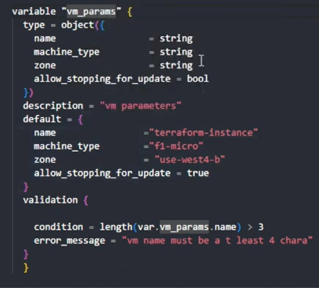

**Variable.tf File**

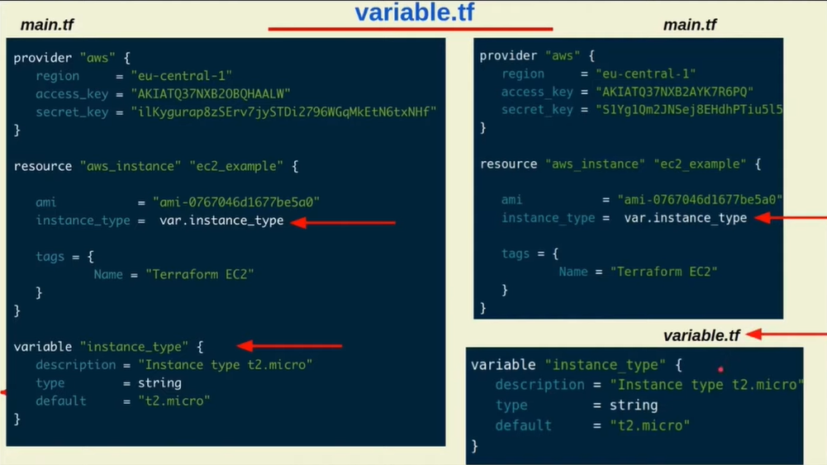

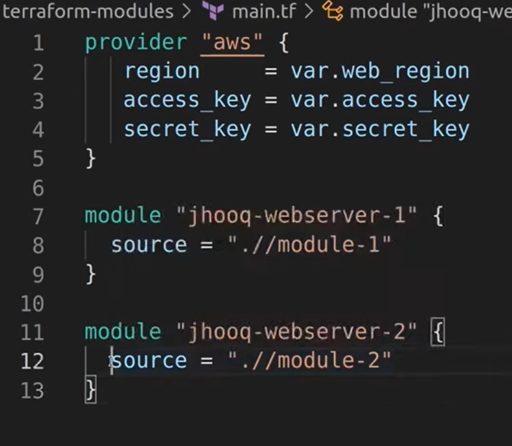

# **Docker**

A **Container** is a lightweight, portable, isolated unit that holds an application and its dependencies, allowing it to run consistently across different environments.

**Containerization:** It is the process of packaging an application and its dependencies into a lightweight, portable container that can run consistently across different environments.

A container includes everything needed to run the application, such as code, runtime, system tools, libraries, and settings.

Imagine you have a web application. Instead of installing all the necessary software and dependencies directly on a server, you package the application along with its environment (like the web server, database connectors, etc.) into a container.

This container can then be easily moved and run on any machine that supports containers, ensuring consistent behavior regardless of where it's deployed.

**Why Docker:** Docker simplifies application packaging and deployment by creating, managing, and running containers efficiently.

**Why Kubernetes:** Kubernetes automates the deployment, scaling, and management of containerized applications across clusters for high availability and reliability.

**Docker** is a platform for developing, shipping, and running applications inside containers. Containers are lightweight, portable units that package an application and its dependencies together.

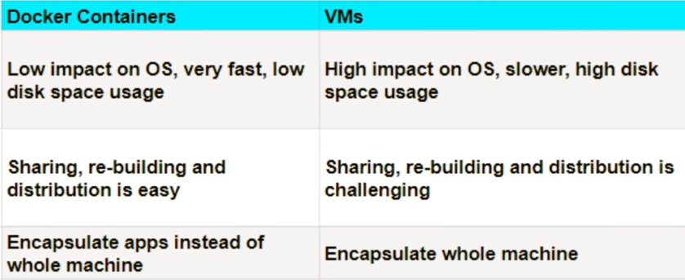

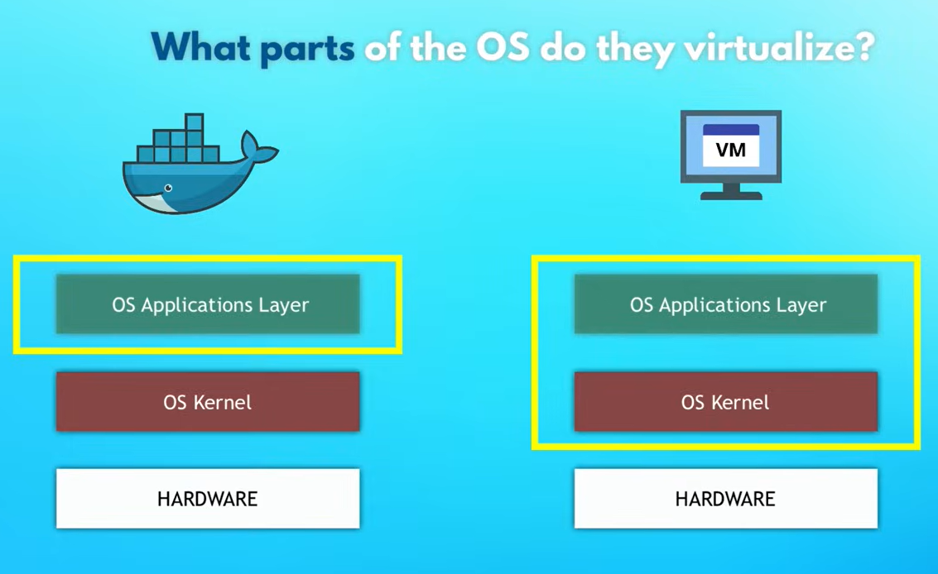

**Dockerfile → Blueprint**

**Docker Image → Packaged App**

**Docker Container → Running App**

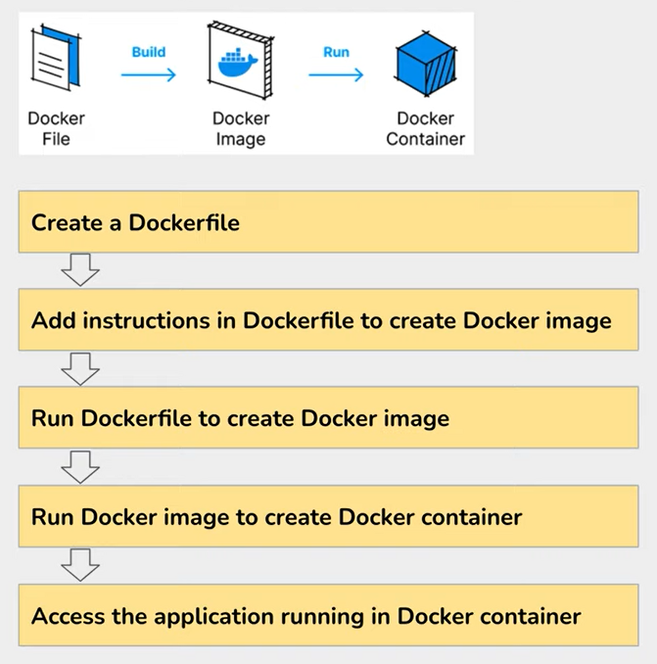

**Dockerfile → Docker Image**:

* Write a Dockerfile to define how an image should be constructed.
* Use the docker build command to build a Docker image from the Dockerfile.

**Docker Image → Docker Container**:

* You use a Docker image to create and run Docker containers. Containers are instances of Docker images and include the application and its environment.

**Containers**:

* **Isolation**: Containers encapsulate an application and its dependencies, ensuring that it runs consistently regardless of where it’s deployed.
* **Lightweight**: Containers share the host OS’s kernel, which makes them more efficient compared to virtual machines.

**Images**:

* **Build**: Docker images are templates used to create containers. They contain the application code, runtime, libraries, and environment variables.
* **Dockerfile**: A file where you define how to build an image. It includes instructions for setting up the environment and installing dependencies.

**Docker Engine**:

* **Runtime**: The Docker Engine runs on the host machine and is responsible for running and managing containers.
* **CLI**: The Docker Command Line Interface (CLI) is used to interact with Docker, including building images, running containers, and more.

**Docker Hub**:

* **Registry**: A cloud-based registry service for sharing and managing Docker images. You can pull images from Docker Hub or pushyour own.

**How Docker Works**

1. **Building an Image**: You write a Dockerfile with instructions on how to set up your application. You then use the docker build command to create an image from this Dockerfile.
2. **Running a Container**: Once you have an image, you can create and start a container from that image using the docker run command. The container will run your application in an isolated environment.
3. **Managing Containers**: Docker provides commands to manage your containers, such as docker start, docker stop, docker restart, and docker rm.

**Common Use Cases**

1. **Microservices**: Docker is ideal for building microservices, where applications are divided into smaller, independent services that can be developed, deployed, and scaled individually.
2. **Continuous Integration/Continuous Deployment (CI/CD)**: Docker is often used in CI/CD pipelines to create consistent and isolated build environments.
3. **Development Environments**: Developers use Docker to set up consistent and reproducible development environments that match production.
4. **Testing**: Docker allows for the easy creation of isolated test environments, ensuring tests are run in the same conditions every time.

**Basic Commands**

* docker build: Creates an image from a Dockerfile.
* docker run: Creates and starts a container from an image.
* docker ps: Lists running containers.
* docker stop: Stops a running container.
* docker rm: Removes a container.
* docker images: Lists available images.
* docker rmi: Removes an image.
* docker logs ‘container_id’: For logs.

## Docker File

The base OS you should use when creating a Docker image depends on your use case, security, and efficiency requirements.

### How to Choose Base OS for Docker Images

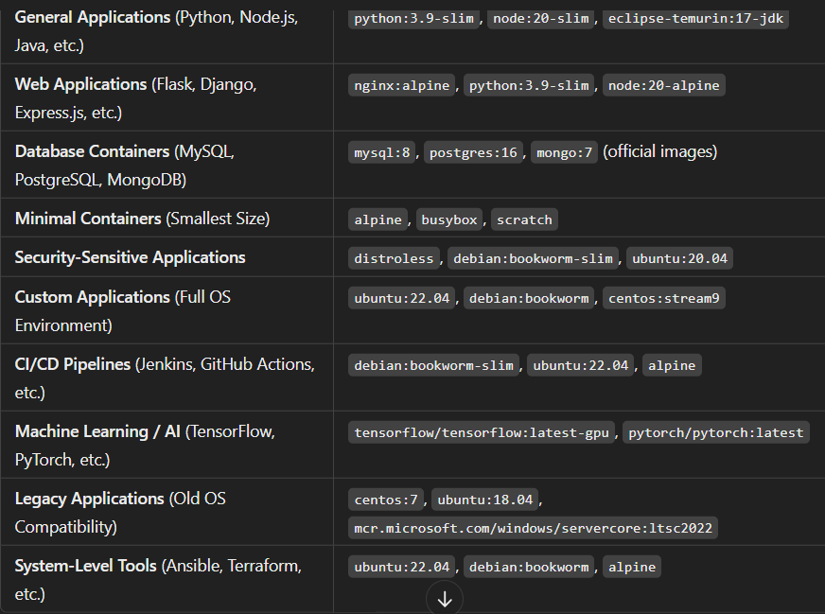

### How to Choose Base OS for Multi-Stage Docker Images

In **multi-stage builds**, we use different base images for different stages to reduce the final image size while keeping all necessary dependencies during the build process. The choice of base OS depends on:

1. **Build Stage:** Needs all dependencies to compile/build the application.
2. **Final Stage:** Should be minimal and optimized for performance.

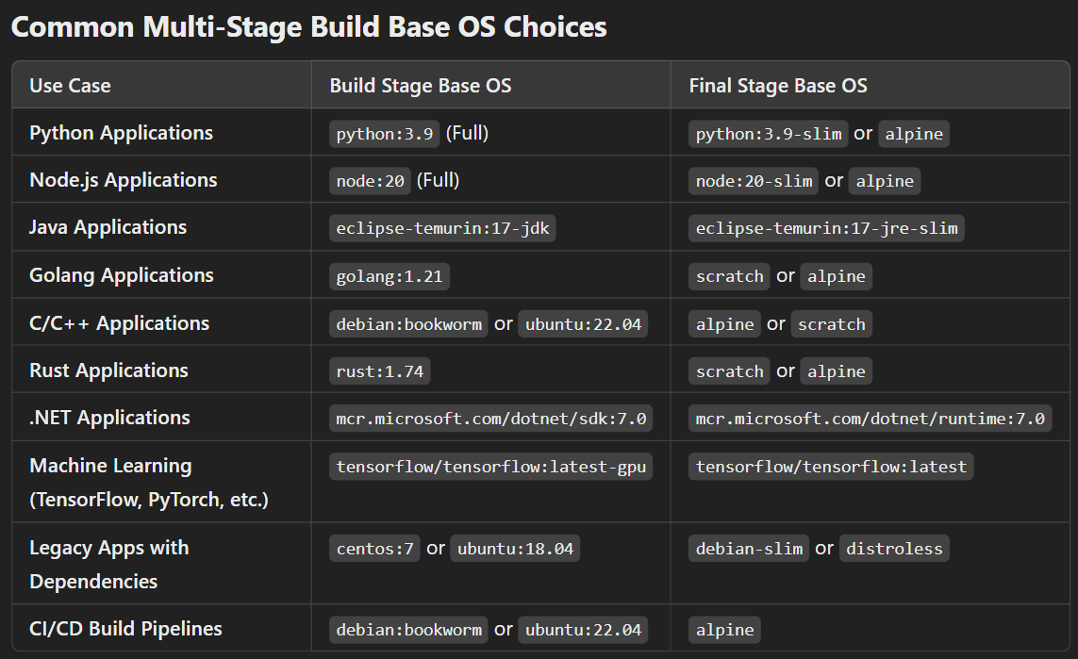

### Docker File Examples:

#### For Python :

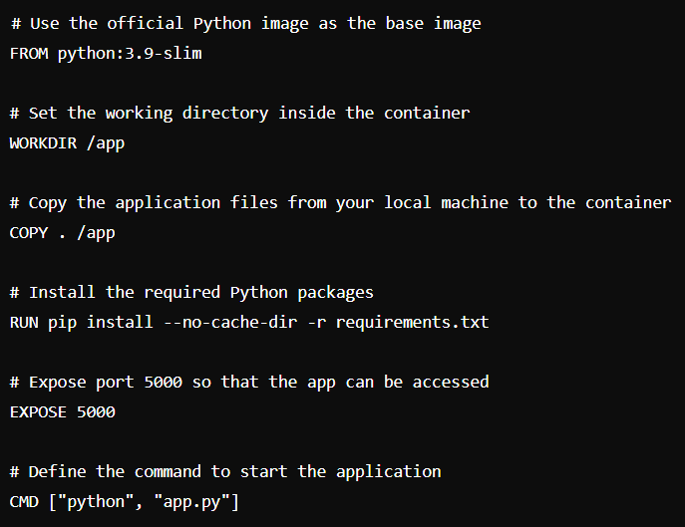

#### For NodeJS :

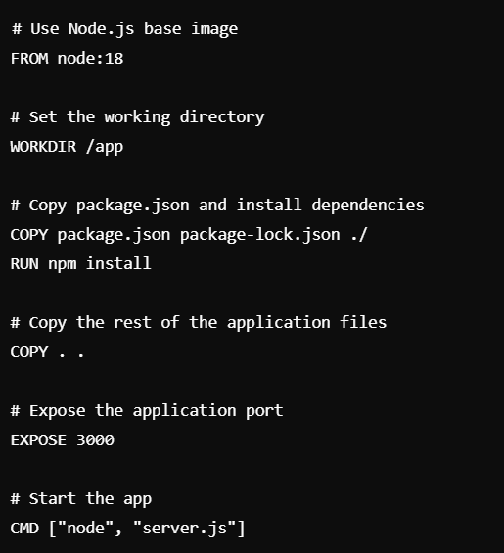

#### For Java Spring boot :

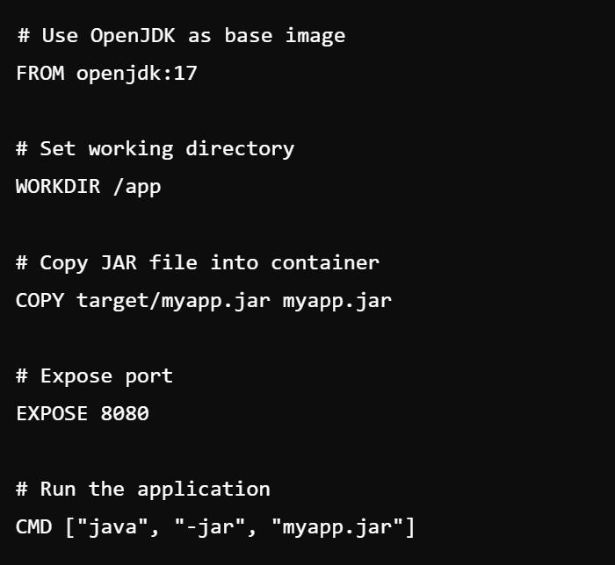

#### For NginX Static Website :

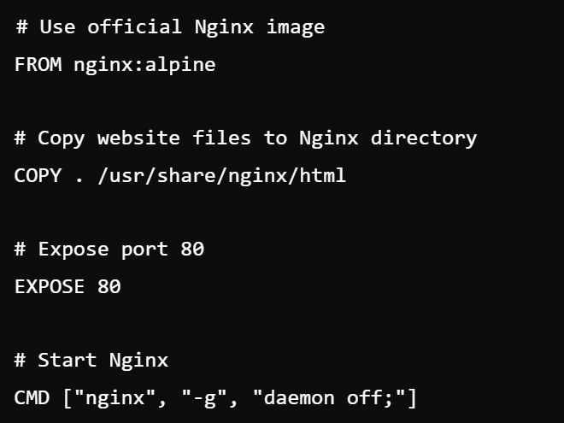

#### Multi Stage Image :

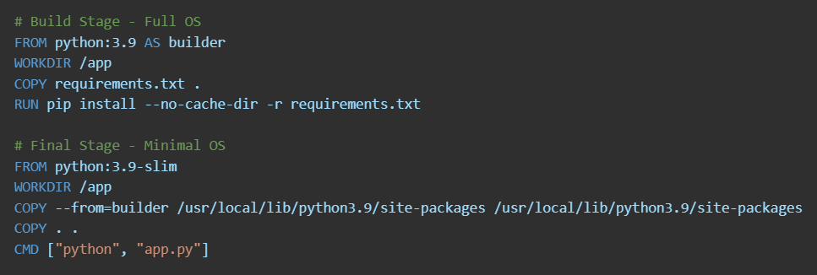

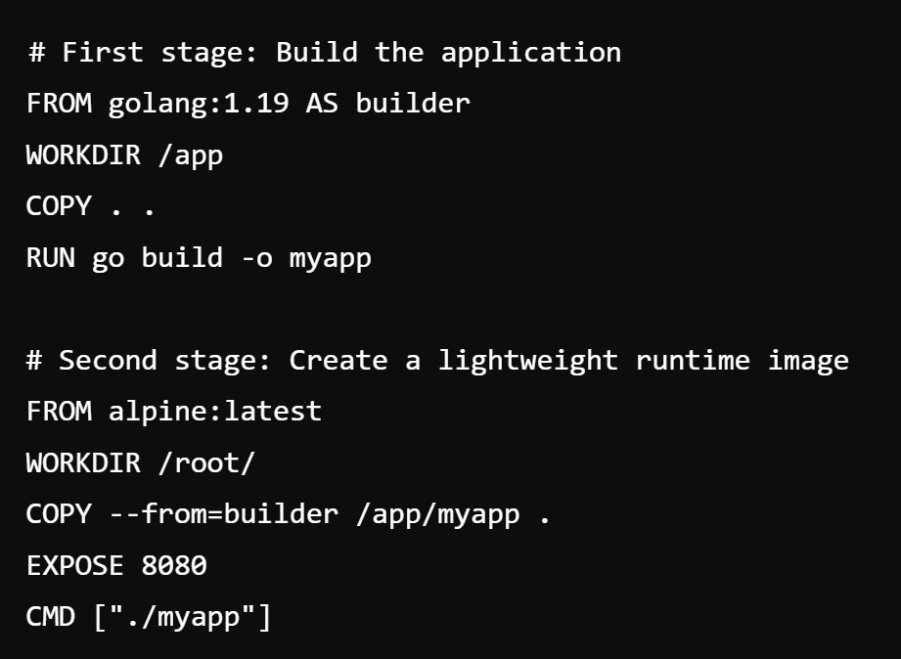

#### For MySQL :

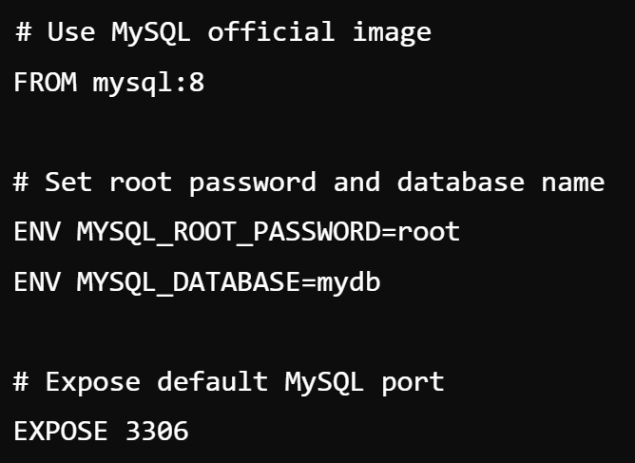

### Build the Docker Image

* Navigate to the directory containing the Docker file and run the following command:

**docker build -t docker-image-name:tag**

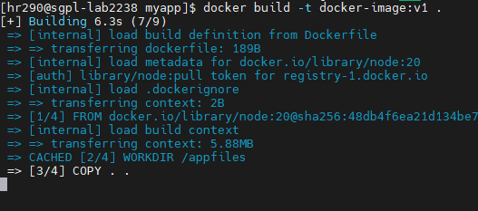

This command builds the image and tags it as my-node-app.

**Run the Docker Container**

Once the image is built, run the container using:

**docker run -p 3000:3000 docker-image-name:tag**

The -p 3000:3000 flag maps port 3000 on your local machine to port 3000 inside the container, allowing you to access the application from your browser at http://localhost:3000.

## Docker Swarm

Docker Swarm is **Docker's built-in tool for managing multiple containers across multiple machines**.

It turns a group of Docker hosts (servers) into a **single, unified cluster** to run and scale containerized applications.

### What It Does:

1. **Clusters Multiple Nodes** – Combines multiple machines into one logical system.
2. **Service Orchestration** – Automatically deploys and manages container services.
3. **Load Balancing** – Distributes traffic across multiple running containers.
4. **Scaling** – Easily increases or decreases the number of running containers.
5. **Fault Tolerance** – If a node fails, it shifts workloads to healthy nodes.

### Example Use Case:

If you have a web app running on a single server, you can **use Docker Swarm to run it on multiple machines**, ensuring high availability and handling more traffic efficiently.

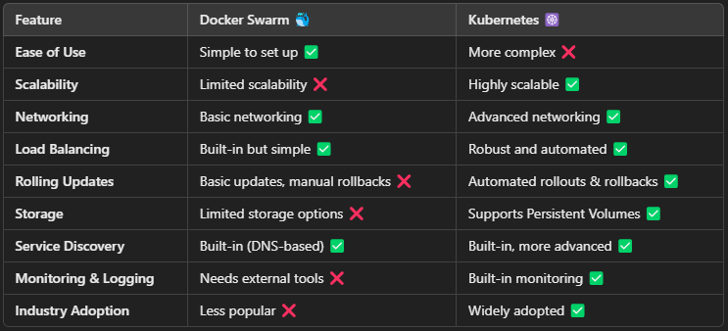

## Docker Compose

Docker Compose **helps you define and run multiple containers together** using a single YAML file (**docker-compose.yml**). Instead of manually running multiple docker run commands, you can start all containers with just **one command** (docker-compose up).

### What It Actually Does:

1. **Defines Services** – You describe your application’s services (like database, backend, frontend) in a YAML file.
2. **Creates Containers** – It pulls images and starts containers based on the configuration.
3. **Manages Networking** – It automatically creates a network so the containers can communicate.
4. **Handles Volumes** – It mounts persistent storage for databases or shared files.
5. **Starts and Stops Everything Together** – You can bring up or take down all services with a single command.

### Example Use Case:

A web app needs:

* **Frontend (React/Angular container)**
* **Backend (Node.js/Flask container)**
* **Database (PostgreSQL/MySQL container)**

Docker Compose starts and connects all of them easily.

### Why Not Use Docker Compose Instead of Kubernetes?

* **Works Only on One Machine** – It cannot manage containers across multiple machines like Kubernetes.
* **No Auto-Scaling** – It doesn’t automatically increase or decrease the number of containers based on demand.
* **No Self-Healing** – If a container crashes, it won’t restart automatically.
* **Limited Load Balancing** – It doesn’t efficiently distribute traffic like Kubernetes.
* **No Advanced Networking & Security** – Kubernetes has better networking and access control.

**Conclusion**

Use **Docker Compose** for small setups and local testing. Use **Kubernetes** for **scalable, high-availability, and production-grade applications**.

## Real-time example of the usage of Single Docker container, Docker Compose, Docker Swarm and Kubernetes.

**1. Single Container**

You start with one container for a simple app (like a Flask app). It runs in isolation with all dependencies inside the container.

**Example:**

Imagine you're running a **simple Flask app** in a Docker container. The app runs inside a container that contains everything it needs to run (code, libraries, dependencies). You can access it via the local port (like localhost:5000).

**Challenges**:

* Limited scalability
* No redundancy

**2. Docker Compose (Multi-Container Local Setup)**

As your app grows, you need multiple services (like a database). **Docker Compose** lets you run and allow communication between multiple containers easily with a single configuration file.

**Example**:  
Imagine you have a Flask app running in one container and a **Redis** cache in another container. You need both containers to communicate, but managing them manually is cumbersome. With Docker Compose, you can define both containers and their relationship in a single file.

Now, with a single command, both the **Flask app** and **Redis** containers will start, and they will be able to communicate easily.

**Why Docker Compose?**

* Simple way to manage multi-container apps on a single machine.
* Good for local development.

**3. Docker Swarm (Scaling Across Multiple Machines)**

Docker Swarm is a **cluster management tool** that turns your Docker engines into a single, coordinated cluster. It automatically handles tasks like container scaling, load balancing, and failover.

**Example:**

As your app grows, you need more **scalability** and **fault tolerance**. You can no longer just use Docker Compose locally or on single server.

you need a way to manage **multiple Docker hosts** (servers) and **distribute your containers** across them. This is where **Docker Swarm** comes in.

Let’s say your Flask app is getting a lot of traffic, and a single container can’t handle the load. You use Docker Swarm to **deploy your app on multiple machines**. Docker Swarm will make sure that there are multiple instances (replicas) of the Flask app running across the cluster.

**Why Docker Swarm?**

* Scales your app across multiple machines.
* Provides automatic failover and load balancing.

**4. Kubernetes (Advanced Orchestration)**

Kubernetes is a **container orchestration platform** that automates the deployment, scaling, and management of containerized applications. It provides advanced features like service discovery, auto-scaling, rolling updates, and self-healing.

**Example:**

As your application continues to grow and becomes more complex (with multiple services, databases, message queues, etc.), you need a more powerful solution for container orchestration. That's where **Kubernetes** comes in.

Let’s take the example of an e-commerce platform. It has several components:

* **Web front-end** (Flask app)
* **Database** (PostgreSQL)
* **Caching system** (Redis)
* **Payment processing service**
* **Order processing service**

As the app grows, you need a way to efficiently **manage and scale all these services** in a **production environment**. Kubernetes will allow you to manage all these services in a **declarative manner**, using configuration files that define how your app should behave.

**With Kubernetes:**

* **Pods**: Each service (like Flask, Redis, PostgreSQL) runs in a **pod**, which can contain one or more containers.
* **Services**: Kubernetes manages **internal communication** between containers with **services**.
* **Auto-scaling**: Kubernetes can automatically scale the number of replicas based on traffic or resource usage.
* **Rolling updates**: Kubernetes can deploy new versions of your app without downtime by rolling out updates to containers one at a time.

**Why Kubernetes?**

* Best for large, complex applications with many services.
* Offers features like auto-scaling, rolling updates, and fault tolerance.

# Kubernetes

A **Container** is a lightweight, portable, isolated unit that holds an application and its dependencies, allowing it to run consistently across different environments.

**Containers** are lightweight, start faster, and use fewer resources than VMs because they share the host OS instead of running a full OS for each instance.

A **Docker image** is a lightweight, standalone package that contains everything needed to run a container, including code, runtime, libraries, and dependencies.

* **Runtime**: The software that runs our code in the container.
* **Libraries**: Libraries are collections of pre-written code that developers use to add functionality to their applications without writing everything from scratch.
* **Dependencies**: All external software your application needs to work.

**Orchestration** is about managing and coordinating multiple components in a system, often in an automated way.

**Kubernetes** is a tool that provides orchestration for containers, helping to deploy, manage, scale and heal containerized applications efficiently across a cluster of computers.

**Kubernetes**

**Kubernetes** ( K8 ) is an open-source platform used to automate the deployment, scaling, and management of containerized applications.

It simplifies the process of managing containers across a cluster of machines.

### Benefits of Kubernetes

1. **Automated Deployment**: Automatically deploys and updates containerized applications.
2. **Scaling**: Easily scales applications up or down based on demand.
3. **High Availability**: Ensures that applications are always available by managing replicas and handling failures.
4. **Resource Efficiency**: Optimizes the use of computing resources by efficiently scheduling containers.
5. **Flexibility**: Supports a wide range of applications and services, both stateless and stateful.

### Common Use Cases

* **Microservices**: Managing and scaling microservices architectures.

* **Continuous Deployment**: Automating the deployment of applications in CI/CD pipelines.
* **Hybrid and Multi-cloud**: Managing workloads across different cloud providers and on-premises environments.

## Micro Service Architecture

Microservices architecture breaks an application into **small, independent services** that communicate via APIs. Kubernetes (K8s) is used to **orchestrate, scale, and manage** these microservices efficiently.

### **Why Use Kubernetes for Microservices?**

Kubernetes helps microservices-based applications by providing:  
**Service Discovery & Load Balancing** – Handles traffic routing.  
**Self-Healing** – Restarts failed containers automatically.  
**Horizontal Scaling** – Scales services up/down based on load.  
**Rolling Updates & Rollbacks** – Deploy updates without downtime.  
**Secret & Config Management** – Manages sensitive data securely.  
**Automated Scheduling** – Optimizes resource utilization.

### **Deploying a Microservices-Based Application in Kubernetes**

Deploying a microservices-based application in Kubernetes involves multiple steps, tools, and configurations. Below is a detailed **real-time** process that includes different **container types, images, scripts, and tools like Istio** for managing traffic, security, and monitoring.

#### **1. Understanding the Architecture**

A typical microservices application consists of:  
✅ **Frontend Service** – UI layer (React, Angular, or Vue).  
✅ **Backend Microservices** – Business logic (Spring Boot, Node.js, Flask).  
✅ **Database Service** – Data storage (PostgreSQL, MySQL, MongoDB).  
✅ **API Gateway** – Central access point (NGINX, Istio, Kong).  
✅ **Service Mesh** – Traffic control & security (Istio, Linkerd).  
✅ **Messaging Queue** – Async communication (Kafka, RabbitMQ).  
✅ **Monitoring & Logging** – Observability (Prometheus, Grafana, ELK).

**High-Level Architecture Diagram**

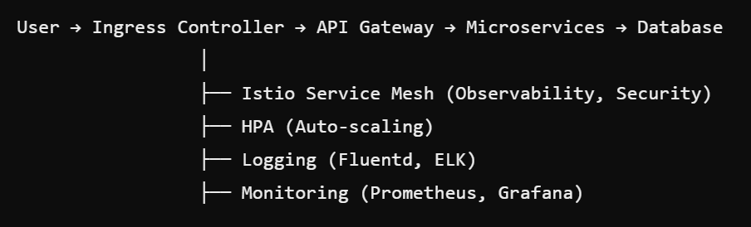

#### **2. Tools & Their Roles**

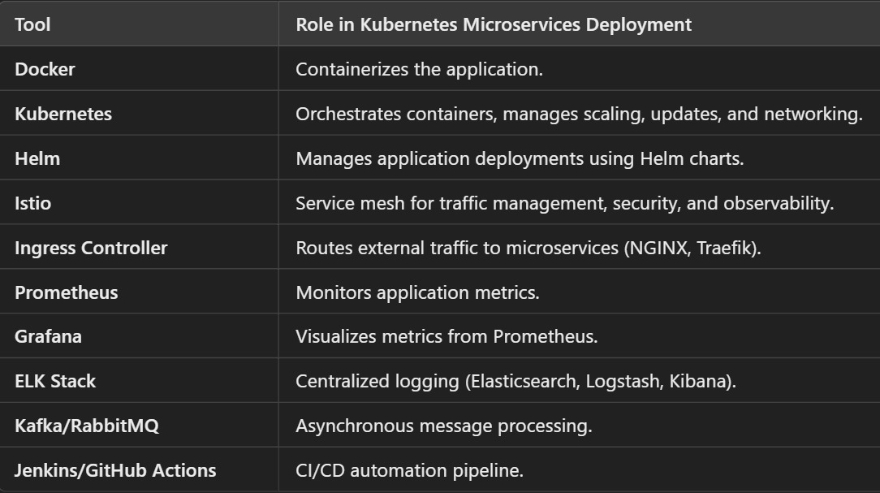

#### **3. Building & Containerizing Microservices**

Each microservice is packaged as a **Docker container**.

**Example: Dockerfile for User Service (Spring Boot)**

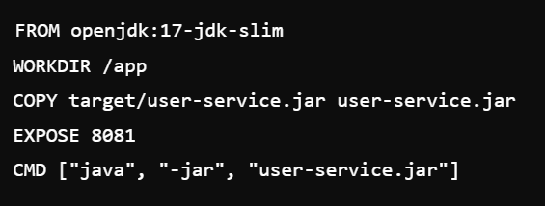

Example: Dockerfile for Order Service (Node.js)

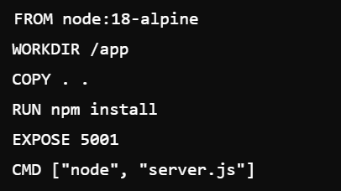

#### **4. Deploying a Microservices-Based Application in Kubernetes**

Let's deploy a **User Service** (Spring Boot) and **Order Service** (Flask) inside Kubernetes.

##### **A. Define Deployments**

User Service (Spring Boot)

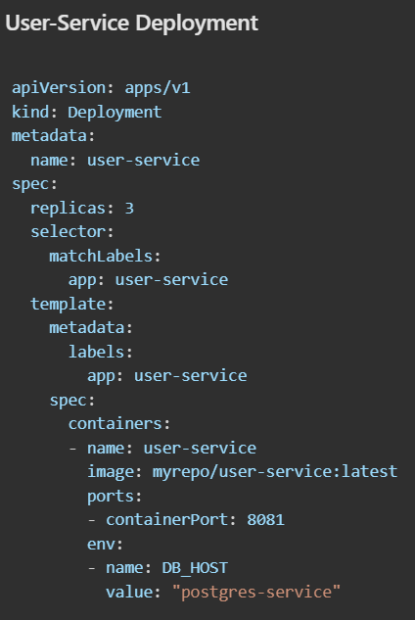 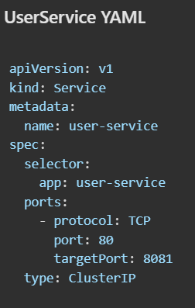

**Order Service (Python Flask)**

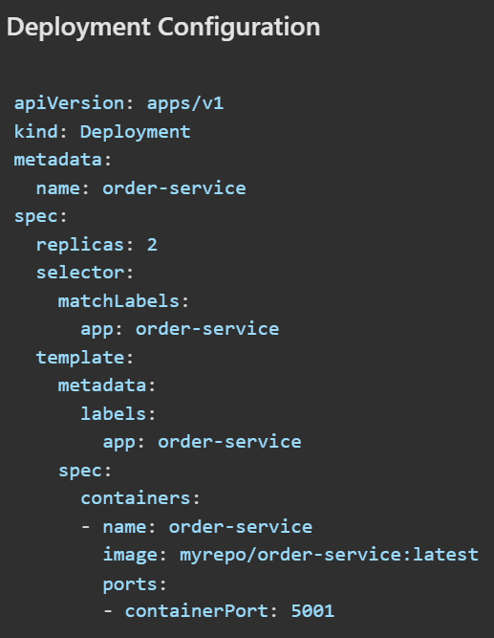 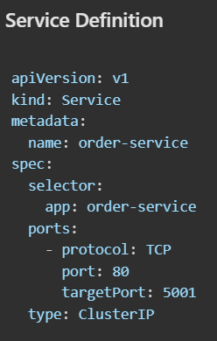

##### B. Configure Database (PostgreSQL)

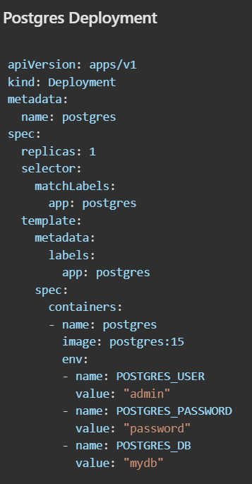 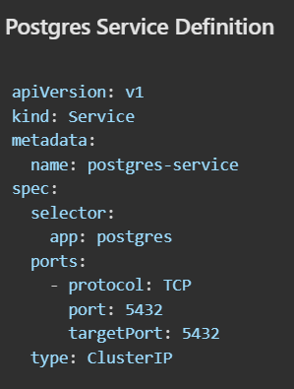

##### **C. Setup API Gateway (Ingress)**

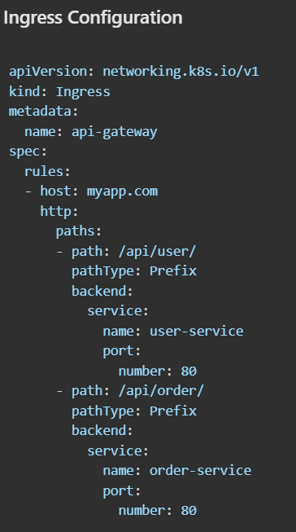

#### **5. Scaling Microservices**

**Auto-Scaling Using HPA**

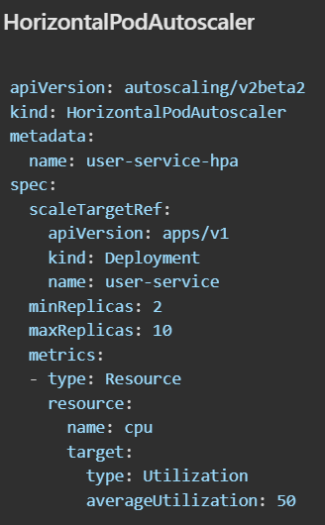

#### 6.Observability: Logging & Monitoring

**Prometheus + Grafana** for monitoring  
**ELK (Elasticsearch, Logstash, Kibana) for logs**

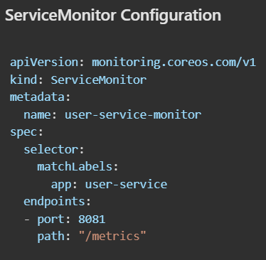

## **Namespaces**

Namespaces in Kubernetes help divide a large cluster into smaller, manageable parts. They allow you to:

* Group related resources together (e.g., all resources for a project or team).
* Provide isolation between different environments (like development, testing, production).
* Control resource limits and access.

### **Why are Namespaces Useful?**

* **Organization**: You can have multiple namespaces for different teams or projects, making it easier to manage and view resources.
* **Resource Quotas**: You can set limits on the amount of CPU, memory, and other resources that can be used within a namespace, preventing one team from using up all the resources.
* **Access Control**: You can control who has access to which namespaces using Kubernetes’ role-based access control (RBAC).
* **Environment Separation**: You can use namespaces to separate resources for different stages of development (e.g., dev, test, prod) on the same cluster.

Namespaces in Kubernetes provide a way to logically separate and isolate resources in the following areas:

* **Resource management** (pods, services, deployments, etc.)
* **Resource limits** (quotas, limits)
* **Network access** (network policies, service discovery)
* **Access control** (RBAC, service accounts)
* **Security** (security contexts, pod policies)
* **Logging and monitoring** (namespace-specific logs)

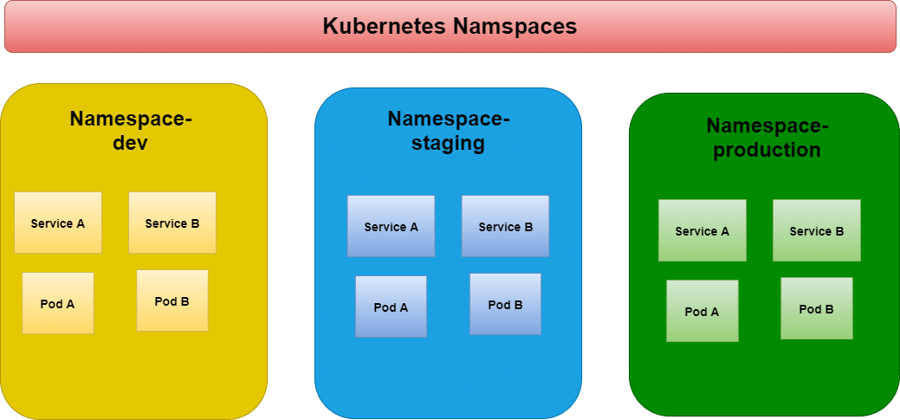

**Namespace Management**

* kubectl get namespaces - List all namespaces in the cluster.
* kubectl create namespace <name> - Create a new namespace.
* kubectl delete namespace <name> - Delete a specific namespace.
* kubectl get pods -n <namespace-name> - See pods in particular ns.
* kubectl config set-context --current --namespace=<namespace-name> - Change current name space.
* kubectl config view --minify | grep namespace:

## Architecture

**API Server** is the boss, **Scheduler** assigns tasks, **Controller Manager** ensures stability of pods, **etcd** stores data, **Kubelet** runs pods, **Kube Proxy** manages networking, and the **Container Runtime** runs containers.

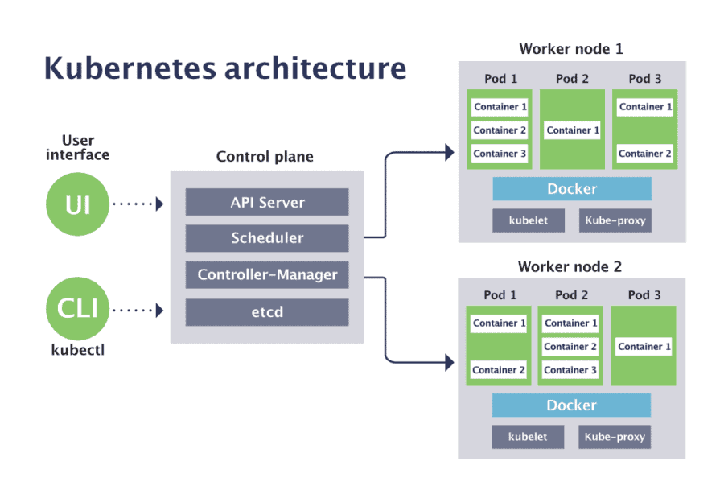

### **Master Node Components**

### **1.API Server (kube-apiserver)**

* **What it does?** It is the front desk of Kubernetes, handling all requests (kubectl, Terraform, etc.).
* **How it works with others?** It talks to all components, processes commands, and updates the database (etcd).

### **2.Controller Manager (kube-controller-manager)**

* **What it does?** It watches the cluster and ensures everything is as expected (e.g., restarts failed pods).
* **How it works with others?** If something goes wrong, it tells the API Server, which then makes changes.

### 3.S**cheduler (kube-scheduler)**

* **What it does?** It finds the best worker node to run new Pods (applications).
* **How it works with others?** It takes scheduling requests from the API Server and assigns Pods to Nodes.

### **4.etcd (Database)**

* **What it does?** It stores all Kubernetes data (pods, services, configurations).
* **How it works with others?** The API Server reads and writes data to etcd, ensuring consistency.

### **Work Node Components**

### **1.Kubelet (kubelet)**

* **What it does?** It runs on each worker node and makes sure the pods are running as expected.
* **How it works with others?** If any pods stopped working, It’ll tell info to master node to do something.

### **2.Kube Proxy (kube-proxy)**

* **It provides IP addresses, Networking and Load balancing.**
* **What it does?** It manages networking, making sure pods can talk to each other and the internet.
* **How it works with others?** It works on each node to route network traffic properly.

### **3.Container Runtime (Docker, containerd, etc.)**

* **What it does?** It actually runs the containers inside the pods.
* **How it works with others?** Kubelet tells the container runtime to start or stop containers.

### **How They Work Together?**

User sends a request (e.g., deploy a pod) → **API Server** handles it.  
**Scheduler** finds the best node for the pod.  
**Controller Manager** makes sure the pod is running.  
**Kubelet** on the node ensures the pod is running.  
**Container Runtime** runs the containers inside the pod.  
**Kube Proxy** ensures the pod can communicate with others.  
**etcd** stores all data so Kubernetes knows what’s happening.

**Cluster**:

* **What**: A Kubernetes cluster is a group of machines (nodes) that run containerized applications.
* **Why**: It provides the necessary resources and infrastructure to manage and run containers.

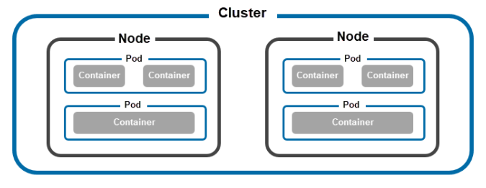

**Nodes**:

* **What**: Nodes are individual machines (physical or virtual) in a cluster. There are two types: master nodes and worker nodes.
* **Master Node**: Manages the cluster, scheduling tasks, and maintaining the overall state of the system.
* **Worker Node**: Runs the containers and workloads.

**Pods**:

* **What**: Pods are the smallest deployable units in Kubernetes. They can contain one or more containers.
* **Why**: Containers in a pod share resources like networking and storage, and are managed together.

**Containers**:

* **What**: Containers are lightweight, standalone units that package an application and its dependencies.
* **Why**: They ensure that an application runs consistently across different environments.

## The Complete Process of Creating a Container in Kubernetes from deployment.yml

When you write a **deployment.yml** file and run **kubectl apply -f deployment.yml**, several components work together to create and manage the container.

**Step 1: You Write deployment.yml**

The deployment.yml file defines:

* **Deployment** (manages pods)
* **ReplicaSet** (ensures correct pod count)
* **Pod** (smallest unit, runs the container)
* **Container** (actual application inside the pod)

**Step 2: kubectl apply -f deployment.yml**

You run this command to tell Kubernetes to **create** the resources defined in **deployment.yml**.

**What happens next?**

1. **Kubectl (CLI Tool)** sends the request to the **API Server**.
2. **API Server** checks if the request is valid and **stores** it in **etcd (Cluster Database)**.
3. **API Server** informs the **Controller Manager** that a new deployment is needed.

**Step 3: Controller Manager Creates Deployment & ReplicaSet**

The **Controller Manager** sees the new deployment request and:

* Creates a **Deployment** resource.
* Creates a **ReplicaSet**, which is responsible for maintaining the number of pods.

**Step 4: Scheduler Assigns Pods to Nodes**

The **Scheduler** looks for the best node to run the new pod.

It checks:

* **Resource availability (CPU, Memory)**
* **Taints and Tolerations (Node restrictions)**
* **Node Selectors and Affinities (Preferred nodes)**

Once a suitable node is found, it **assigns the pod to that node**.

**Step 5: Kubelet Creates the Pod & Pulls the Docker Image**

On the assigned node, the **Kubelet** (agent running on each node) does the following:

* Reads the pod specification.
* Pulls the required **Docker Image** from **Docker Hub or a private registry**.
* Creates a **container runtime (like Docker, containerd, or CRI-O)** to run the container.

**Step 6: Kube-Proxy & Network Setup**

**Kube-Proxy** sets up networking so that:

* Pods can talk to each other.
* Pods can be accessed via a **ClusterIP, NodePort, or LoadBalancer service**.

**Step 7: Health Checks & Readiness**

* **Liveness Probe:** Checks if the container is running. If not, Kubernetes restarts it.
* **Readiness Probe:** Checks if the app inside the container is ready to handle traffic.

**Step 8: Deployment is Ready & Exposed (If Service is Created)**

If you have a **Service (ClusterIP, NodePort, LoadBalancer)** in your deployment.yml, it:

* Assigns a stable **IP and DNS name** to the pods.
* Routes traffic to the correct pod.
* Load balances traffic across multiple pods.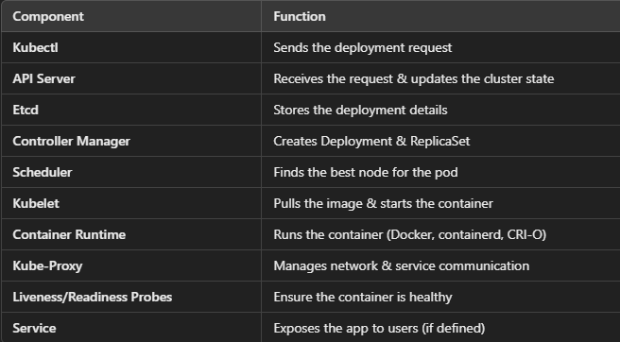

### **Main API Version Types:**

1. **v1** (Stable) → Used for core objects like Pods, Services, ConfigMaps, etc.

* Example: apiVersion: v1 (used for Pod, Service, ConfigMap, etc.)

1. **apps/v1** (Stable) → Manages workloads like Deployments, StatefulSets, DaemonSets.

* Example: apiVersion: apps/v1 (used for Deployment, StatefulSet, etc.)

1. **batch/v1** (Stable) → Used for Jobs and CronJobs (for batch processing).

* Example: apiVersion: batch/v1 (used for Job, CronJob)

1. **autoscaling/v2** (Stable) → Used for Horizontal Pod Autoscaler (HPA).

* Example: apiVersion: autoscaling/v2 (used for HorizontalPodAutoscaler)

1. **networking.k8s.io/v1** (Stable) → Manages networking resources like Ingress and NetworkPolicy.

* Example: apiVersion: networking.k8s.io/v1 (used for Ingress, NetworkPolicy)

1. **policy/v1** (Stable) → Used for PodSecurityPolicy (PSP) before it was deprecated.
2. **rbac.authorization.k8s.io/v1** (Stable) → Used for Role-Based Access Control (RBAC).

* Example: apiVersion: rbac.authorization.k8s.io/v1 (used for Role, ClusterRole)

## **Deploying an App in Kubernetes: Pods vs ReplicaSets vs Deployments**

**Pods** → Only for quick testing, not for production.

**ReplicaSet Without Deployment** → Good for maintaining multiple copies of an app, but updates are manual.

**ReplicaSet With Deployment** → Best for production, allowing smooth updates, rollbacks, and scaling.

### **Using Only Pods**

* A **Pod** is like a single unit of your app running in Kubernetes.
* If the Pod crashes, **Kubernetes will NOT restart it** automatically.
* You must manually create a new Pod if it fails.

**Example**:  
You run a website as a Pod, but if it crashes, the site goes down until you restart it manually.

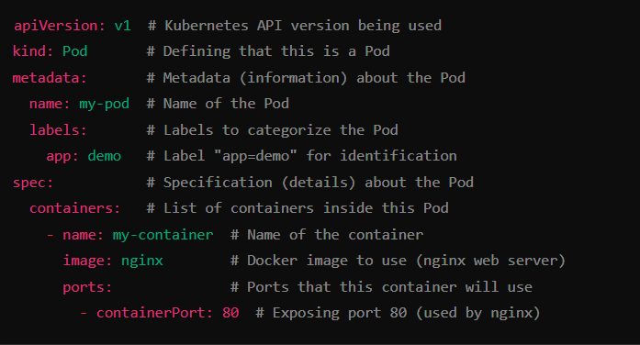

### **Using ReplicaSets (Without Deployments)**

* A **ReplicaSet** ensures that multiple copies (replicas) of your app run.
* If one Pod crashes, the ReplicaSet **automatically replaces it**.
* However, **updating the app is manual** (delete old ReplicaSet, create a new one).

**Example**:  
You run three copies of your app using a ReplicaSet. If one crashes, Kubernetes creates a new one. But if you want to update the app (change version), you must manually delete the old ReplicaSet and create a new one.

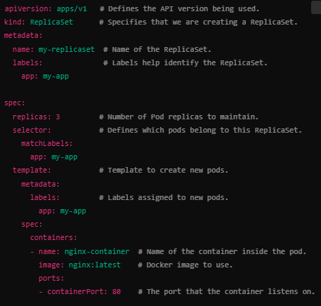

### **Using Deployments (Best Method)**

* A **Deployment** manages a ReplicaSet for you.
* It allows **easy updates** (Kubernetes replaces old Pods with new ones automatically).
* **Rollback is possible** if something goes wrong.

**Example**:  
You have an online shopping website. If you want to update the app from version 1.0 to 1.1, a Deployment will **gradually update it** without downtime. If there’s an issue, you can **roll back to the previous version easily**.

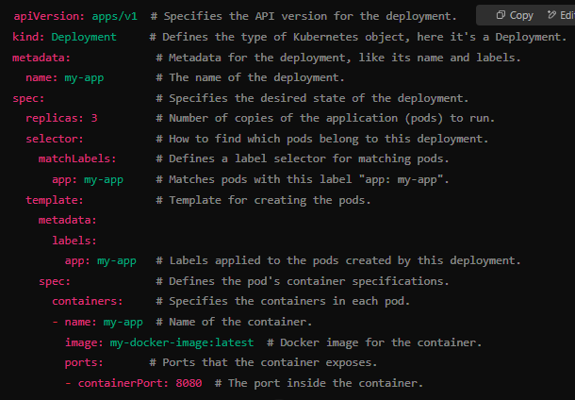

**Services (Makes Apps Accessible)**

**What?** A Service gives a **fixed IP and DNS name** to your Pods, so other apps and users can reach them.  
**Problem?** Pods get replaced over time, and their IPs change—without a Service, it’s hard to keep track.  
**Use case?** Used to expose an application inside or outside the cluster.

**Example**: You create a **Service** to expose your website to users. Even if Pods are replaced, the Service always routes traffic to the right ones.

### **Rollout**

Rollout means **deploying a new version** of your application. It ensures that new pods are created while old ones are deleted **without downtime**.

**Example:** You update your app by changing the Docker image version in your deployment file.

**How Rollout Works?**

1. Kubernetes creates **new pods** with the updated version.
2. It slowly **replaces the old pods** with the new ones.
3. If something goes wrong, it **pauses the rollout** (if a probe fails).

**Commands for Rollout:**

Check rollout status: kubectl rollout status deployment <deployment-name>

Check rollout history: kubectl rollout history deployment <deployment-name>

Apply a new rollout (update deployment): kubectl set image deployment/<deployment-name> <container-name>=new-image:tag

### **Rollback**

Rollback means **going back to a previous version** if the new deployment has issues.

**Example:** You updated your app, but it's not working properly, so you want to go back to the previous version.

**How Rollback Works?**

1. Kubernetes **reverts to the last stable version** stored in its history.
2. It **replaces faulty pods** with the old version.
3. The service remains **available without downtime**.

**Commands for Rollback:**

Rollback to the last version: kubectl rollout undo deployment <deployment-name>

* Rollback to a specific version: kubectl rollout undo deployment <deployment-name> --to-revision=2
* View rollout history (to see previous versions): kubectl rollout history deployment <deployment-name>

**Example Scenario**

1.Imagine you have a **web app** running in Kubernetes.

**Initial Deployment (Version 1.0)**

apiVersion: apps/v1

kind: Deployment

metadata:

name: my-app

spec:

replicas: 2

selector:

matchLabels:

app: my-app

template:

metadata:

labels:

app: my-app

spec:

containers:

- name: my-app

image: myrepo/my-app:v1

Kubernetes deploys **Version 1.0** of the app successfully.

**2.Update to Version 2.0 (Rollout)**

kubectl set image deployment/my-app my-app=myrepo/my-app:v2

Kubernetes replaces **old pods with new ones (v2)** without downtime.

**3.Something is wrong? (Rollback)**

kubectl rollout undo deployment my-app

Kubernetes brings back **Version 1.0**, fixing the issue.

## Deployment Strategies

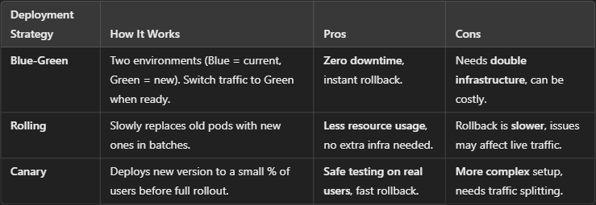

### **Blue-Green Deployment (Zero Downtime, Two Environments)**

In a **Blue-Green deployment**, you have **two separate environments**:

* **Blue:** Current running version
* **Green:** New version being deployed

**How It Works?**

1. **Deploy the new version (Green) but do not route traffic to it.**
2. **Once tested, switch traffic** from **Blue** (old) to **Green** (new).
3. If there is an issue, **switch traffic back to Blue**.

**Advantages:**

✅ **Zero downtime** – The switch is instant.  
✅ **Safe rollback** – Just switch back to the old version.  
✅ **Easy testing** before making it live.

**Disadvantages:**

* **Requires double resources** (both Blue and Green run simultaneously).
* More **complex** than rolling deployments.

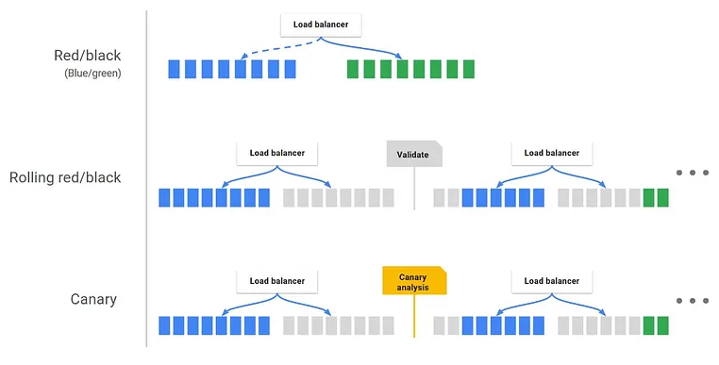

### **Rolling Deployment (Most Common)**

In a **rolling deployment**, Kubernetes **gradually replaces old pods with new ones** without stopping the service.

**How It Works?**

1. **New pods are created** with the updated version.
2. **Old pods are deleted one by one.**
3. The service always remains available.

**Advantages:**

✅ **No downtime** – The application keeps running.  
✅ **Automatic rollback** if something goes wrong.  
✅ **Efficient** – Uses existing resources, no extra infrastructure needed.

**Disadvantages:**

❌ If the new version has a bug, some users may face issues before rollback.  
❌ Hard to test new features in isolation.

### **Canary Deployment (Test on a Small Group of Users)**

In a **canary deployment**, **only a small percentage** of users get the new version at first.

**How It Works?**

1. **Deploy the new version** but **only route 10% of traffic** to it.
2. Monitor the performance.
3. If successful, **gradually increase traffic** to the new version.
4. If an issue occurs, **rollback immediately** before all users are affected.

**Advantages:**

✅ **Safe testing** with real users before full rollout.  
✅ **Gradual traffic shift** reduces risk.  
✅ **Easy rollback** if problems occur.

**Disadvantages:**

❌ **Complex configuration** to manage traffic distribution.  
❌ **Takes time** to fully deploy the new version.

## **Services:**

Kubernetes **Services** help expose applications running inside the cluster so they can be accessed by users or other services.

There are **three main types of services**:

**ClusterIP** → Used for internal communication.  
**NodePort** → Makes the app accessible on each node’s IP and a fixed port.  
**LoadBalancer** → Exposes the app to the internet using a cloud provider’s Load Balancer

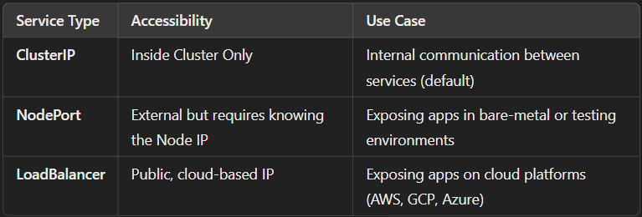

**Real-World Scenario Example**

You have a **frontend, backend, and database** in a Kubernetes cluster.

* **Database (ClusterIP)** → Only backend should access it.
* **Backend API (NodePort)** → Developers can access it directly for testing.
* **Frontend Web App (LoadBalancer)** → Users should access it via a public URL.

### NodePort:

It’s like a virtual server inside the node. It has its own IP

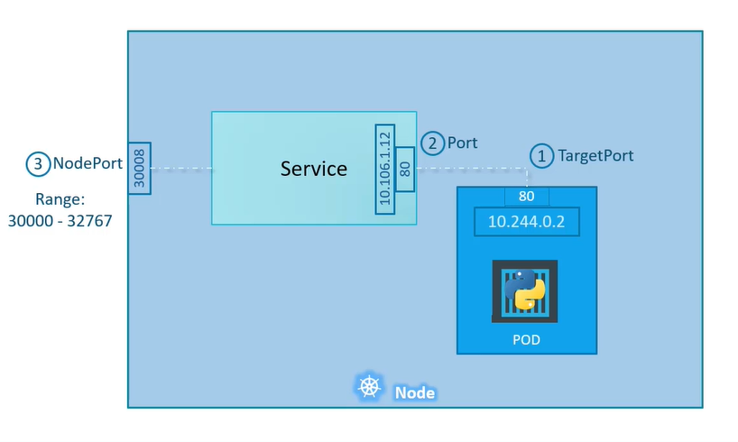

**What it does?**

* Makes the application **accessible on every node’s IP and a fixed port (30000-32767)**.
* You can access the app using http://<Node-IP>:<NodePort>.

**When to use?**

* If you want to **test or expose** your app externally without a Load Balancer.
* If you have a **bare-metal cluster** without a cloud provider.

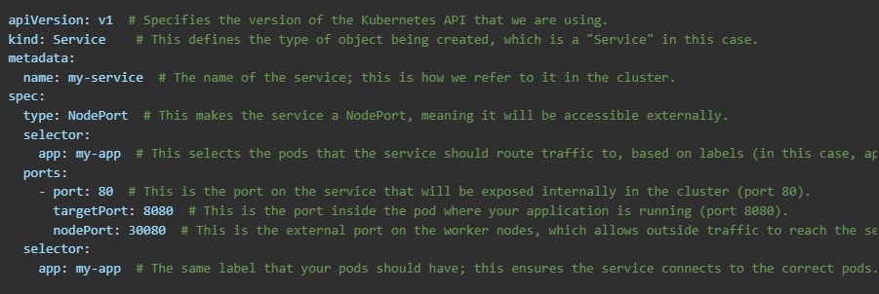

### ClusterIP:

**What it does?**

* Exposes the application **inside the cluster only**.
* Other pods in the cluster can communicate using this service.
* It is **not accessible from outside the cluster**.

**When to use**

* If you want internal communication between micro services.
* If only other services inside the cluster need to access the app.

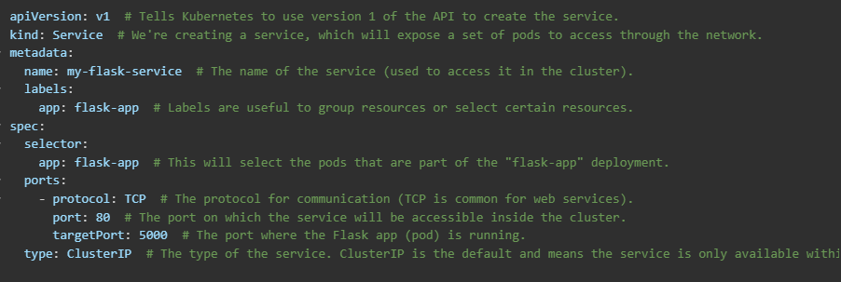

**How it works?**

* This service listens on **port 80** inside the cluster.
* It forwards requests to the pods running on **port 8080**.
* **Cannot be accessed directly from outside** the cluster.

### LoadBalancer:

A **LoadBalancer** Service in Kubernetes **exposes your application to the internet** by creating an **external IP address** and forwarding traffic to your application inside the cluster.

**How it Works?**

**User sends a request to the external IP** → Request goes to the **Load Balancer**

**Load Balancer forwards the request** → It selects a healthy pod based on the load-balancing algorithm

**Pod processes the request and responds** → The response is sent back through the Load Balancer

**What it does?**

* Creates a **cloud provider-managed Load Balancer** (AWS, GCP, Azure) and exposes the service to the internet.
* It automatically assigns a **public IP** to access the app.

**When to use?**

* When you need a **publicly accessible** application.
* When running on a **cloud provider like GCP, AWS, or Azure**

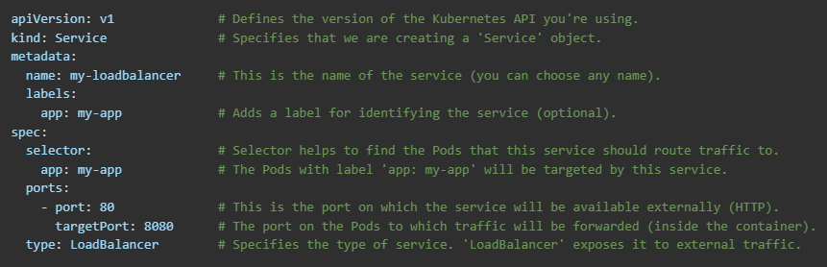

### ExternalName :

* **When to use:** When you need Kubernetes services to talk to external services outside the cluster using DNS names.
* **Example:** Connecting to an external database like MySQL hosted outside your Kubernetes cluster (like an RDS instance).

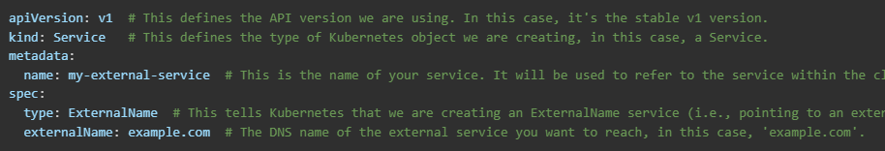

### Headless Service : **A** **Headless Service** is a Kubernetes service that **does not have a fixed IP address**. Instead, it gives **each pod in a StatefulSet a unique DNS name**, allowing direct communication between pods.

**When to use:** When you need direct access to individual Pods, for example in StatefulSets where each Pod needs to be accessed individually, or when you want your app to manage its own load balancing.

**Example:** Stateful applications like a Kafka broker or Redis cluster, where each pod’s identity matters.

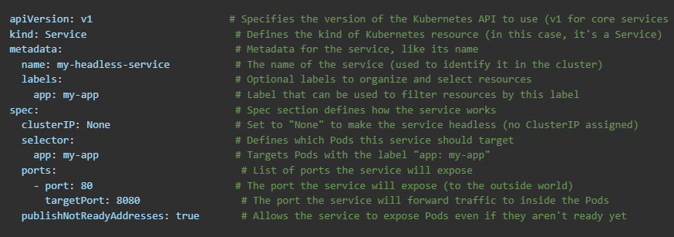

### Ingress Controller :

An **Ingress Controller** is needed because it provides more advanced traffic routing and management (like URL-based routing, SSL termination, and load balancing) for Kubernetes services, whereas a **Load Balancer** only exposes services but lacks these features.

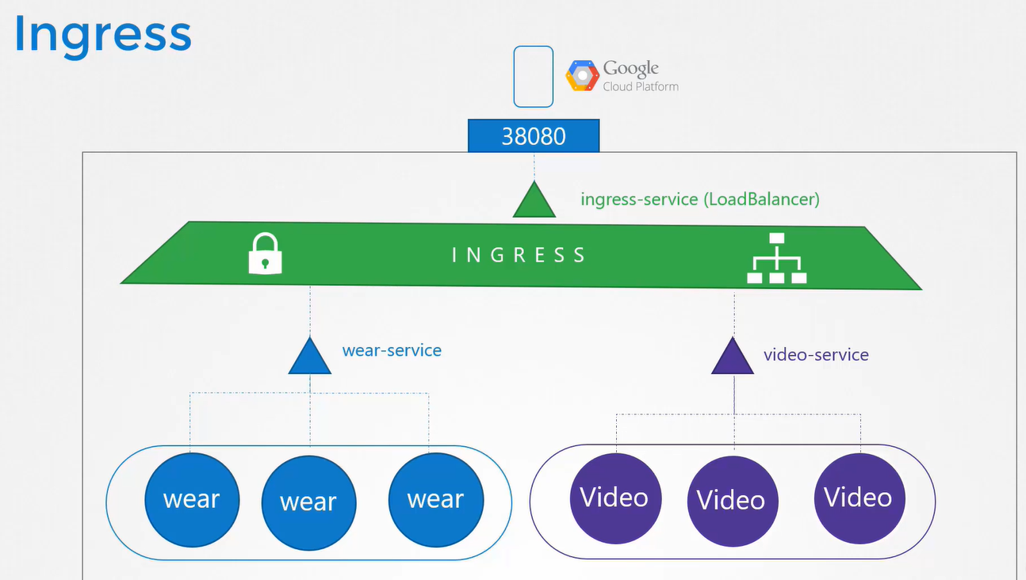

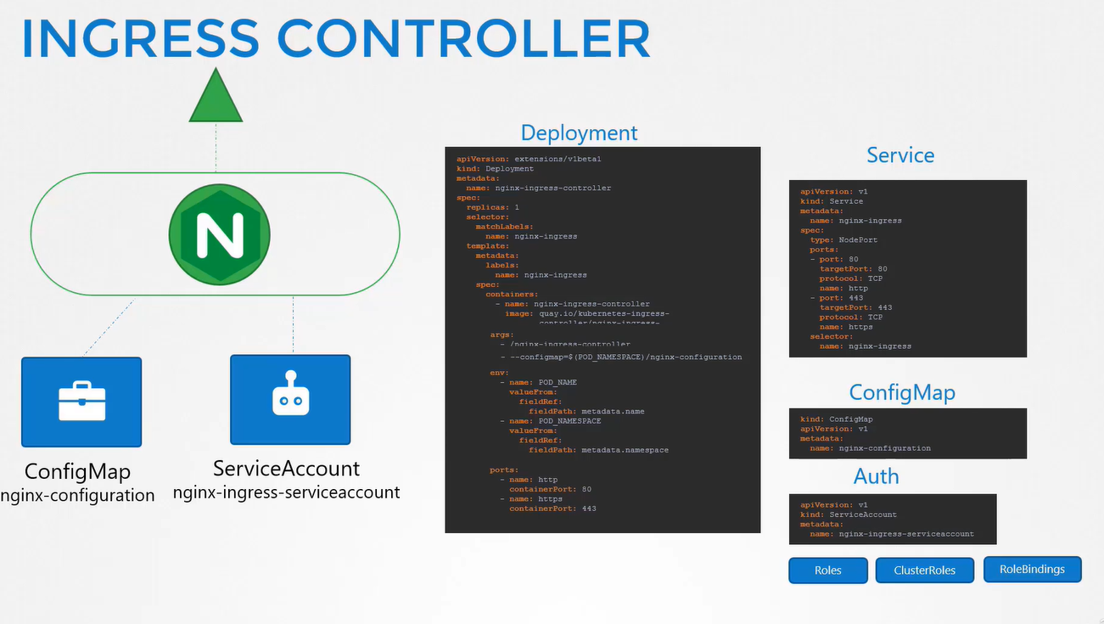

### **Load Balancer Type for HTTP(S):**

The **LoadBalancer service** provides basic load balancing at the transport layer (TCP/UDP), while an **Ingress Controller** provides HTTP(S)-level routing. If you're working with web applications, you need an Ingress Controller to handle advanced routing and HTTP-specific features.

**Example:**

* You have two services: web-service and api-service.
* If you only used a LoadBalancer, you'd need to expose each service with its own LoadBalancer.
* But with an **Ingress Controller**, you can expose both services under different paths or domains:
  + myapp.com/ -> web-service
  + myapp.com/api/ -> api-service

This simplifies traffic management and reduces the number of LoadBalancers you need.

**Summary:**

* **LoadBalancer**: Handles traffic distribution to Kubernetes services (Layer 4).
* **Ingress Controller**: Handles advanced HTTP(S) routing and traffic management (Layer 7) based on URL paths, domains, SSL/TLS, etc.

While a LoadBalancer service provides basic external access, an **Ingress Controller** adds powerful HTTP routing capabilities, allowing you to manage and route traffic to multiple services in a more flexible and efficient manner.

## **Kubernetes Job**

A **Job** is a Kubernetes object that runs a **task** (like a script or a program) **once or multiple times** until it **completes successfully**. Unlike Deployments, Jobs do **not run continuously**.

**How It Works?**

* A Job **creates Pods** to complete a task.
* Once the task is **successful**, the Job **stops** the Pods.
* If a Pod **fails**, Kubernetes restarts it **until the job is done** (based on retry settings).

**Example: Job YAML File**

This Job runs a container that **prints "Hello, Kubernetes!"** and then exits.

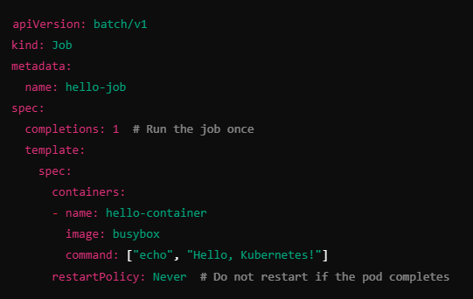

**Important Job Parameters:**

* **completions** → How many times the task should be completed.
* **parallelism** → How many Pods should run **at the same time**.
* **restartPolicy** → Set to Never or OnFailure (default is Never).

**Example: Job Running Multiple Tasks**

This job runs **3 Pods in parallel** and completes when **5 tasks** are done.

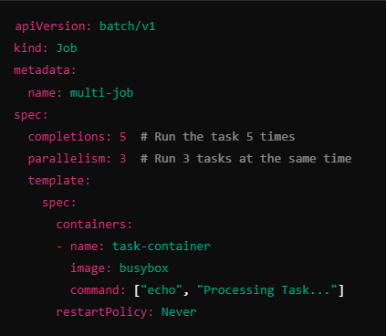

**How it works?**

* It runs **3 Pods in parallel**.
* When a Pod completes, a **new Pod starts** until **5 tasks** are finished.

## Multi-Container Pods in Kubernetes

A **Pod** in Kubernetes can have **multiple containers** inside it. These containers **share the same network and storage** and work together.

**Sidecar Pattern** – A helper container that supports the main app.

Example: A **logging** container that collects logs from the main app.

**Ambassador Pattern** – A container that **acts as a proxy** for communication.

Example: A **cache** container that sits between the app and database.

**Adapter Pattern** – A container that **modifies or processes** data.

Example: A **metrics** container that formats logs before sending them to a monitoring tool.

### **Single-Pod, Multiple Containers (Sidecar Pattern):**

Multiple containers run inside the same pod and share the same network and storage. One container does the main job, while the other supports it (e.g., logging or proxying).

### **Single-Pod, Multiple Containers (Ambassador Pattern)**:

One container acts as a "gateway" (e.g., proxy), allowing other containers in the pod to communicate with the outside world.

### **Single-Pod, Multiple Containers (Adapter Pattern):**

Containers work independently inside the same pod but transform or adjust data for each other, like data format conversion.

### **Multi-Pod, Multiple Containers:**

Different pods each run their own containers but work together by communicating via services, allowing for better isolation and scalability.

## Init Containers

**What are Init Containers?**

* They are **special containers** that run **before the main app container** starts.

**Why use them?**

* To **prepare** something before the app starts, like downloading files, setting up configs, or waiting for a service to be ready.

**Example Use Case:**

* Your app needs a database, but the database might take time to start.
* An **init container** can wait for the database before starting the main app.

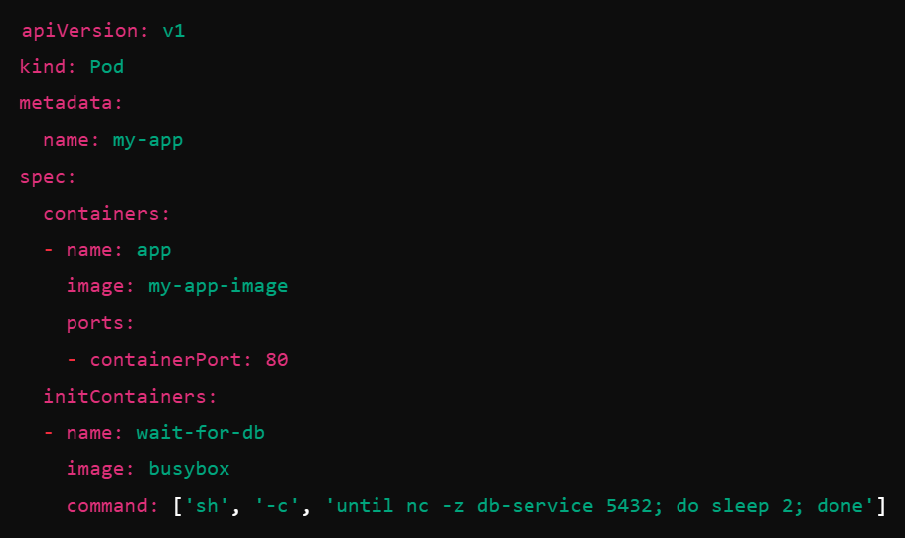

**“Init containers always finish first, then the main app starts!”**

## **Readiness Probe (Is the app ready to serve traffic?)**

* **Use case:** Prevents sending traffic to an app **before it is fully ready**.
* **Example:** A database-based app that needs time to connect before handling requests.

## **Liveness Probe (Is the app still alive?)**

* **Use case:** Restarts a stuck or unresponsive app **automatically**.
* **Example:** A web server that hangs due to a memory leak and needs a restart.

**Both help keep your app running smoothly by controlling traffic flow and auto-restarting failures.**

In Kubernetes, **API versions** define how resources are structured and managed. They evolve over time to introduce new features and improvements.

## **Persistent Volume (PV)**

A **Persistent Volume (PV)** is **a piece of storage** in the Kubernetes cluster that is provisioned either **dynamically** or **manually**. It acts like a hard disk and is independent of any specific pod.

A **PV is a storage resource** in Kubernetes that is created and managed **by the administrator**. It is like a pre-configured **hard drive or USB drive** that different applications can use.

**Key Features of PV:**

* It is **independent** of any specific Pod (it stays even if the Pod is deleted).
* It can be backed by different storage types (AWS EBS, GCP Disk, NFS, etc.).
* It has a **fixed size and access type** (ReadWriteOnce, ReadOnlyMany, ReadWriteMany).
* Created and managed by the cluster administrator.
* Can use cloud storage (GCP, AWS, Azure) or on-premises storage (NFS, local disk).
* Lives beyond the life of a single pod.
* Supports different storage types like SSDs, HDDs, and network storage.

## **Persistent Volume Claim (PVC)**

A **Persistent Volume Claim (PVC)** is a **request for storage** made by a pod. It tells Kubernetes how much space and access type (Read/Write) a pod needs.

* Created by developers when they need storage for a pod.
* Automatically binds to an available PV that meets the request.
* Allows users to **request storage** without worrying about the backend.

## **How PV and PVC Work Together**

* Admin **creates a PV** with storage specifications.
* Developer **creates a PVC** requesting storage.
* Kubernetes **binds the PVC to a matching PV**.
* Pod **mounts the PVC** to use the storage.

If you have **Multiple Persistent Volumes (PVs)** and create a **Persistent Volume Claim (PVC)**, Kubernetes will **automatically select** a PV that **best matches** the PVC's request.

When you create a PVC, Kubernetes follows these steps to find a suitable PV:

1. **Size Match** – The PV must have **equal or more** storage than requested in the PVC.
2. **Access Mode Match** – The PV must support the **same access mode** as the PVC.
3. **Storage Class Match (if defined)** – If the PVC specifies a **StorageClass**, it must match the PV’s StorageClass.
4. **Available Status** – The PV must be **unbound** (not already assigned to another PVC).
5. **First Come, First Serve** – If multiple PVs match, Kubernetes picks **one randomly** (usually the first available).

### **Persistent Volume (PV) YAML**

This defines **10Gi of storage** on an NFS server.

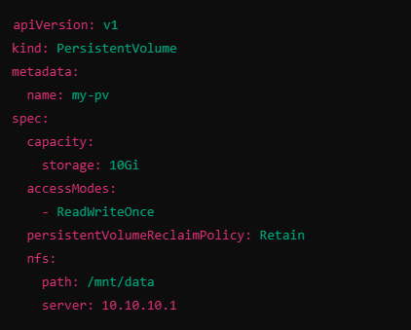

**Explanation:**

* **capacity.storage:** Defines size (10Gi).
* **accessModes:** Specifies access type:
  + ReadWriteOnce → Used by a single node.
  + ReadOnlyMany → Can be shared across nodes in read-only mode.
  + ReadWriteMany → Allows multiple nodes to write.
* **persistentVolumeReclaimPolicy:**
  + Retain → Keeps data even if PVC is deleted.
  + Recycle → Wipes and reuses the PV.
  + Delete → Deletes the PV when PVC is removed.
* **nfs:** Specifies the **NFS storage path** and **server IP**.

### **Persistent Volume Claim (PVC) YAML**

This requests **5Gi storage** for a pod.

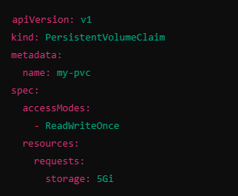

**Explanation:**

* PVC asks for **5Gi of storage**.
* It requires a **PV with ReadWriteOnce access mode**.
* Kubernetes finds and binds it to an available **PV with at least 5Gi**.

### **Pod Using PVC**

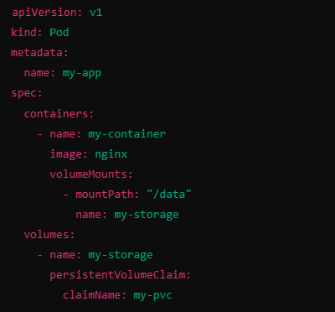

**Explanation:**

* The pod **mounts the PVC (my-pvc) to /data** inside the container.
* The container **saves data to this storage** instead of its local filesystem.

## Storage Classes

In Kubernetes, **Storage Classes** allow you to create **different types of storage** automatically based on your needs.

Instead of manually creating a Persistent Volume (PV), Storage Classes **dynamically** create one when a Persistent Volume Claim (PVC) requests storage.

**Why Do We Need Storage Classes?**

* Automates **PV creation** (no need to manually set up storage).
* Provides **different types of storage** (SSD, HDD, network storage).
* Allows **different performance levels** for different apps (fast storage for databases, slower for logs).

**How Storage Classes Work?**

* A developer **creates a PVC** and requests storage.
* The PVC **refers to a StorageClass** (e.g., "fast-storage").
* Kubernetes **creates a PV automatically** using that StorageClass.
* The pod **mounts the storage** and starts using it.
* **StorageClasses automate PV creation** when a PVC requests storage.
* They allow **different storage types (SSD, HDD, network storage).**
* They work with **cloud and on-prem storage solutions**
* You can **set a default StorageClass** to avoid specifying it every time.

**Different StorageClass Provisioners**

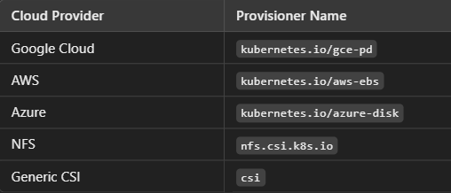

## **StatefulSets**

A **StatefulSet** is used to deploy **stateful applications** in Kubernetes, meaning applications that **need to remember data even if a pod is restarted or replaced**.

* **Unique Pod Names** → Each pod gets a fixed name like web-0, web-1, web-2 instead of random names.
* **Stable Storage** → Each pod gets **its own persistent storage** that stays even if the pod is deleted.
* **Ordered Scaling** → Pods are created **one by one**, not all at once, ensuring proper order.
* **Ordered Updates** → If the application is updated, pods restart **one at a time**, keeping stability.

**When to Use StatefulSets?**

**Databases** (MySQL, PostgreSQL, MongoDB) → Need stable storage and network identity.

**Message Queues** (Kafka, RabbitMQ) → Need pods to communicate reliably.

**Caching Services** (Redis, Zookeeper) → Need ordered startup and shutdown.

## **ConfigMaps** and Secrets:

* **ConfigMaps**: Store configuration data that can be used by applications.
* **Secrets**: Store sensitive information like passwords and API keys.
* **Why**: They help manage and secure application configuration and sensitive data.

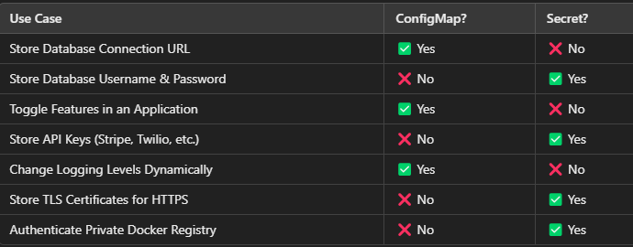

### **Centralized Configuration Management** (ConfigMap)

**Scenario**: A company has **multiple microservices** (e.g., Payments, Orders, Users) running in a Kubernetes cluster. Each service needs to **connect to the same database**, but the database host and port might change.

**Solution**: Use a **ConfigMap** to store the **database connection URL**, so when it changes, all services automatically get updated without changing the application code.

### **Dynamic Feature Flags for Applications** (ConfigMap)

**Scenario**: A **travel booking website** is rolling out a new "Discount Offers" feature, but only for **certain users**. Instead of changing the application code every time, they store a **feature flag** in a ConfigMap.

**Solution**: Use a ConfigMap to enable/disable features dynamically

### **Managing Sensitive Database Credentials** (Secret)

**Scenario**: A team is deploying a **Django application** that requires a **database username and password**. Instead of storing credentials in **code or ConfigMaps**, they use **Secrets** to keep them secure.

**Solution**: Store database credentials as a **Kubernetes Secret** and use them in the app.

### **Using TLS Certificates for HTTPS in Ingress** (Secret)

**Scenario**: A **public website** running in Kubernetes needs to **enable HTTPS** using an **SSL certificate**.

**Solution**: Store the **TLS certificate and private key** in a **Kubernetes Secret** and use it in an **Ingress**.

### **Private Docker Registry Authentication** (Secret)

**Scenario**: A **company stores container images** in a **private Docker registry**, and Kubernetes needs to pull images securely.

**Solution**: Use a Kubernetes **Secret** to store **Docker credentials**.

## **Resource Requirements in Kubernetes :**

**Resource requirements** in Kubernetes help manage CPU and memory usage for containers. They ensure that pods get the right amount of resources and prevent resource starvation.

### **1. Preventing Overuse of Resources**

**Scenario:** Multiple apps run in the cluster, and one app consumes too much CPU or memory.

**Solution:** Set **limits** to prevent one app from **hogging** resources.

**Example:**

resources:

limits:

cpu: "500m" # Max 0.5 CPU cores

memory: "256Mi" # Max 256MB RAM

This ensures that the container **cannot use more than 0.5 CPU cores and 256MB RAM**.

### **2. Ensuring Minimum Resources for Critical Apps**

**Scenario:** A **high-priority app** (e.g., payment service) must always have **enough resources**.

**Solution:** Set **requests** so that Kubernetes **reserves** resources for it.

**Example:**

resources:

requests:

cpu: "250m" # Minimum 0.25 CPU cores

memory: "128Mi" # Minimum 128MB RAM

Ensures the app **always gets at least 0.25 CPU and 128MB RAM**.

### **3. Managing Performance in a Multi-Tenant Cluster**

**Scenario:** Multiple teams deploy apps in a shared cluster, and you want to **prevent one team from using too many resources**.

**Solution:** Use **resource quotas** at the namespace level to limit each team’s usage.

**Example:**

apiVersion: v1

kind: ResourceQuota

metadata:

name: team-quota

namespace: team1

spec:

hard:

requests.cpu: "2" # Max 2 CPU cores for all pods

requests.memory: "4Gi" # Max 4GB RAM for all pods

This ensures that **Team 1 cannot request more than 2 CPUs and 4GB RAM**.

### **4. Avoiding Node Overload and OOM (Out of Memory) Errors**

**Scenario:** If a pod **requests too much memory**, the node can **run out of memory and crash**.

**Solution:** Use **limits** to prevent memory overuse.

**Example:**

resources:

limits:

memory: "1Gi" # Max 1GB RAM

If the container tries to use more than 1GB RAM, **it will be killed** instead of affecting other apps.

### **5. Ensuring Fair CPU Sharing for Batch Jobs**

**Scenario:** Running **batch jobs** (e.g., data processing) should not slow down live apps.

**Solution:** Use **Guaranteed, Burstable, or Best-Effort QoS classes** with resource requests and limits.

**Example:**

resources:

requests:

cpu: "500m" # Ensure it gets at least 0.5 CPU cores

limits:

cpu: "2" # But it can use up to 2 CPU cores if available

This lets the job **burst to 2 CPUs when free but guarantees at least 0.5 CPUs**.

### **6. Running Performance-Intensive Applications**

**Scenario:** AI/ML workloads or video processing apps need **high-performance resources**.

**Solution:** Request **specific CPU and GPU resources**.

**Example:**

resources:

requests:

cpu: "4"

memory: "16Gi"

nvidia.com/gpu: "1" # Request 1 GPU

Ensures the container gets **4 CPU cores, 16GB RAM, and 1 GPU**.

### **7. Enforcing Cost Optimization in Cloud Clusters**

**Scenario:** To **reduce cloud costs**, apps should not use unnecessary resources.

**Solution:** Set **strict resource limits** to avoid scaling up expensive nodes.

**Example:**

resources:

requests:

cpu: "100m" # Minimum 0.1 CPU

memory: "64Mi" # Minimum 64MB RAM

limits:

cpu: "500m" # Max 0.5 CPU

memory: "256Mi" # Max 256MB RAM

Prevents apps from **wasting CPU and memory**, reducing cloud bills.

### **8. Ensuring Stability in High-Traffic Web Apps**

**Scenario:** A web app should **scale up when traffic increases** but not crash under high load.

**Solution:** Use **Horizontal Pod Autoscaler (HPA)** with resource requests.

**Example:**

resources:

requests:

cpu: "250m" # Start with 0.25 CPU

memory: "256Mi" # Start with 256MB RAM

Kubernetes can **automatically create more replicas** when CPU usage is high.

## **Taints and Tolerations**

### Taints

A **taint** is a **mark or label** applied to a **node** in your Kubernetes cluster. It tells Kubernetes to **avoid scheduling certain Pods** on that node unless the Pods can handle the taint (i.e., they are specifically allowed).

Think of it like putting a "No Entry" sign on a **specific node** that tells Kubernetes **not to put Pods there** unless those Pods have a **special permission** (a toleration).

**Key Features of Taints:**

* **Prevents Pods from being scheduled** on a node unless explicitly allowed.
* **Taints are applied to nodes**, not Pods.
* Taints consist of 3 parts:

**Key**: The label or identifier for the taint.

**Value**: An optional value to give more detail.

**Effect**: The effect of the taint (e.g., NoSchedule, PreferNoSchedule, NoExecute).

### Tolerations

A **toleration** is a **permission** that allows a **Pod** to **ignore the "No Entry" sign** (taint) on a node and be scheduled there.

Just like an **invitation card** lets a specific person enter a restricted room, a **toleration** allows a Pod to run on a node with a taint.

**Key Features of Tolerations:**

* Tolerations are applied to **Pods**.
* A toleration allows the Pod to **ignore** certain taints on nodes and be scheduled there.
* Tolerations must match the **taint’s key, value, and effect** to be effective.

**Taints** prevent pods from running on a node unless the pod has a **Toleration**, which allows it to run there.

**Taints and Tolerations** in Kubernetes help **control where pods run** by allowing or preventing certain nodes from accepting specific workloads, ensuring better resource use, security, and performance.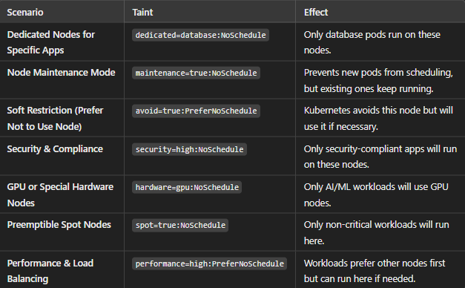

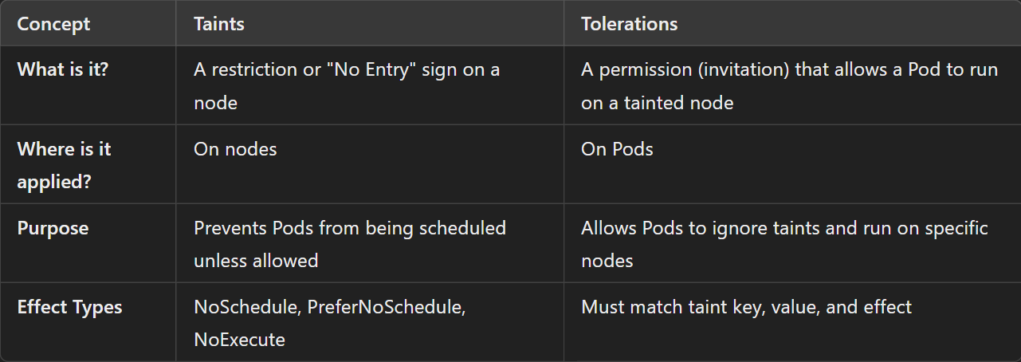

### **When to Use Taints and Tolerations**

#### **1. Isolating Critical Applications**

Imagine you have a cluster where most of your applications are running. But, you have a **highly important application** (like a database or an AI model) that needs to run on **special hardware**, such as a server with a **GPU**.

* **Taint on GPU Nodes**: You can add a **taint** to these special nodes so that **normal applications** don’t get scheduled on them.
* **Toleration on Critical Pods**: The **important application** (that needs the GPU) will have a **toleration** for the taint, meaning it’s **allowed** to run on the special node.

This ensures that only **critical apps** use the **GPU** nodes, while others are prevented from using them.

#### **2. Maintenance or Temporary Isolation**

You need to perform **maintenance** on a specific node in the cluster, like upgrading or restarting the server. During this maintenance, you don’t want any new Pods to be scheduled on that node.

* **Taint on Node During Maintenance**: You can add a taint to the node, which tells Kubernetes **not to schedule any new Pods** on it.
* **Tolerations on Certain Pods**: Some **important Pods** (e.g., critical monitoring services) may still need to run even during maintenance, so you add a **toleration** to them, allowing them to stay on the node.

This ensures that during maintenance, the rest of the Pods are moved elsewhere, but your **critical services** stay active.

#### **3. Preventing Overloaded Nodes**

Suppose you have a node that is **running low on resources**, like memory or CPU. You don’t want new, resource-heavy Pods to be scheduled on that node.

* **Taint to Prevent New Pods**: You can apply a taint to mark this node as **unsuitable** for new Pods.
* **Tolerations on Lightweight Pods**: You might have **lightweight Pods** (e.g., monitoring or logging apps) that **don't use many resources**. You can apply a toleration to these Pods, allowing them to run on this node even if it’s overloaded.

This helps you keep **heavy workloads** off the node while still letting **small, non-critical services** run on it.

#### **4. Dedicated Nodes for Specific Tasks**

Imagine you are running a **machine learning cluster** where certain nodes have **high-performance GPUs** for training AI models. You want to make sure only **machine learning tasks** run on those nodes.

* **Taint the GPU Nodes**: Apply a taint to the GPU-enabled nodes so that **non-machine learning Pods** won’t be scheduled on them.
* **Tolerations for ML Pods**: The **machine learning Pods** will have a toleration for that taint, allowing them to **run on the GPU nodes** without interference.

This keeps the **GPU resources dedicated to machine learning**, and **other tasks** don’t waste those resources.

#### **5. Isolation for Testing or Staging**

You may have a **staging environment** (where new apps are tested) and a **production environment** (where your live apps run). You want to ensure that staging apps don't accidentally get deployed on production servers.

* **Taint the Production Nodes**: Apply a taint to the **production nodes** to prevent non-production apps from being scheduled there.
* **Tolerations for Production Apps**: The **production apps** will have tolerations, meaning they can still run on the **production nodes**, but staging apps will be blocked from running there.

This ensures that **production resources** are reserved for **live apps** only, keeping them isolated from **testing** or **staging** environments.

## Node Selectors vs. Node Affinity in Kubernetes

### **Node Selector** (Basic way)

A **Node Selector** is a way to tell Kubernetes, "I want my application (Pod) to run on a specific type of node" based on **labels** attached to those nodes.

* **Node Selector** ensures your application(pod) only runs on **nodes with specific labels.**
* **Example:** Run all **database pods** only on **nodes with SSD storage**.
* **Limitation:** It only supports exact **label matches**, no advanced rule.

**How to Use Node Selectors**

**1. Label the Nodes (Offices)**

An administrator adds labels to the nodes. For example, a node that has more memory might be labeled like this:

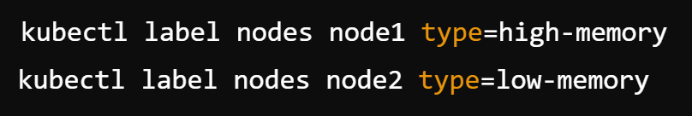

**2. Create a Pod with Node Selector**

Now, when you create a **Pod**, you specify the **node selector** to make sure it runs only on the node with **high-memory**:

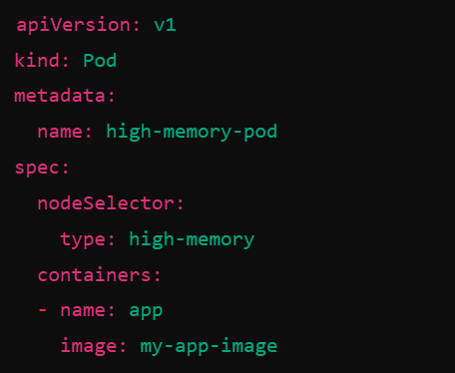

**Node Affinity** (Advanced way)

* More **flexible** than node selectors, allowing **soft and hard rules**.
* **Example:** Prefer running a pod on **nodes in a specific zone**, but if not available, run elsewhere.
* **Types:**

**Required (Hard rule)** → Pod **must** go to specific nodes.

**Preferred (Soft rule)** → Pod **tries** to go to specific nodes but can run elsewhere if needed.

## **Helm**

Helm is a tool that helps you **easily install, upgrade, and manage applications in Kubernetes**.

Instead of writing long YAML files for every deployment, Helm **packages everything into a single reusable unit called a "Chart"**.

Think of Helm as a **package manager** for Kubernetes, just like:

* **apt** for Ubuntu
* **yum** for CentOS
* **pip** for Python
* **npm** for Node.js

### **Why Do We Need Helm?**

In Kubernetes, deploying an application means writing multiple YAML files for **Deployments, Services, ConfigMaps, Secrets, etc.** Managing all these files manually can be difficult, especially for large applications.

Helm makes this process easier by bundling everything into a **Chart**, so you can deploy an entire app with just one command.

### **Why Add helm Repository while installing any service/app?**

* **Helm Needs a Source** → Helm doesn’t know where to find Prometheus charts unless you add the repo.
* **Access Latest Versions** → Ensures you install the latest stable Prometheus releases.
* **Security & Reliability** → Official community-maintained charts are safe and well-tested.
* **Easier Upgrades** → Easily upgrade Prometheus using

### **Real-Time Example: Deploying a WordPress Website**

Imagine you want to deploy **WordPress** on Kubernetes. To do this manually, you need:

1. A **Deployment** for WordPress
2. A **Service** to expose WordPress
3. A **Persistent Volume** to store website data
4. A **Deployment** for MySQL (database)
5. A **Service** for MySQL
6. A **ConfigMap** for database settings
7. A **Secret** for database passwords

This means **7+ YAML files** that you must create, update, and maintain.

With Helm, instead of writing these files manually, you can just **use a Helm Chart for WordPress**, and it will:

* Automatically create all the required Kubernetes objects.
* Configure WordPress and MySQL correctly.
* Allow easy updates and rollbacks

So instead of spending hours writing YAML files, **you just install the Helm Chart, and everything works**.

### **How Helm Works in a Real-Life Project?**

Let's say you are working on an e-commerce website. Your project needs:

* A **frontend** (React/Angular app)
* A **backend** (Java, Node.js, or Python app)
* A **database** (PostgreSQL or MySQL)
* A **message queue** (RabbitMQ or Kafka)
* A **monitoring system** (Prometheus + Grafana)

Without Helm, you would need **tons of YAML files** to deploy everything.

With Helm, you can use **pre-built charts** for:

* **Frontend:** Use an Nginx Helm chart
* **Backend:** Package your backend app as a custom Helm chart
* **Database:** Use a MySQL Helm chart
* **Monitoring:** Use a Prometheus Helm chart

Each service can be deployed **quickly and easily**, and you can update or roll back any part of the system when needed.

### **Real-Time Scenarios Where You Should Use Helm**

Helm is useful when you need to **automate, standardize, and simplify Kubernetes deployments**.

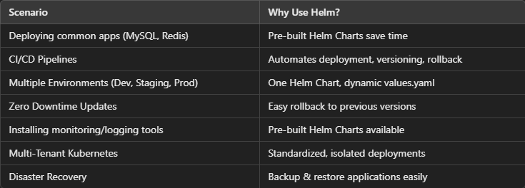

#### 1.Deploying Common Applications (Easier & Faster)

**Scenario:** You need to deploy a database like **MySQL, PostgreSQL, or Redis** in Kubernetes.  
**Why Use Helm?** Instead of writing complex YAML files, you can install these apps with a single Helm command.  
**Example:** helm install my-db bitnami/mysql

**Benefit:** Saves time, reduces errors, and comes with best-practice configurations.

#### 2.Managing Microservices Deployment in CI/CD Pipelines

**Scenario:** Your project has multiple **microservices** (frontend, backend, database), and each service has its own deployment YAML.  
**Why Use Helm?** Helm packages all YAML files together and allows easy **versioning, rollback, and updates**.  
**Example:** When you release a **new app version**, you can update it using Helm instead of manually updating each Kubernetes manifest.

helm upgrade my-app ./my-app-chart

**Benefit:** Simplifies deployments and version management in CI/CD workflows.

#### 3.Managing Configurations Across Different Environments (Dev, Staging, Prod)

**Scenario:** Your application runs in **multiple environments (Dev, QA, Staging, Production)**, and each has different resource requirements.  
**Why Use Helm?** Instead of maintaining separate YAML files, you can use a single **Helm Chart** with a **values.yaml** file to change settings dynamically.  
**Example:**

* **Dev:** Small instance size, low replicas.
* **Prod:** Large instance size, high replicas.
* Helm allows you to switch between these easily:

helm install my-app -f values-prod.yaml ./my-app-chart

**Benefit:** **No duplicate YAML files** and quick environment changes.

#### 4. Zero Downtime Updates (Rolling Updates & Rollbacks)

**Scenario:** Your team deployed a new version of an application, but it **has a bug** and needs to be rolled back.  
**Why Use Helm?** Helm allows **easy rollbacks** to the previous version with one command.  
**Example:** helm rollback my-app 1

**Benefit:** **Faster recovery** from failed deployments.

#### 5.Deploying Third-Party Tools Like Monitoring & Logging

**Scenario:** You want to install **Prometheus for monitoring** or **ELK stack for logging** in Kubernetes.  
**Why Use Helm?** These tools already have **official Helm Charts** that make deployment easy.  
**Example:**

helm install prometheus prometheus-community/kube-prometheus-stack

**Benefit:** Deploys complex tools with best-practice settings in **minutes** instead of hours.

#### 6.Helm for Multi-Tenant Kubernetes Clusters

**Scenario:** You are running a **multi-tenant** Kubernetes cluster where different teams have separate namespaces.  
**Why Use Helm?** Helm lets each team deploy their apps independently using Helm Charts while maintaining a **consistent structure**.  
**Benefit:** **Scalability & isolation** for large teams.

#### *7.Disaster Recovery & Backup (Helm Export)*

**Scenario:** Your Kubernetes cluster crashes, and you need to **restore** all applications quickly.  
**Why Use Helm?** Helm allows you to back up and restore applications easily.  
**Example:** helm get manifest my-app > backup.yaml

**Benefit:** Quick disaster recovery.

## **Commands in K8**

**Cluster Management**

* kubectl config view - View Kubernetes configuration settings.
* kubectl config set-context - Switch to a specific Kubernetes cluster context.
* kubectl cluster-info - Display cluster information like the API server address.

**Deployment Management**

* kubectl create deployment - Create a new deployment.
* kubectl get deployments - List all deployments in the current namespace.
* kubectl describe deployment <name> - Show detailed information about a specific deployment.
* kubectl delete deployment <name> - Delete a specific deployment.

**Pod Management**

* kubectl get pods - List all running pods.
* kubectl describe pod <name> - Show detailed information about a specific pod.
* kubectl logs <pod-name> - Fetch logs from a specific pod.
* kubectl exec -it <pod-name> -- <command> - Run a command inside a running pod.
* kubectl delete pod <pod-name> - Delete a specific pod.

**Service Management**

* kubectl expose deployment <name> - Create a service for a deployment.
* kubectl get svc - List all services in the current namespace.
* kubectl describe svc <name> - Show details about a specific service.
* kubectl delete svc <name> - Delete a specific service.

**Namespace Management**

* kubectl get namespaces - List all namespaces in the cluster.
* kubectl create namespace <name> - Create a new namespace.
* kubectl delete namespace <name> - Delete a specific namespace.

**Configuration and Resources**

* kubectl apply -f <file.yaml> - Apply changes or create resources from a YAML file.
* kubectl delete -f <file.yaml> - Delete resources defined in a YAML file.
* kubectl edit <resource> <name> - Edit the configuration of a resource in the cluster.

**Scaling and Autoscaling**

* kubectl scale deployment <name> --replicas=<num> - Scale a deployment to the desired number of replicas.
* kubectl autoscale deployment <name> --max=<num> --cpu-percent=<threshold> - Enable autoscaling for a deployment.

**Monitoring and Debugging**

* kubectl top pods - Display resource usage (CPU/Memory) of pods.
* kubectl top nodes - Show resource usage for nodes.
* kubectl get events - List events in the cluster to debug issues.

**Node Management**

* kubectl get nodes - List all nodes in the cluster.
* kubectl describe node <name> - Show detailed information about a specific node.
* kubectl cordon <node-name> - Mark a node as unschedulable.
* kubectl drain <node-name> - Evacuate all pods from a node.
* kubectl uncordon <node-name> - Mark a node as schedulable again.

**Miscellaneous**

* kubectl version - Display the client and server versions.
* kubectl get all - List all resources (pods, deployments, services, etc.).
* kubectl explain <resource> - Show documentation for a specific resource.
* kubectl rollout restart deployment <name> - Restart all pods in a deployment.

# GitOps

## **What is GitOps?**

GitOps is a **modern way** to manage and deploy applications and infrastructure using **Git as the single source of truth**.

**Think of Git as the "control center"** for your deployments. Instead of running manual commands, everything is written in Git, and automation tools (like Argo CD) ensure your system matches what’s in Git.

### **How GitOps Works (Step-by-Step)**

**1. Developers make changes in Git** (e.g., update Kubernetes YAML files).  
**2. A GitOps tool (like Argo CD) watches Git for updates.  
3. When a change is detected, the tool applies it to Kubernetes.  
4. If someone manually changes Kubernetes, the tool corrects it to match Git.**

**Result?** 🚀 No manual deployments, no broken environments, and full control over changes!

## **Real-Time Examples & Scenarios Where Argo CD Helps (Simple English)**

Argo CD helps in **real-world DevOps workflows** by making Kubernetes deployments easy, automated, and error-free. Let’s go through some **common scenarios** where Argo CD is useful.

### **Scenario 1: Deploying a New Version of an Application**

**Problem:**

* A company has a website running on **Kubernetes**, and they want to update it from **v1.0 to v2.0**.
* Traditionally, they would **manually run kubectl apply** or set up a complex CI/CD pipeline.

**How Argo CD Helps:**

1. A developer updates the deployment.yaml file in **GitHub** to use my-app:v2.0.
2. Argo CD **automatically detects** this change in GitHub.
3. It **deploys the new version (v2.0) to Kubernetes** without needing manual intervention.
4. The website is now updated safely without any manual steps.

🔥 **Benefit:** Faster and automated application releases with no risk of manual errors.

### **Scenario 2: Preventing Manual Changes in Kubernetes**

**Problem:**

* A team follows **GitOps** and stores all configurations in GitHub.
* A developer manually changes the number of replicas from **3 to 5** using kubectl scale.
* Now, the **actual cluster state** (5 replicas) **does not match** GitHub (3 replicas).

**How Argo CD Helps:**

1. Argo CD **detects the drift** (cluster has 5 replicas, but GitHub says 3).
2. It **automatically corrects it** by resetting the replicas back to 3.
3. No unauthorized changes stay in the system.

🔥 **Benefit:** Ensures Kubernetes **always follows Git** and prevents unapproved manual changes.

### **Scenario 3: Easy Rollbacks if a Deployment Fails**

**Problem:**

* A developer deploys a new version **v3.0**, but it **breaks the app**.
* Rolling back manually using kubectl is risky and slow.

**How Argo CD Helps:**

1. The team **clicks a rollback button** in the Argo CD UI.
2. Argo CD **automatically reverts** Kubernetes to the last stable version **(v2.0)** from GitHub.
3. The app is back to normal within seconds.

🔥 **Benefit:** Fast, **one-click rollback** without any complex commands.

### **Scenario 4: Managing Multiple Kubernetes Clusters**

**Problem:**

* A company has **multiple Kubernetes clusters** (e.g., dev, staging, production).
* They must ensure that each cluster **receives the correct version** of the application.

**How Argo CD Helps:**

Argo CD allows teams to **define which Git branch** controls which environment:

* dev cluster follows dev branch
* staging cluster follows staging branch
* production cluster follows main branch

When a change is **merged into main**, Argo CD automatically **deploys it to production**.

🔥 **Benefit:** **No need to manage each cluster separately**—Argo CD does it all from Git.

### **Scenario 5: Automating Helm & Kustomize Deployments**

**Problem:**

* A team uses **Helm charts** or **Kustomize** to manage Kubernetes manifests.
* They need an easy way to deploy and update Helm-based applications.

**How Argo CD Helps:**

1. Argo CD supports **Helm and Kustomize natively**.
2. It detects changes in Helm values and **applies updates automatically**.
3. No need for manual helm install or helm upgrade commands.

🔥 **Benefit:** Helm-based apps are **deployed and updated automatically**.

### **Scenario 6: Enforcing Security and Compliance**

**Problem:**

* A financial company must ensure **only approved configurations** are deployed.
* Developers should **not manually edit Kubernetes settings**.

**How Argo CD Helps:**

1. **Only approved changes in GitHub** are deployed.
2. If someone **manually modifies Kubernetes**, Argo CD **immediately corrects it**.
3. Auditors can track **who changed what** in Git.

🔥 **Benefit:** Ensures **100% compliance** by forcing all changes through Git.

### **Scenario 7: Automatically Deploying Microservices**

**Problem:**

* A company has **multiple microservices** running in Kubernetes.
* Each microservice has its own repository and deployment files.
* Deploying updates manually **for each service is slow and error-prone**.

**How Argo CD Helps:**

1. Argo CD watches **each microservice’s Git repository**.
2. When a new version is pushed (e.g., service-a:v2.0), Argo CD **deploys it automatically**.
3. If there’s an issue, **Argo CD rolls back** to the last working version.

🔥 **Benefit:** **Fast, automatic deployments for multiple microservices** without manual effort.

### **Scenario 8: Blue-Green Deployment Without Downtime**

**Problem:**

* A company wants to **update their application** without causing downtime.
* They need a **Blue-Green deployment** (deploy a new version while keeping the old one live).

**How Argo CD Helps:**

1. A developer pushes a new version (e.g., app:v2.0) to GitHub.
2. Argo CD **deploys v2.0 as a separate environment (Green)** while v1.0 (Blue) is still running.
3. Once v2.0 is tested, traffic is switched from **v1.0 (Blue) → v2.0 (Green)**.
4. If there’s an issue, traffic is quickly **rolled back to v1.0**.

🔥 **Benefit:** **Zero downtime during deployments** and easy rollback if something goes wrong.

### **Scenario 9: Canary Deployment for Safer Releases**

**Problem:**

A team wants to **test a new version of their app** on 10% of users before rolling it out to everyone.

**How Argo CD Helps:**

1. A developer updates the Git repo with app:v2.0.
2. Argo CD **deploys v2.0 to only 10% of users** while keeping v1.0 active.
3. If v2.0 works fine, Argo CD **gradually increases** the rollout to 50%, then 100%.
4. If v2.0 fails, Argo CD **automatically rolls back** to v1.0.

🔥 **Benefit:** **Safe and controlled releases** without breaking the entire application.

### **Scenario 10: Managing Kubernetes Across Multiple Cloud Providers**

**Problem:**

A company runs Kubernetes in **AWS and GCP**, and managing deployments across both clouds is complex.

**How Argo CD Helps:**

1. Argo CD watches the **same Git repository** but deploys changes to **both AWS and GCP clusters**.
2. Developers **don’t need to log in** to AWS or GCP Kubernetes—Argo CD syncs everything.
3. If one cloud cluster **drifts from Git**, Argo CD **automatically fixes it**.

🔥 **Benefit:** **One Git repo controls all cloud environments, making multi-cloud management easy.**

### **Scenario 11: Automatically Deploying Security Patches**

**Problem:**

* A security team discovers a vulnerability and updates the nginx base image.
* All applications using nginx need to be updated quickly.

**How Argo CD Helps:**

1. The security team updates the Dockerfile and pushes it to GitHub.
2. Argo CD **detects the change and updates all affected applications**.
3. Every Kubernetes pod using the old image is **replaced with the secure version automatically**.

🔥 **Benefit:** **Faster security updates with no manual intervention.**

### **Scenario 12: Self-Healing Infrastructure**

**Problem:**

* A developer **accidentally deletes a Kubernetes service or deployment**.
* The application **stops working** because of this mistake.

**How Argo CD Helps:**

1. Argo CD **detects that the service is missing** from the cluster.
2. It **automatically redeploys** the deleted service from Git.
3. The application is restored without any manual action.

🔥 **Benefit:** **Prevents accidental outages and keeps infrastructure self-healing.**

### **Scenario 13: Managing Configuration for Multiple Teams**

**Problem:**

* A company has **multiple teams (Dev, QA, Production)**, each needing different Kubernetes configurations.
* Managing all configurations manually is complex.

**How Argo CD Helps:**

1. Each team has a **separate Git branch** (dev, qa, prod).
2. Argo CD automatically deploys:

* **Dev branch → Development cluster**
* **QA branch → Testing cluster**
* **Prod branch → Production cluster**

1. Teams **don’t need to manually configure Kubernetes**—just push changes to Git.

🔥 **Benefit:** **Easier configuration management for multiple environments.**

### **Scenario 14: Disaster Recovery After Cluster Failure**

**Problem:**

* A Kubernetes cluster **crashes** due to a major failure.
* The company needs to **restore it quickly** with the same applications.

**How Argo CD Helps:**

1. A new Kubernetes cluster is created.
2. Argo CD **re-syncs all applications from Git** into the new cluster.
3. Within minutes, everything is restored **exactly as it was before**.

🔥 **Benefit:** **Quick disaster recovery with no loss of data or configurations.**

# **GCP Kubernetes**

**GKE (Google Kubernetes Engine)** is a **managed service** provided by **Google Cloud** that runs Kubernetes for you. It **automates** the setup, maintenance, and scaling of Kubernetes clusters, so you don’t have to manage everything manually.

* **Kubernetes** is a tool you can install anywhere and manage yourself.
* **GKE** is a **pre-configured** Kubernetes service that Google **manages** for you.

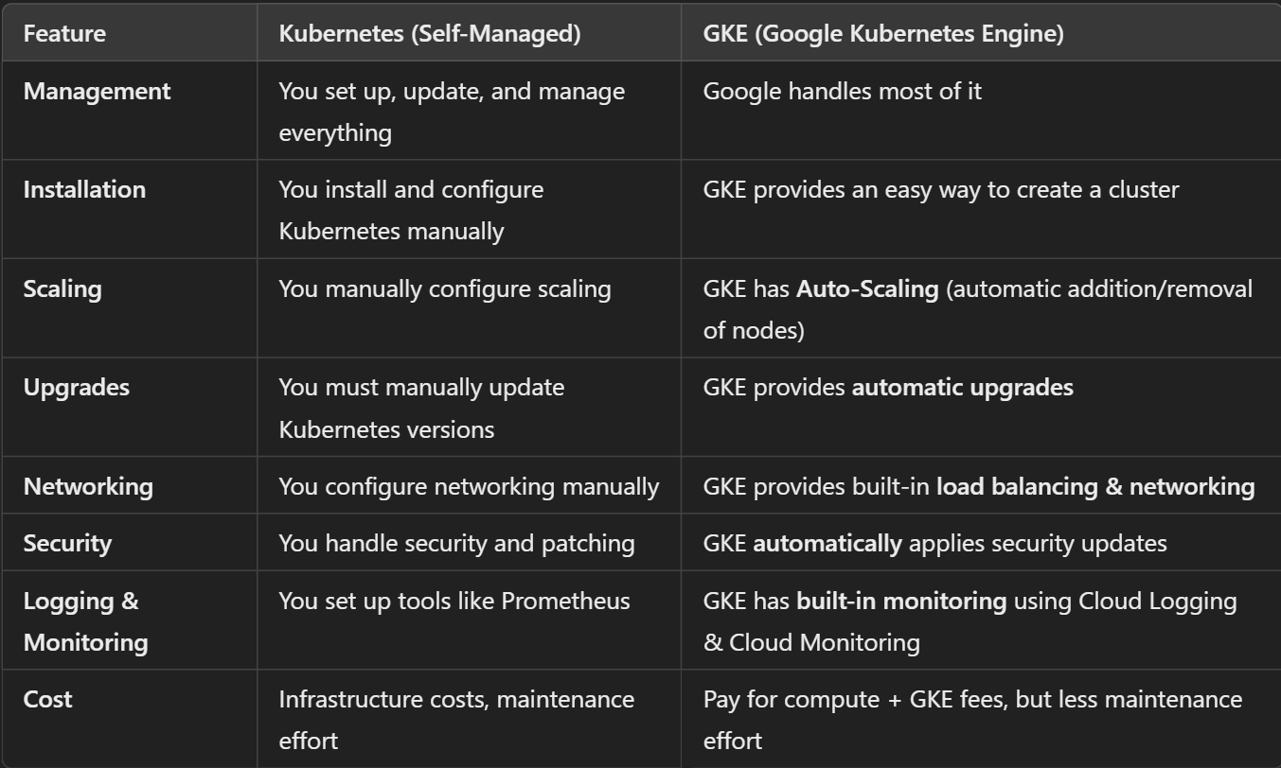

### **Key Features of GKE That Kubernetes Doesn't Have by Default**

1. **GKE Autopilot** – A fully automated Kubernetes mode where Google manages **everything** (no need to manage nodes).
2. **Node Auto-Repair** – Automatically fixes failing nodes.
3. **Cluster Autoscaler** – Adds or removes nodes automatically based on demand.
4. **Built-in Load Balancing** – Uses Google’s global load balancer for better traffic distribution.
5. **Pre-Configured Logging & Monitoring** – Works seamlessly with Google Cloud Logging and Monitoring.
6. **Automatic Upgrades & Patching** – Ensures Kubernetes stays secure and up to date.

# Docker + Kubernetes

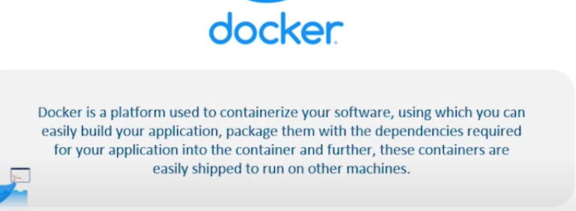

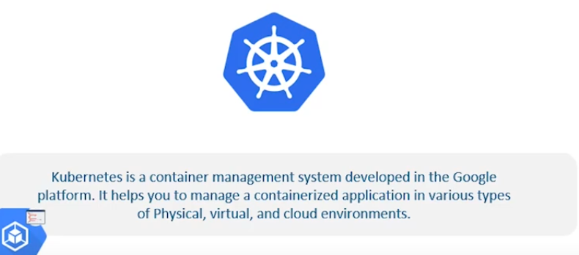

**While Docker handles the creation and running of containers.**

**Kubernetes manages and orchestrates these containers across multiple nodes.**

* **Docker** is used for containerizing applications, making them portable and consistent.
* **Kubernetes** orchestrates and manages these containers, providing features like automated scaling, load balancing, and deployment.
* **Google Kubernetes Engine (GKE)** is a managed Kubernetes service on GCP that simplifies the deployment and management of Kubernetes clusters.

## **Deploying a Web-App on local container (Minikube)**

* Create a react based app

**npx create-react-app myapp**

* Create a dockerfile
* To create docker image from dockerfile

**docker build -t <image-name>:<tag>**

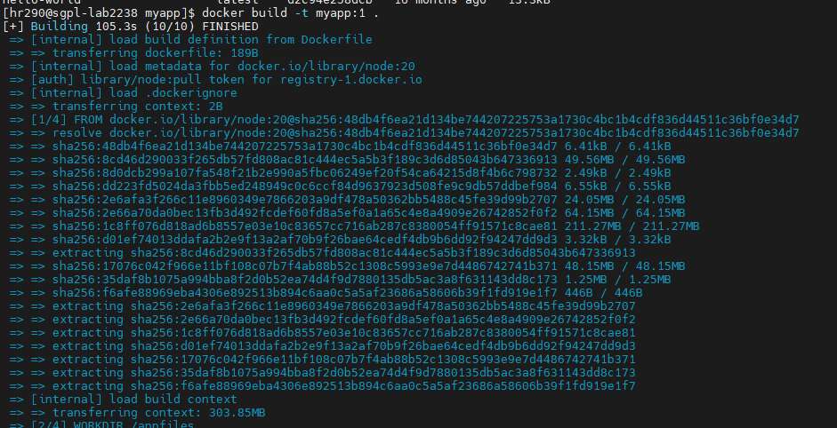

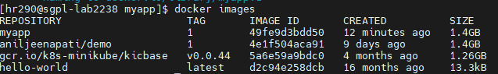

* To create container using docker image.

**docker run -d -p 3000:3000 <image-name>:<tag>**

**docker run -d --name <container-name> -p 3000:3000 <image-name>:<tag>**

**docker run -d -p 3000:3000 <image-id >**

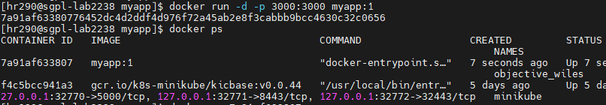

* To see running containers

**docker ps ( add –a to see all all containers)**

* To remove images

**docker rmi <image id>**

* To remove containers

**docker rm <container name>**

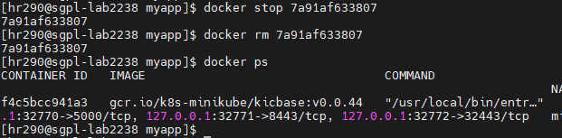

* To create a Deployment

**kubectl create deployment <dep name> --image=<image name>**

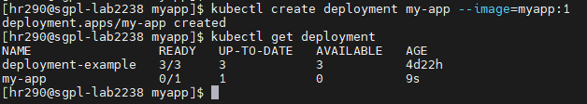

* To see all Deployments

**kubectl get deployments**

* To delete any deployment

**kubectl delete deployment <dep name>**

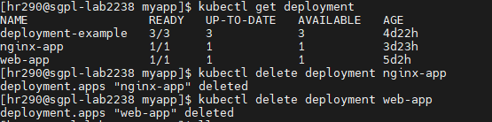

* To expose our deployment Service

**kubectl expose deployment <dep name> --port=<port no> --type=<type> (Ex. LoadBalancer)**



* To see no pods for each Deployment.

**kubectl get pods**

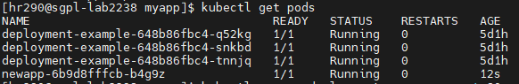

* To create a Service

**kubectl create service <name> --port=<port no>**

* To see app through URL

**minikube service <service-name>**

* To see details of a particular pod.

**kubectl logs newapp-6b9d8fffcb-b4g9z**

**Push on-prem docker image to GCP Atrifact Registry**

To push a Docker image from your CentOS VM to Google Artifact Registry, you’ll need to follow these steps:

1. **Authenticate with Google Cloud**:
   * Install the Google Cloud SDK if you haven’t already:

sudo dnf install -y google-cloud-sdk

* + Log in to your Google Cloud account:

gcloud auth login

* + Set your Google Cloud project:

gcloud config set project PROJECT_ID

1. **Enable the Artifact Registry API**:
   * Enable the API (replace PROJECT_ID):

gcloud services enable artifactregistry.googleapis.com

1. **Create an Artifact Registry repository**:
   * If you haven’t already created a repository, create one with:

gcloud artifacts repositories create REPOSITORY_NAME --repository-format=docker --location=LOCATION

* + Replace REPOSITORY_NAME and LOCATION (e.g., us-central1) with your specific values.

1. **Tag your Docker image**:
   * Tag your local Docker image with the Artifact Registry path:

docker tag LOCAL_IMAGE_NAME LOCATION-docker.pkg.dev/PROJECT_ID/REPOSITORY_NAME/IMAGE_NAME:TAG

* + Example:

docker tag my-app us-central1-docker.pkg.dev/my-project/my-repo/my-app:v1

1. **Authenticate Docker with Artifact Registry**:
   * Configure Docker to use the gcloud credential helper:

gcloud auth configure-docker LOCATION-docker.pkg.dev

1. **Push the image to Artifact Registry**:
   * Finally, push the tagged image:

docker push LOCATION-docker.pkg.dev/PROJECT_ID/REPOSITORY_NAME/IMAGE_NAME:TAG

Replace PROJECT_ID, REPOSITORY_NAME, IMAGE_NAME, TAG, and LOCATION with your specific values. This will upload your image to Artifact Registry, making it available for deployment across your GCP projects.

**Create and Deploy app to GCP Kube cluster**

* To select project

**gcloud config set project < project id>**

* To create cluster from CLI

**gcloud container clusters create my-cluster --num-nodes 3 --zone us-central1-a --project < project-id >**

* To authenticate ( redirect into a page where we can log in )

**gcloud init**

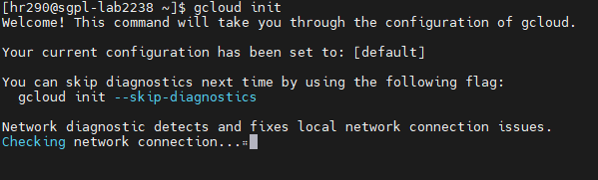

* Copy command line key from GCP Cluster and run it in CLI.

**gcloud container clusters get-credentials my-cluster --zone us-central1-a --project solid-course-258105** 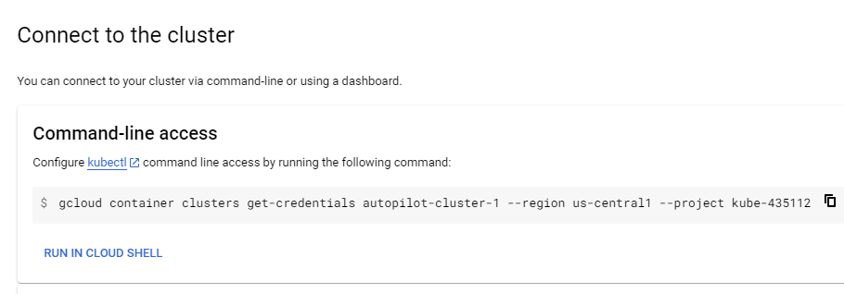

* To create a deployment.

**kubectl create deployment < web-app > --image=aniljeenapati/demo:1**

* **kubectl get deployment**
* **kubectl expose deployment < web-app > --type=LoadBalancer --port=8080**
* **kubectl get services**

**Other commands**

* Increase number of instances of your microservice:

**kubectl scale deployment hello-world-rest-api --replicas=3**

* Increase No of Nodes

**gcloud container clusters resize my-cluster --node-pool NodePoolName --num-nodes 5**

* Setup auto scaling for your microservice:

**kubectl autoscale deployment hello-world-rest-api --max=10 --cpu-percent=70**

* Setup auto scaling for your Kubernetes Cluster

**gcloud container clusters update cluster-name --enable-autoscaling --min-nodes=1 -- max-nodes=10**

* Delete the Microservices Delete service

**kubectl delete service**

* Delete the Cluster

**gcloud container clusters delete**

**Rolling out in Kubernetes**

Rolling out updates in Kubernetes typically involves deploying new versions of your applications.

**Check the Current Status of the Deployment:**

kubectl rollout status deployment/<deployment-name>

**Update the Deployment**

kubectl set image deployment/<deployment-name> <container-name>=<new-image>:<tag>

**Roll Back if Needed:**

kubectl rollout undo deployment/<deployment-name>

**Pause and Resume a Rollout:**

kubectl rollout pause/resume deployment/<deployment-name>

**Scaling**

### **Manual Scaling**

### kubectl scale deployment <deployment-name> --replicas=<number-of-replicas>

**Auto Scaling**

kubectl autoscale deployment <deployment-name> --min=<min-replicas> --max=<max-replicas> --cpu-percent=<target-CPU-utilization>

# Ansible

Ansible is a tool that helps you **automate tasks** on multiple computers at the same time. It is mainly used for:

1. **Configuration Management** – Setting up and managing software on servers.
2. **Application Deployment** – Installing and updating applications automatically.
3. **Orchestration** – Managing multiple servers and making sure they work together.
4. **Provisioning** – Setting up new servers from scratch.

**How it Works:**

* You **write instructions** (called **Playbooks**) in **YAML** format.
* You run these instructions from one main machine (called the **control node**).
* Ansible connects to other machines (called **managed nodes**) over **SSH** and performs the tasks.
* It does **not** need any software installed on the managed nodes except **Python** and SSH access.

### How Ansible Controls Servers in the Same Network

* **Direct Connection**: If the servers are on the same network, Ansible connects directly to them using their **IP addresses or hostnames** over SSH.
* **Inventory File**: You list all these servers in an inventory file, and Ansible knows where to find them.

**EXAMPLE :**

To install Apache on both servers (192.168.2.100 and 192.168.1.200) using Ansible, you can follow these steps:

### **1. Create an Inventory File**

First, create an inventory file (my_inventory) that lists your servers and the corresponding credentials.

Example of my_inventory:

[webservers]

192.168.1.100 ansible_user=anil ansible_ssh_pass=anilpass

192.168.1.200 ansible_user=sunil ansible_ssh_pass=sunilpass

### **2. Create a Playbook to Install Apache**

Now, create an Ansible playbook (e.g., install_apache.yml) to install Apache on both servers.

Example of *install_apache.yml*:

---

- name: Install Apache Web Server on Servers

hosts: webservers

become: yes # Use sudo (privilege escalation)

tasks:

- name: Install Apache on Ubuntu/Debian

apt:

name: apache2

state: present

update_cache: yes

when: ansible_os_family == "Debian"

- name: Install Apache on CentOS/RHEL

yum:

name: httpd

state: present

when: ansible_os_family == "RedHat"

- name: Ensure Apache is running

service:

name: apache2

state: started

enabled: yes

when: ansible_os_family == "Debian"

- name: Ensure Apache is running (CentOS/RHEL)

service:

name: httpd

state: started

enabled: yes

when: ansible_os_family == "RedHat"

### **3. Run the Playbook**

Finally, run the playbook with Ansible to install Apache on both servers.

ansible-playbook -i my_inventory install_apache.yml

**How It Works:**

**Inventory File**: The my_inventory file contains the server details, including the username and password.

**Playbook**: The playbook installs Apache using the appropriate package manager for each server (apt for Debian-based, yum for RedHat-based).

**Privilege Escalation**: The become: yes line ensures that Ansible runs tasks with root privileges (using sudo).

### How Ansible Controls Servers Outside the Network

1. **Public IP or VPN**:

* For remote servers, Ansible connects using their **public IP addresses**.
* If there’s no public IP, you can use a **VPN** to connect to the remote network.

1. **SSH Key Authentication**:

* Ansible uses **SSH keys** to securely connect to the servers. You just need to set up key-based access.

1. **Bastion Host**:

* If the servers are behind a firewall, you can use a **bastion host** (a middle server) that Ansible connects to first, and it relays commands to the other servers.

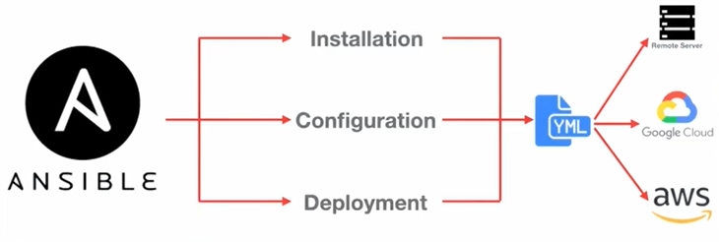

## Components of Ansible:

**Control Node**:

**Definition**: The machine where Ansible is installed and from which you run your automation scripts.

**Role**: It manages and controls the entire automation process.

**Managed Nodes**:

**Definition**: The machines that Ansible manages. These can be servers, VMs, cloud instances, or even network devices.

**Communication**: Managed nodes are controlled over SSH.

**Inventory**:

**Definition**: A list of managed nodes. It can be a simple text file or a dynamic inventory script.

**Example**:

[webservers]

web1.example.com

web2.example.com

[databases]

db1.example.com

db2.example.com

**Playbooks**:

**Definition**: YAML files that define a set of tasks to be executed on managed nodes.

**Example**:

- name: Install and start Apache

hosts: webservers

become:yes

tasks:

- name: Ensure Apache is installed

apt:

name: apache2

state: present

- name: Ensure Apache is running

service:

name: apache2

state: started

**Modules**: These are the building blocks for your tasks. Think of them as commands that Ansible runs on your managed hosts.

**Plugins**: They enhance the core Ansible features, allowing you to customize its behavior and extend its capabilities.

**Roles**: Roles help you organize and reuse your configurations. They are a way to package and distribute your tasks, variables, templates, and handlers.

**Collections**: Collections are a way to bundle and distribute related Ansible content. They include roles, modules, plugins, and documentation.

**Handlers**: Handlers are a special kind of task that only runs if explicitly triggered by another task. They are typically used for state changes like restarting a service.

| **Component** | **Description** | **Purpose** | **Example Use** |
| --- | --- | --- | --- |
| **Modules** | Small, standalone units of code that perform specific tasks. Core functionality in Ansible. | Execute tasks on remote systems (e.g., file operations, service management). | ansible.builtin.shell, ansible.builtin.copy, ansible.builtin.yum |
| **Plugins** | Extend Ansible's core functionality. Can be used for connections, lookups, cache, etc. | Enhance and customize behavior. | Connection plugins (ssh), Lookup plugins (file), Cache plugins (jsonfile) |
| **Roles** | A way to group and organize tasks, variables, files, templates, and handlers. | Reuse and share configurations across multiple playbooks. | A role to set up a web server with tasks to install Nginx, configure, and start it |
| **Collections** | A distribution format for Ansible content (roles, modules, plugins, and documentation). | Package and distribute Ansible content as a single entity. | ansible.posix, community.general, azure.azcollection |
| **Handlers** | Special tasks triggered by other tasks. Run once at the end of a play if notified. | Manage state changes (e.g., restart services after configuration changes). | Restarting Apache service after configuration changes. |

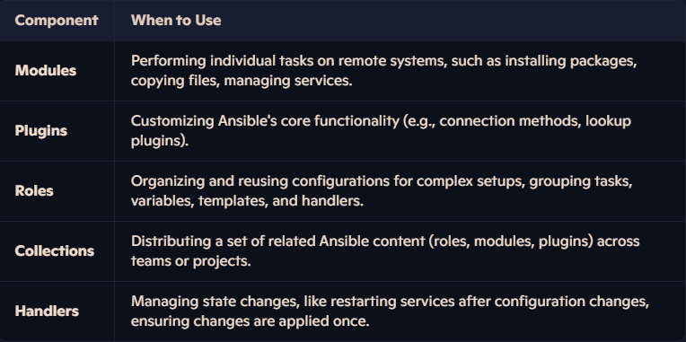

### **1. Modules**

**What they are**: Modules are the smallest units of work in Ansible. They are scripts (written in Python, PowerShell, or other languages) that perform specific tasks on managed nodes (e.g., installing a package, managing files, starting a service).

**Purpose**: Modules are used to execute discrete actions. Ansible ships with hundreds of built-in modules, and you can also write custom modules.

**Example**: The yum module installs packages on Red Hat-based systems, and the copy module copies files to remote hosts.

**Usage**: Called directly in playbooks or ad-hoc commands.

**Type of Modules :**

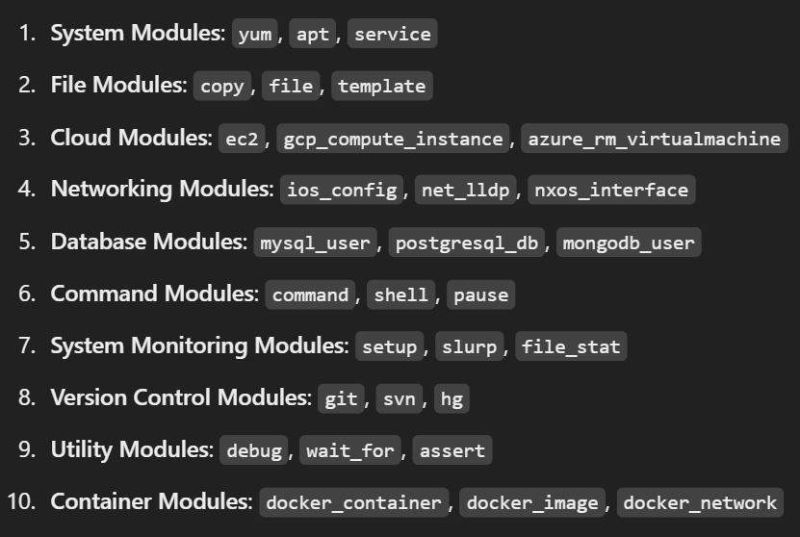

#### 1. **Installing Software (Using the** yum **module)**

**Use Case**: Automating the installation of a web server (e.g., Apache or Nginx) on a fleet of servers.

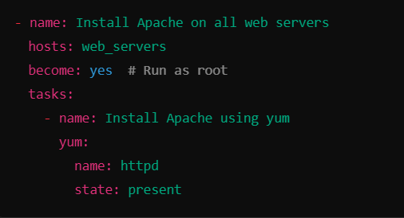

**Real-time Scenario**: You have 50 servers, and you need to install Apache on all of them. Instead of manually logging into each one and running the command, Ansible automates the process with one command.

#### 2. **Creating/Managing Users (Using the** user **module)**

**Use Case**: Creating a user and setting permissions for the user on multiple machines.

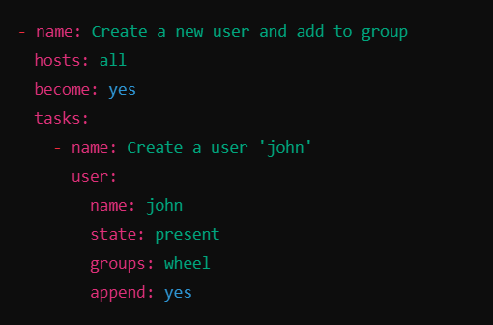

**Real-time Scenario**: You need to add a new user to all the servers in your environment. Ansible can automatically create the user on all systems with the specified permissions.

#### **3. Configuring Services (Using the** service **module)**

**Use Case**: Ensuring a service (like Apache or Nginx) is running on all web servers.

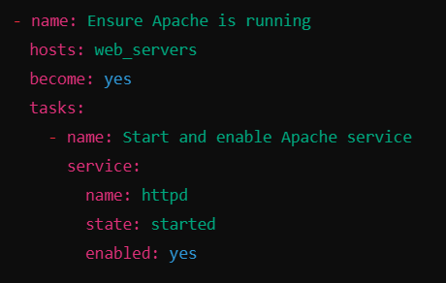

**Real-time Scenario**: After installing Apache, you need to ensure it's running and set to start automatically after a reboot. Ansible ensures that the service is always in the desired state across all machines.

#### **4. Copying Files (Using the** copy **module)**

**Use Case**: Deploying configuration files across multiple servers.

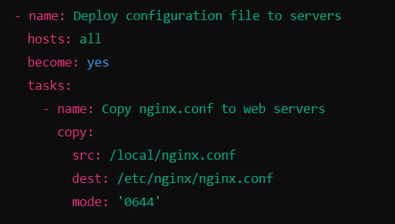

**Real-time Scenario**: You need to update a configuration file (nginx.conf) on all web servers. Ansible copies the file from your local machine to all target servers in the correct location.

#### **5. Running Linux Commands (Using the** shell **module)**

**Use Case**: Running a custom shell command across multiple servers to update configurations or apply patches.

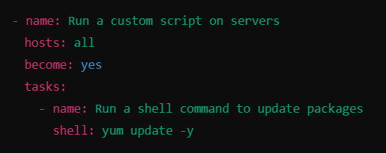**Real-time Scenario**: After patching a vulnerability in your environment, you need to run an update command (yum update -y) on all Linux servers. Ansible runs the command automatically on all target machines.

#### **6 Gathering System Information (Using the** setup **module).**

**Use Case**: Gathering system facts like the OS type, memory, and disk space.

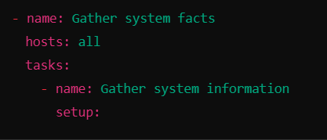

**Real-time Scenario**: Before making changes (e.g., upgrading software), you need to gather details about the systems like OS version or available memory. The setup module automatically collects and stores this information.

#### 7. **Managing Packages (Using the** pip **module)**

**Use Case**: Installing Python packages across multiple servers.

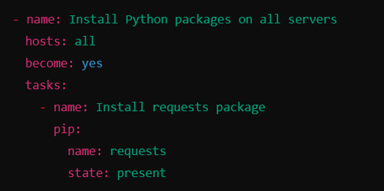

**Real-time Scenario**: You need to install a Python package (like requests) on multiple machines for a Python-based application. Ansible automates this installation process.

#### 8. **Creating Directories (Using the** file **module)**

**Use Case**: Ensuring a specific directory structure exists for an application.

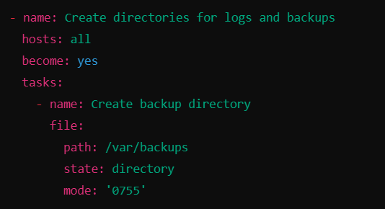

### **2. Plugins**

**What they are**: Plugins are pieces of code that extend Ansible's core functionality. They are used internally by Ansible to perform various tasks like connecting to hosts, transforming data, logging, and more.

**Purpose**: Plugins enhance Ansible's capabilities and allow customization of its behavior.

**Usage**: Typically configured in ansible.cfg or used implicitly in playbooks.

**Types of Plugins**:

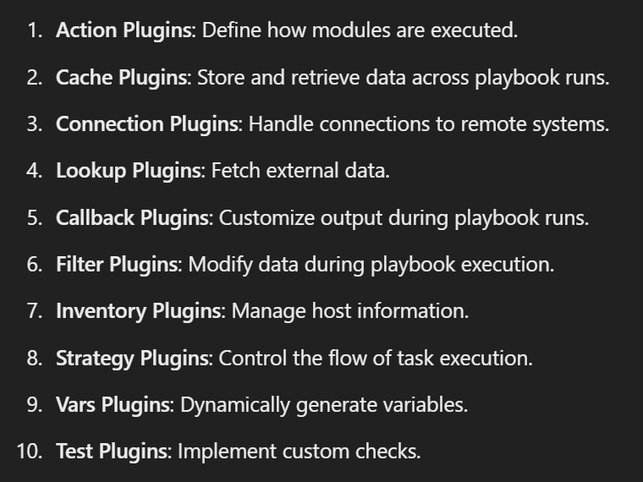

#### 1. Connection Plugin – Helps Ansible Connect to Systems

**Example Plugin: ssh (for Linux) / winrm (for Windows)**  
**Use Case**: Ansible needs to connect to remote servers before running tasks.

* The **ssh plugin** helps connect to Linux servers.
* The **winrm plugin** helps connect to Windows servers.

**Real-Time Example:**

* Automating software installation on **100+ Linux servers** via SSH.
* Configuring **Windows servers** using Ansible over WinRM.

#### 2. Inventory Plugin – Fetches List of Servers Dynamically

**Example Plugin:** gcp compute, aws ec2, azure rm

* Use Case Instead of manually listing servers, Ansible can fetch them from GCP, AWS, or Azure
* The gcp compute plugin pulls a list of active GCP virtual machines
* The aws ec2 plugin fetches AWS EC2 instances dynamically

**Real-Time Example**

* Managing cloud servers without maintaining a manual inventory file
* Auto-scaling when new virtual machines are created, Ansible automatically detects and manages them

#### 3. Callback Plugin – Formats Ansible Output for Logging

**Example Plugin:** json, log plays, slack

* Use Case Helps save logs or send playbook results to monitoring tools or Slack
* The json plugin saves output in JSON format for logging systems
* The slack plugin sends Ansible playbook results to Slack channels

**Real-Time Example**

* Keeping detailed logs of Ansible playbooks in JSON format for troubleshooting
* Sending a Slack notification when a server setup is complete

#### 4. Lookup Plugin – Fetches Data from External Sources

**Example Plugin:** env, file, password

* Use Case Reads values from files, environment variables, or secret stores
* The env plugin retrieves system environment variables
* The file plugin reads values from a file

**Real-Time Example**

* Fetching database passwords from a secrets file instead of hardcoding them
* Reading API keys from environment variables for security

#### 5. Filter Plugin – Modifies Data in Playbooks

**Example Plugin:** ipaddr, json query, regex replace

* Use Case Helps format and modify data within playbooks
* The ipaddr plugin extracts IP addresses from network data
* The json query plugin helps filter JSON responses

**Real-Time Example**

* Extracting the private IP of a cloud instance and using it in another task
* Formatting raw API data to extract only the necessary information

### **3. Handlers**

**Handlers** in Ansible are special tasks that only execute when they are notified by another task in the playbook.

Handlers are executed **at the end of the playbook**, after all tasks are completed.

**Idempotent**: Handlers are idempotent, meaning they will **only** run when necessary. If a handler has already run (due to a change), it won't run again in the same playbook run.

#### 1. **Restarting a Service After Config Change**:

Imagine you want to modify a configuration file for Apache and then restart the Apache service. You can do this with handlers: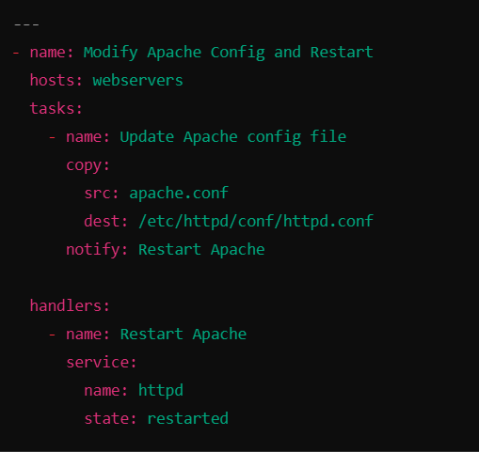

In this case, if the apache.conf file is modified, Apache will restart to apply the changes.

#### 2. **Notify a Monitoring System**:

If you modify a configuration on a system and want to notify a monitoring tool to pick up the change, you can use handlers as follows:

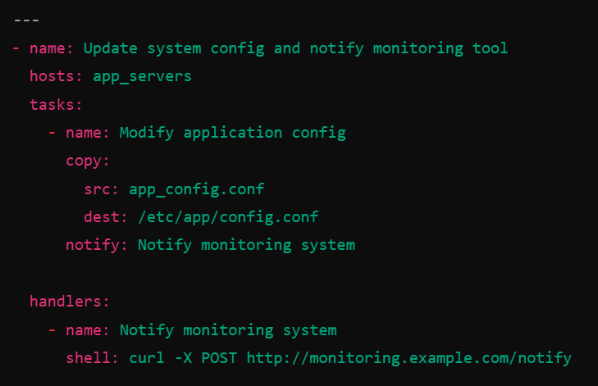

This playbook sends a notification to a monitoring system **only if** the configuration file is changed.

#### 3. **Clear Cache After Update**:

After installing a new package, you may want to clear the application cache:

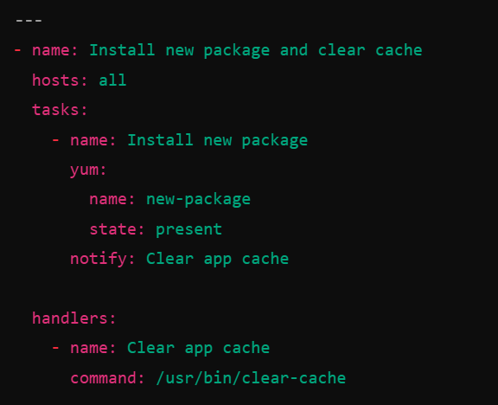

Here, after installing the new package, the handler will clear the application cache only if the package installation changes the system.

### **4. Roles**

#### What are Ansible Roles

* Ansible roles help organize playbooks into smaller, reusable parts.
* They group related tasks, variables, templates, and handlers.
* Instead of writing long playbooks, roles make automation **structured and reusable**.

#### Why Use Roles

* Avoid repeating the same tasks in multiple playbooks.
* Keep playbooks clean and easy to manage.
* Reuse the same role for different projects with minor changes.

#### Real-Time Uses of Ansible Roles

#### Automating Web Server Setup

* **Use Case:** You need to install and configure Apache or Nginx on multiple servers.
* **Solution:** Create a role named web server to handle installation, configuration, and service management.
* **Benefit:** Use this role in any playbook without rewriting tasks.

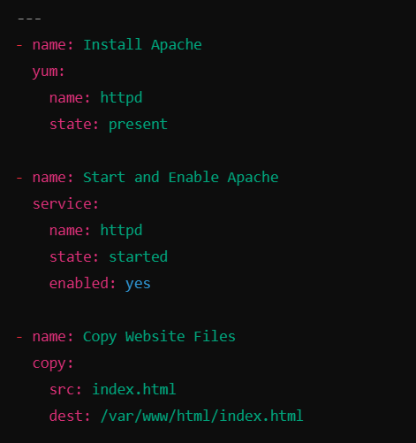 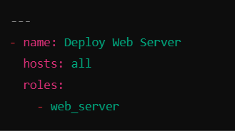

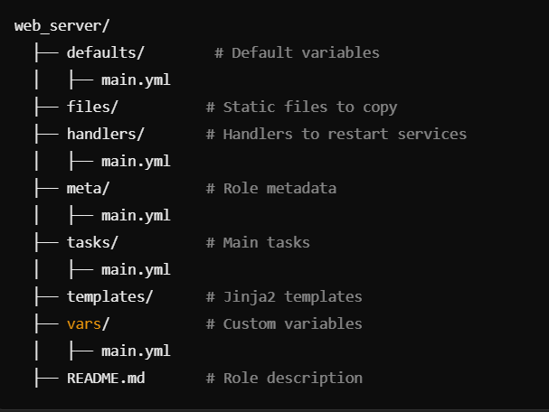

#### Deploying an Application

* **Use Case:** You need to deploy a Flask or Java application.
* **Solution:** Create a role named app deploy that installs dependencies, copies code, and starts the app.
* **Benefit:** Reuse this role for different applications with small changes.

#### Managing Cloud Resources in GCP

* **Use Case:** You need to create virtual machines in Google Cloud.
* **Solution:** Create a role named gcp vm that provisions instances using the gcp compute module.
* **Benefit:** Use this role whenever a new virtual machine is needed without rewriting the same code.

### **5. Collections**

A **collection** is a larger package that includes multiple **roles, modules, plugins, and documentation** for a specific purpose.  
Collections are usually **published by Ansible, vendors, or the community** for common use cases like cloud automation, networking, and security.

**When to Use Collections?**

* When you need **pre-built modules and roles** for complex automation.
* When working with **cloud providers like GCP, AWS, or Azure**.
* When automating **networking devices** like Cisco, Juniper, or F5 load balancers.

**Real-Time Example of Collections**

* Using google.cloud to create **GCP virtual machines and networking resources**.
* Using kubernetes.core to **deploy applications in Kubernetes**.
* Using cisco.ios to **automate network switch configurations**.

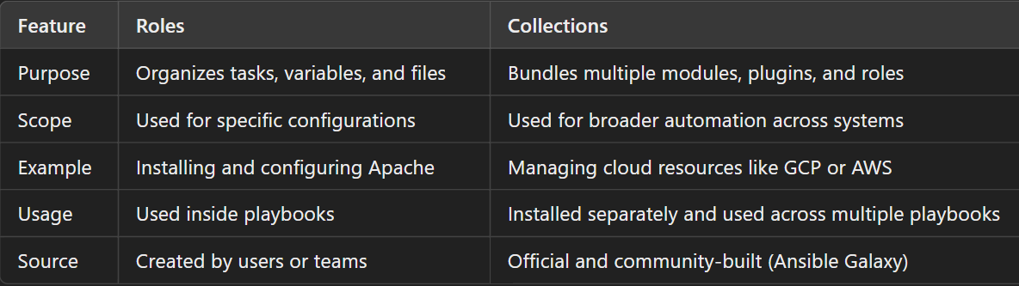

### **6. Environment Variables:**

**Environment variables** are used to set environment variables for tasks. This can be useful for tasks that require certain environment settings to run correctly.

* **Definition**: Environment variables are specified under the environment key within a task.
* **Usage**: They can be used to provide context-specific environment settings for a task.

**Example:**

---

- name: Run a script with specific environment variables

hosts: all

tasks:

- name: Run my script

command: /path/to/my_script.sh

environment:

MY_VAR: my_value

ANOTHER_VAR: another_value

### **7.Variables**

**Variables** in Ansible allow you to store and reuse values across your playbooks. They can be defined in multiple places, such as in playbooks, inventory files, or variable files.

* **Definition**: Variables are defined using key-value pairs.
* **Usage**: They help avoid hardcoding values and make playbooks more flexible and easier to maintain.

**Example:**

---

- name: Install a package

hosts: all

vars:

package_name: nginx

tasks:

- name: Install package

apt:

name: "{{ package_name }}"

state: present

***Conditional Statements (If/Then/Else)***

**Conditional statements** in Ansible allow you to execute tasks based on certain conditions. This is done using the when keyword.

* **Definition**: Conditions are defined using the when keyword followed by a Jinja2 expression.
* **Usage**: Conditional statements enable you to create more complex and dynamic playbooks.

**Example:**

---

- name: Install a package based on OS type

hosts: all

tasks:

- name: Install Apache on Debian-based systems

apt:

name: apache2

state: present

when: ansible_os_family == "Debian"

- name: Install Apache on Red Hat-based systems

yum:

name: httpd

state: present

when: ansible_os_family == "RedHat"

# Prometheus

**Prometheus** is an open-source monitoring tool used to collect and analyze metrics, especially in cloud-native environments like Kubernetes.

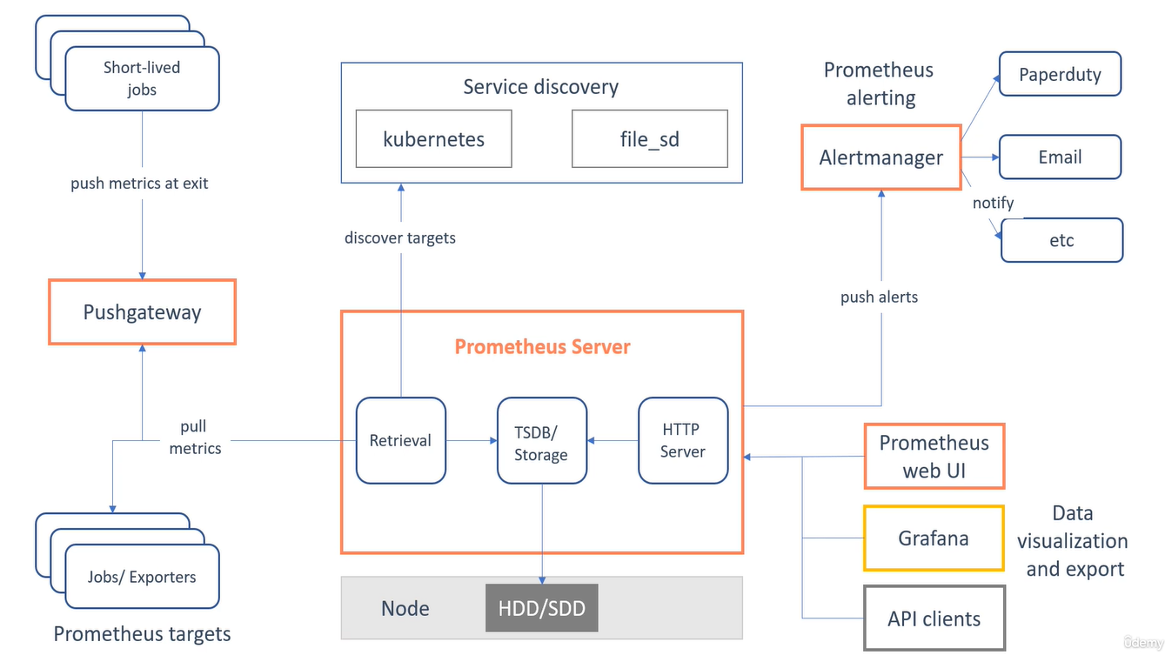

**Prometheus Server**

* The brain of Prometheus. It collects, stores, and processes all the data.
* **Core Component**: The heart of Prometheus, responsible for collecting and storing metrics.
* **Key Tasks**:
  + **Scraping**: Periodically pulls (scrapes) metrics data from target systems.
  + **Storage**: Stores this data in a time-series database.
  + **Querying**: Allows you to query this data using **PromQL** (Prometheus Query Language).

**Targets**

* **What are they?**: Systems or services that expose metrics for Prometheus to scrape.
* **Examples**:
  + Web servers, databases, Kubernetes nodes, etc.
* **How?**: Targets expose metrics via an HTTP endpoint (usually /metrics).

**Exporters**

* **Why Exporters?**: Not all systems natively provide metrics in Prometheus format.
* **Role**: Convert metrics from various systems into a format Prometheus can understand.
* Like sensors in your factory, these are small programs that send information about specific things to Prometheus.
* **Example**: A database exporter sends details about how the database is working.
* **Examples**:
  + **Node Exporter**: For system-level metrics like CPU and memory usage.
  + **Blackbox Exporter**: For probing endpoints (e.g., HTTP or TCP checks).

**Push Gateway (Optional)**

* **When to Use**: For applications that cannot be scraped directly (e.g., short-lived batch jobs).
* **How It Works**: Applications push their metrics to the gateway, and Prometheus scrapes the gateway.
* If something doesn't stay online long enough for Prometheus to pull data, the Pushgateway collects that data and hands it to Prometheus.

**Alertmanager**

* **Purpose**: Handles alerts generated by Prometheus.
* When something goes wrong, the Alertmanager sends notifications (like emails or messages) to the right person or team.
* **Workflow**:
  + Prometheus generates alerts based on defined rules.
  + Alerts are sent to Alertmanager.
  + Alertmanager routes these alerts to channels like email, Slack, PagerDuty, etc.

**Visualization Tools**

* **Why Needed?**: Raw metrics can be hard to interpret.
* **Tool Examples**:
  + **Grafana**: Popular tool to create dashboards using Prometheus metrics.

**Prometheus Workflow (Step-by-Step)**

1. **Scrape Targets**: Prometheus collects metrics from various sources.
2. **Store Metrics**: Data is stored in its own time-series database.
3. **Query Metrics**: Use PromQL to analyze data.
4. **Generate Alerts**: Based on thresholds or conditions you define.
5. **Visualize**: View metrics and alerts on dashboards (like Grafana).

**PromQL**  
This is Prometheus's language to ask questions. For example, "Show me how much memory this server is using over the last hour."

**Data Types in PQL**

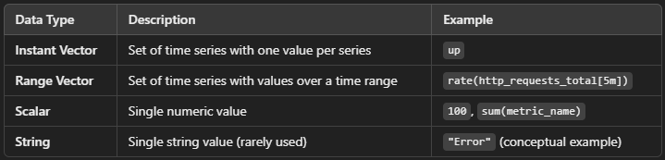

**1. Instant Vector**

* **Definition**: A set of time series, each with exactly one data point at a given time.
* **Usage**: Used when you need the current value of metrics or a snapshot of data at a specific point in time.
* **Example**: up

This returns a vector with the current status (1 for up, 0 for down) of all targets.

**2. Range Vector**

* **Definition**: A set of time series, each with multiple data points over a specified time range.
* **Usage**: Used for operations over a time range (e.g., rate calculations, averages).
* **Example**: rate(http_requests_total[5m])

This calculates the per-second rate of http_requests_total over the last 5 minutes.

**3. Scalar**

* **Definition**: A single numeric value without any associated time series or labels.
* **Usage**: Typically used for thresholds, constants, or as the result of certain calculations.
* **Example**: 100 - (sum(node_memory_MemFree_bytes) / sum(node_memory_MemTotal_bytes) * 100)

This calculates the percentage of used memory.

**4. String**

* **Definition**: A single string value (rarely used in PromQL).
* **Usage**: Mostly appears in the context of Prometheus runtime or error messages, not in regular metric queries.
* **Example**: "up"

Strings are not often directly manipulated in PromQL.

**Selectors and Matches**

**Selectors**: Like using filters in a spreadsheet to find specific rows of data (e.g., "Show rows where Category is Sales").

**Matches**: Like setting up automated alerts for rows that meet certain conditions (e.g., "Send an email if Profit is less than $500").

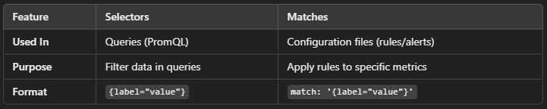

### **Selectors**

Selectors are used in Prometheus queries to pick specific metrics or data based on certain conditions.

#### **Types of Selectors:**

1. **Instant Vector Selector**  
   Selects specific metrics at the current time.  
   Example:
   * cpu_usage → Selects all data for the cpu_usage metric.
2. **Range Vector Selector**  
   Selects metrics over a range of time.  
   Example:
   * cpu_usage[5m] → Selects cpu_usage data for the last 5 minutes.

### **Matches**

Matches are used to filter metrics by their **labels**, which are additional pieces of information attached to metrics. Labels are like tags that tell you more about the data.

#### **How Matches Work**

Labels in Prometheus look like this:  
metric_name{label_key="label_value"}

#### **Examples of Matches:**

1. **Exact Match**  
   Matches a specific label value.
   * cpu_usage{instance="server1"} → Only shows cpu_usage for server1.
2. **Regex Match (~)**  
   Matches label values using patterns.
   * cpu_usage{instance=~"server.*"} → Matches all instances with names starting with "server."
3. **Not Equal (!=)**  
   Excludes a specific label value.
   * cpu_usage{job!="batch"} → Excludes data from the batch job.
4. **Regex Not Match (!~)**  
   Excludes values matching a pattern.
   * cpu_usage{instance!~"test.*"} → Excludes instances starting with "test."

### **How They Work Together**

We can combine selectors and matches in queries to get exactly the data you need.

#### **Examples:**

1. **Get Data for a Specific Instance**

cpu_usage{instance="server1"}[10m]

* + Metric: cpu_usage
  + Instance: server1
  + Time range: Last 10 minutes.

1. **Exclude Certain Jobs**

memory_usage{job!="backup"}

* + Metric: memory_usage
  + Excludes: Jobs labeled backup.

1. **Filter by Regex**

http_requests_total{status=~"5.."}

* + Metric: http_requests_total
  + Matches status codes like 500, 501, 502 (all 5xx errors).

### **1. Binary Operators**

Binary operators perform calculations or comparisons between two metrics or a metric and a constant value.

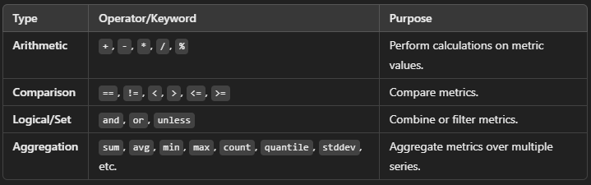

#### **Categories of Binary Operators**

1. **Arithmetic Operators**  
   Perform mathematical operations on metrics.  
   Examples:
   * + (addition)
   * - (subtraction)
   * * (multiplication)
   * / (division)
   * % (modulus, remainder of division)

**Example**:

node_memory_free_bytes / node_memory_total_bytes

* + Calculates the percentage of free memory.

1. **Comparison Operators**  
   Compare metric values and return a boolean result (1 for true, 0 for false).  
   Examples:
   * == (equal to)
   * != (not equal to)
   * < (less than)
   * > (greater than)
   * <= (less than or equal to)
   * >= (greater than or equal to)

**Example**:

http_requests_total > 100

* + Returns metrics where the total HTTP requests exceed 100.

1. **Logical/Set Operators**  
   Work with sets of metrics to combine or filter them.  
   Examples:
   * and (intersection)
   * or (union)
   * unless (complement)

**Example**:

http_requests_total{job="web"} and http_requests_total{job="api"}

* + Returns metrics that are common to both the web and api jobs.

### **2. Aggregation Operators**

Aggregation operators combine multiple metric series into a single series by aggregating their values (e.g., summing, averaging, etc.).

#### **Common Aggregation Operators**

1. **sum**  
   Adds up all values.  
   **Example**:

sum(http_requests_total)

* + Calculates the total number of HTTP requests across all instances.

1. **avg**  
   Calculates the average value.  
   **Example**:

avg(node_cpu_seconds_total)

* + Finds the average CPU usage across all instances.

1. **min**  
   Finds the minimum value.  
   **Example**:

min(node_memory_free_bytes)

* + Finds the instance with the least free memory.

1. **max**  
   Finds the maximum value.  
   **Example**:

max(node_memory_total_bytes)

* + Finds the instance with the most memory.

1. **count**  
   Counts the number of series.  
   **Example**:

count(up)

* + Counts how many instances are up.

1. **count_values**  
   Counts occurrences of each unique value.  
   **Example**:

count_values("version", node_exporter_build_info)

* + Counts how many times each version appears.

1. **quantile**  
   Calculates a quantile (e.g., 95th percentile).  
   **Example**:

quantile(0.95, http_request_duration_seconds)

* + Finds the 95th percentile of request durations.

1. **stddev**  
   Calculates the standard deviation.  
   **Example**:

stddev(node_memory_free_bytes)

* + Measures how free memory varies across instances.

1. **stdvar**  
   Calculates the variance.  
   **Example**:

stdvar(node_cpu_seconds_total)

* + Shows the variance in CPU usage across instances.

### **Grouping in Aggregations**

* You can use the by or without clause to group metrics for aggregation:
  + **by**: Groups metrics by specific labels.
  + **without**: Excludes specific labels from grouping.

**Example with by:**

sum(http_requests_total) by (job)

* Sums HTTP requests, grouped by the job label.

**Example with without:**

avg(node_cpu_seconds_total) without (instance)

* Calculates the average CPU usage across all instances, ignoring the instance label.

**Aggregations with over_time**

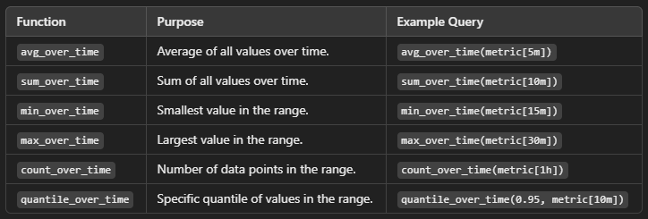

### 1. rate()

* **What does it do?**  
  It calculates the average per-second increase of a counter metric over a specified time range.
* **When to use it?**  
  Use rate() for calculating trends or averages over time for continuously increasing metrics like HTTP requests or bytes transmitted.
* **Example:** rate(http_requests_total[5m])
  + Calculates the average rate of HTTP requests per second over the last 5 minutes.
* **Real-life analogy:**  
  Imagine you’re checking how fast water flows through a pipe on average over 5 minutes.

### 2. irate()

* **What does it do?**  
  It calculates the per-second increase of a counter metric **based only on the most recent two data points**.
* **When to use it?**  
  Use irate() for short-term, high-precision trends (e.g., a sudden spike or drop in requests).
* **Example:** irate(http_requests_total[5m])
  + Shows the instantaneous rate of HTTP requests per second based on the most recent two samples in the last 5 minutes.
* **Real-life analogy:**  
  Checking how fast water is flowing at a specific moment based on the last two readings.

### 3. deriv()

* **What does it do?**  
  It calculates the rate of change (or slope) of a metric over time, even if the metric goes up and down (not just counters).
* **When to use it?**  
  Use deriv() for metrics like CPU temperature, memory usage, or anything that fluctuates rather than continuously increases.
* **Example:** deriv(node_cpu_seconds_total[5m])
  + Calculates the slope of CPU usage over the last 5 minutes.
* **Real-life analogy:**  
  Think of it like monitoring the rate at which the temperature of a room is changing over time.

### 4. predict_linear()

* **What does it do?**  
  Predicts the future value of a metric based on its current trend (linear regression).
* **When to use it?**  
  Use predict_linear() for capacity planning or anticipating thresholds.
* **Example:** predict_linear(node_memory_free_bytes[1h], 3600)
  + Predicts the free memory 1 hour into the future based on the trend in the past hour.
* **Real-life analogy:**  
  Forecasting when a fuel tank will run empty based on the current rate of consumption.

### 5. changes()

* **What does it do?**  
  Counts the number of times a metric's value has changed over a specified time range.
* **When to use it?**  
  Use changes() to detect how often something fluctuates, like service status changes or state transitions.
* **Example:** changes(up[1h])
  + Counts how many times the up metric (indicating service status) has changed in the past hour.
* **Real-life analogy:**  
  Counting how many times a light switch was flipped in the last hour.

**Recording Rules in Prometheus**

Recording rules in Prometheus allow you to **precompute frequently needed queries** or **aggregate data** and store the results back in Prometheus as a new time series

### **Why Use Recording Rules?**

* **Performance Boost:** Precompute complex queries so they don't burden Prometheus when frequently used.
* **Simplify Queries:** Turn long and complex queries into short, reusable names.
* **Reusable Metrics:** Store the output of aggregations or transformations as new metrics for other queries or dashboards.

### **Example**

Imagine you have a metric called http_requests_total, which tracks the total number of HTTP requests. You want to compute the **rate of requests per second** for each service.

#### Without Recording Rules:

You'd write a query like this every time:

rate(http_requests_total[5m])

This query is computationally expensive if used frequently.

#### With Recording Rules:

1. Define a recording rule in a rules file (rules.yml):

groups:

- name: example_rules

rules:

- record: http_requests_per_second

expr: rate(http_requests_total[5m])

**record**: The name of the new metric (http_requests_per_second).

**expr**: The query to compute the metric.

1. Include the rule file in prometheus.yml:

rule_files:

- rules.yml

1. Prometheus evaluates this rule and stores the result as a new metric, **http_requests_per_second**.
2. You can now query **http_requests_per_second** directly in dashboards or alerts instead of writing the original query.

# Harness

## What is harness

Harness is a software platform that helps companies manage and automate their software development processes.

Imagine it as a smart assistant that takes care of deploying your applications, managing infrastructure, and ensuring everything runs smoothly.

### Key Functions

1. **Continuous Integration (CI)**: It helps developers integrate their code changes regularly into a shared repository, making sure everything works together.
2. **Continuous Delivery (CD)**: It automates the process of delivering applications to different environments, like testing or production, ensuring quick and safe deployments.
3. **Infrastructure as Code Management (IaCM)**: It allows you to manage your infrastructure (servers, databases, etc.) as code, ensuring consistency and ease of management.
4. **Monitoring and Optimization**: It continuously monitors your applications and infrastructure, providing insights and optimizing performance.

## Why Harness

Harness and Jenkins are both CI/CD tools, but **Harness is better than Jenkins** in some key areas, especially for modern DevOps workflows. Here are the positions where Harness is better:

### 1. **Built-in Continuous Deployment (CD)**

* **Harness**: Provides native CD features with built-in rollback, verification, and advanced deployment strategies like Canary, Blue-Green, and Rolling updates.
* **Jenkins**: Primarily a CI tool; requires additional plugins (like ArgoCD, Spinnaker) for full CD capabilities.

### 2. **Less Manual Scripting**

* **Harness**: Provides a GUI-based, low-code pipeline setup, reducing the need for custom scripts.
* **Jenkins**: Requires heavy scripting in Groovy, Bash, or Python to achieve similar automation.

### 3. **Automatic Rollbacks**

* **Harness**: Supports automatic rollbacks based on health checks and verification.
* **Jenkins**: No built-in rollback; must script it manually.

### 4. **AI/ML-Powered Verification**

* **Harness**: Uses AI to analyze logs and metrics (e.g., from Datadog, New Relic) to detect deployment failures.
* **Jenkins**: No AI/ML features; manual log checking is required.

### 5. **Cost Management for Cloud Deployments**

* **Harness**: Includes built-in cloud cost visibility and optimization for Kubernetes and cloud resources.
* **Jenkins**: No cost management features.

### 6. **Built-in Security & Governance**

* **Harness**: Provides role-based access control (RBAC), audit trails, and security policies out of the box.
* **Jenkins**: Requires extra plugins for security, which need separate maintenance.

### 7. **Better Kubernetes Support**

* **Harness**: Has native Kubernetes deployment support with Helm, Kustomize, and GitOps.
* **Jenkins**: Can deploy to Kubernetes but needs plugins like Kubernetes plugin, Helm plugin, etc.

### 8. **Faster Onboarding & Maintenance**

* **Harness**: Easier onboarding with a modern UI and predefined workflows.
* **Jenkins**: Requires more setup, maintenance, and troubleshooting for plugins and pipelines.

### 9. **SaaS & Cloud-Native Support**

* **Harness**: Available as a fully managed SaaS solution with automatic updates.
* **Jenkins**: Needs to be self-hosted and manually updated.

### 10. **Pipeline as Code (Harness YAML vs Jenkinsfile)**

* **Harness**: Uses YAML-based pipeline configuration with a structured approach.
* **Jenkins**: Uses Jenkinsfile (Groovy-based), which is harder to maintain for complex pipelines.

**Account**

The top level in Harness, managing multiple organizations.

**Organization**

Groups multiple projects under one unit for better access control.

**Project**

A workspace inside an organization where CI/CD pipelines,services, and environments are created.

## IaCM in Harness

### **Workspaces in Harness Infrastructure as Code (IaC)**

**Workspaces** in Harness **Infrastructure as Code (IaC)** help organize and manage Terraform configurations efficiently. They allow you to separate environments, maintain state files, and apply different settings for different deployments.

### **Workspace in Harness IaC**

A **Workspace** in Harness is similar to a **Terraform workspace**. It helps you:

* Manage different environments (**dev, prod, staging**)
* Separate Terraform state files
* Apply different variables and configurations

### **How to Create a Workspace in Harness IaC?**

1. **Go to Harness → Projects → Infrastructure as Code (IaC)**
2. Click **+ New Workspace**
3. Enter **Workspace Name** (e.g., gcp-prod)
4. Select **Repository** (GitHub, GitLab, Bitbucket)
5. Choose **Branch & Path** (where Terraform files are stored)
6. Configure **Backend State** (GCS, S3, Terraform Cloud, etc.)
7. Click **Save & Continue**

**Workspace Created!**